Win Week 9 Exponent Rules Day 1

Learning Target – Students will simplify monomials using the rules of exponenets.

1. Based upon what you know about multiplication and exponents, the expression 52 • 54  can be written in the following expanded form:

52 • 54  = (5•5)•(5•5•5•5)

Note that the parenthesis is not needed. They are put there to emphasize the two different exponents which are being used.

Based upon how the original expression has been written in expanded form, what would the expression, 52 • 54, be equivalent to in simplified form?

52 • 54  =

1. Complete this table showing the expanded and simplified forms of various expressions. Include the parenthesis in your expanded forms.

Original Expression expanded form simplified form

52 • 54  (5•5)•(5•5•5•5) 56

2• 2 6

B4 • B8

m4• m•9m4

x2• y5

1. Which original expression didn’t become any shorter? Explain why.

**RULE! --Product of Powers**

1. Study all the other “original’ expressions and their respective simplified forms. **Describe the pattern**.
2. Based upon the pattern just described, write this expression in simplified form.

xm • xn  =

Try:

a) 32 • 35  b) x5• x11  c) (3x2)(6x7) d) (-2x2y3)(4xy3) e) (3x2)(2x)(4x3)

1. Complete this table. Do not simplify numerical expression down to what they equal. Be attentive to the location of the various exponents. The first expression has been partially completed for you.

Original Expression expanded form simplified form

 (5•5•5•5) • (5•5•5•5) 







**RULE! --Power of Powers**

1. Study the original expression and its equivalent simplified form. Describe the pattern which is observed.
2. Based upon your description, what would the given expression simplify to?

(am)n =

Try:

a) (62)3 b) (n6)10  c) (x5)9

1. Complete this table. Do not simplify the numerical expressions all the way down to what they equal. Your final “equivalent” form should be written **differently** than the original expression.

Original Expression expanded form simplified form

 (6•5) (6•5) (6•5) 





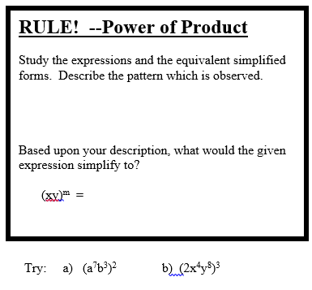

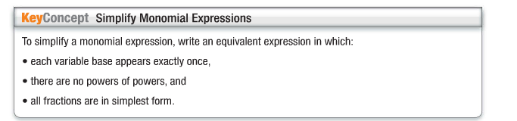

1. More to try:

a)  b)  c)  d) 

Win Week 9 Day 2

Learning Target – Divide monomials using the properties of exponents.

1. Complete the table using what you know about the meaning/use of exponents and also what you know about reducing fractions. Do NOT simplify the numerical expression to what they equal.

Original Expression expanded form simplified form

  









1. Which original expression didn’t become simplified? Explain why!

**RULE! --Quotient of Powers**

1. Study all the other “original” expressions and their respective simplified forms. Describe the pattern.
2. Based upon the pattern you just described, write this expression in simplified form:



Try:

a)  b)  c) d)  e) 

1. Complete this table. Do not simplify the numerical expressions all the way down to what they equal. Your final “equivalent” form should be written **differently** than the original expression.

Original Expression expanded form simplified form

  







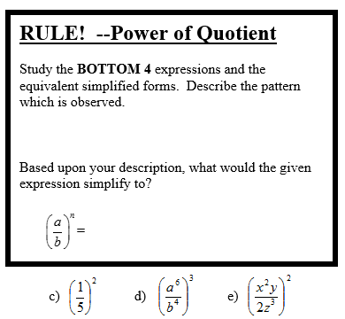

**Zero Exponent**

**Evaluate each using your calculator.**

   

**ZERO EXPONENT RULE**

Study the results. Describe the pattern you observed.

Based upon your description, what would the given expression simplify to?

=

-----------------------------------------------------------------------------------------------------------------------------------------------------

**Negative Exponent**

**Observe the results for each problem**

    

**NEGATIVE EXPONENT RULE.**

Study the results. Describe the pattern you observed.

Based upon your description, write the rule about negative exponents.

**Write the result to each of the following:  **

**Try:**

**a) s-5t2 b) (x2y-3)(x-3y5) c) (2x3y-2)-2**

WIN Week 9 day 2 More Practice





