WIN Week 7 Notes Functions Day 1 – Relations  
Learning Target – Students will represent and interpret relations.

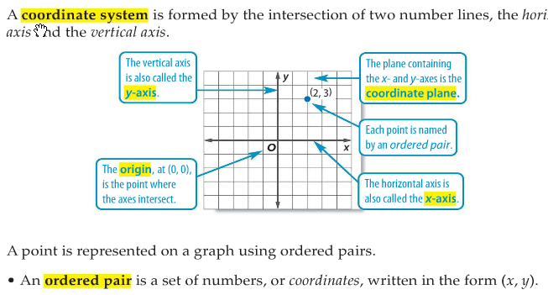

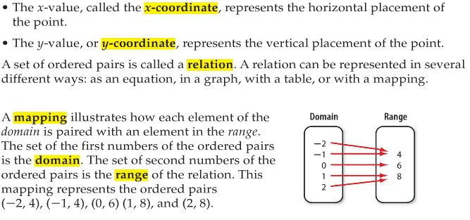

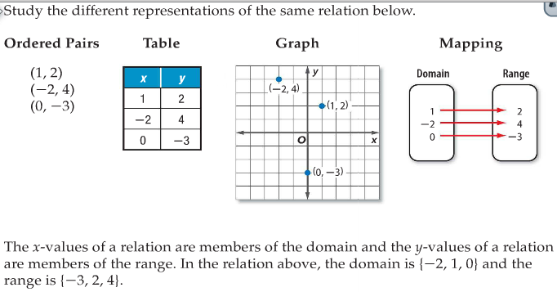

1. 

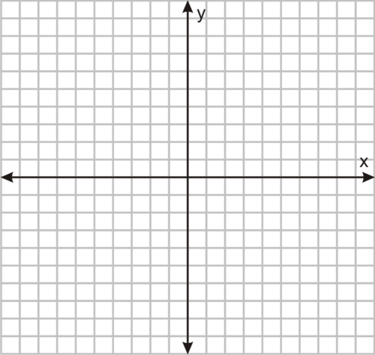Table Graph Mapping

1. Determine the domain and range of the relation in question 1.

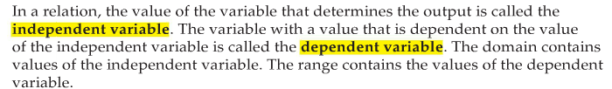

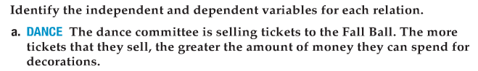



Practice

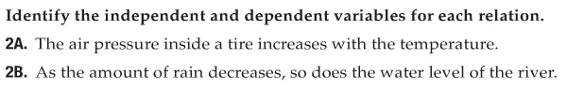



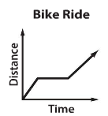

You try:

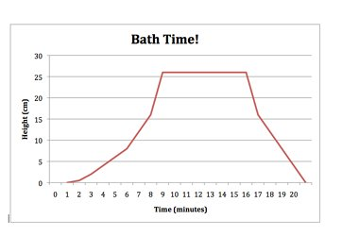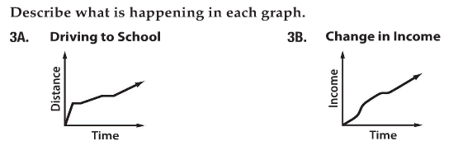

WIN Notes Functions Week 7 day 2 – Functions

Learning Target – Students will determine whether a relation is a function and find function values.



1. Look at each example below. Compare the relation labeled “function” to the relation labeled “not a function”. Determine why the relation labeled “not a function” isn’t a function. Explain your answer.

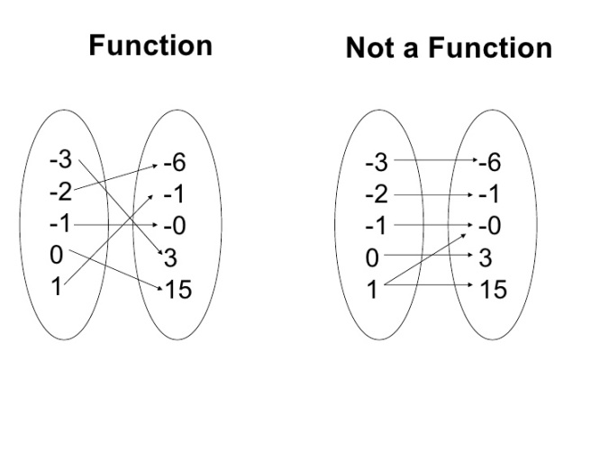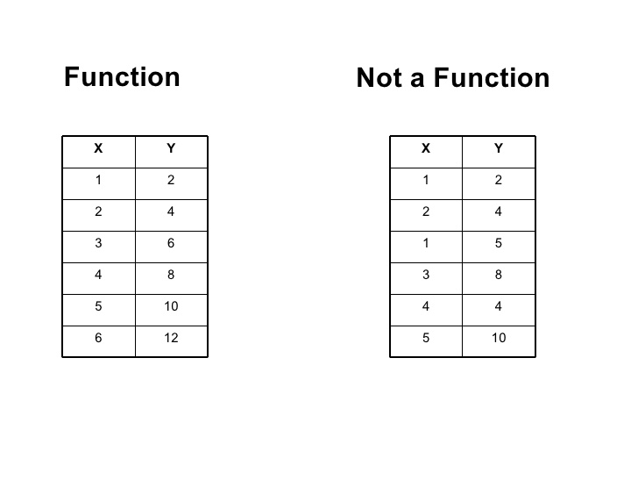

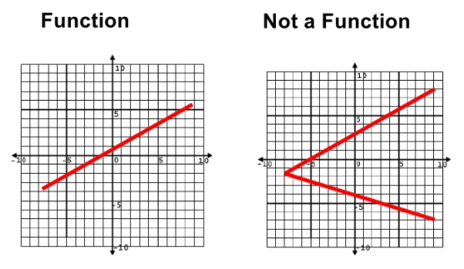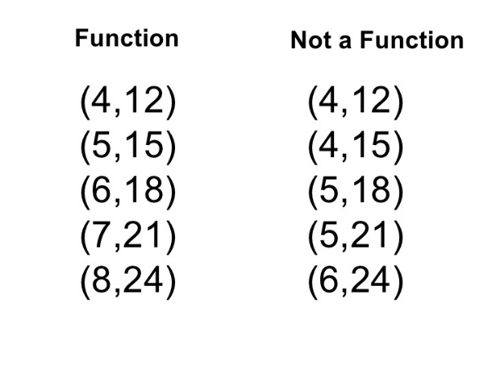

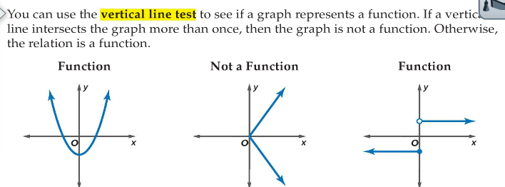

1. 

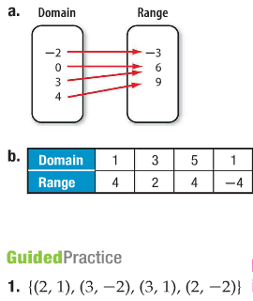



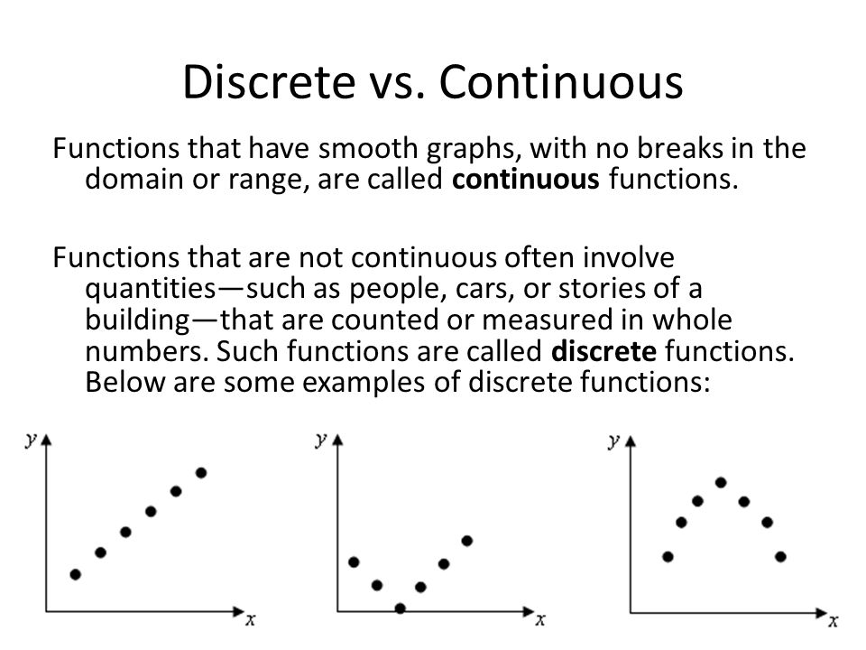

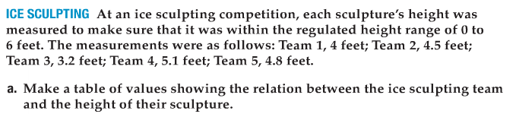



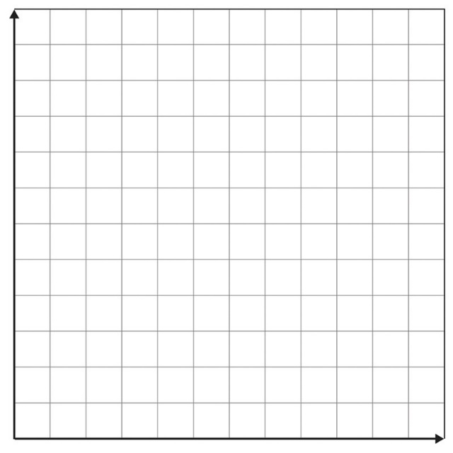





1. 



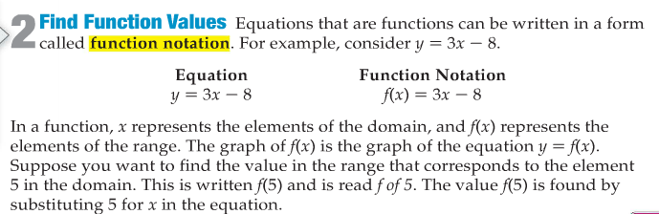





1. 

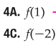







WIN week 7 notes Functions Day 4 – Interpreting Graphs of Functions  
Learning Target – Students will interpret graphs of functions.

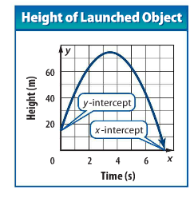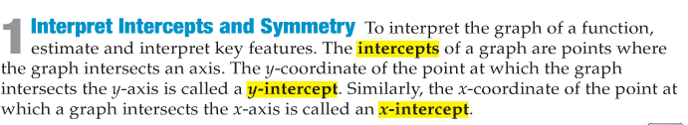

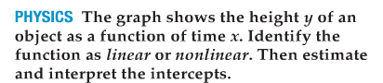

1. Sort all your graphs by Linear verses non linear.

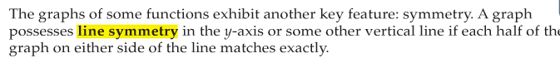

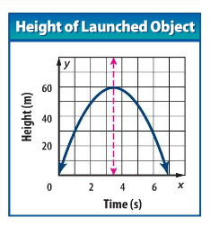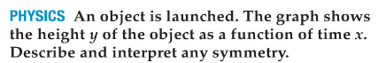

1. Sort your graphs by those with and without an axis of symmetry.

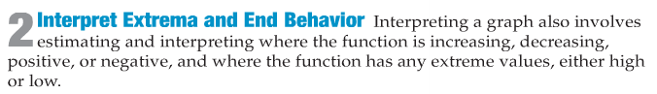

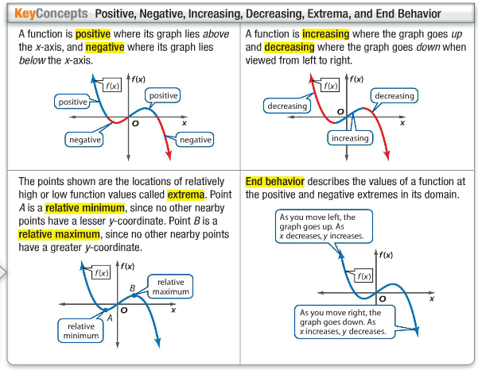

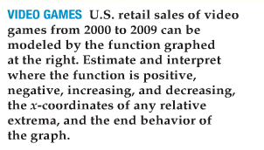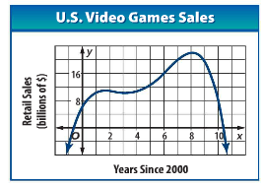

1. Sort your graphs by increasing, decreasing, constant or combination.
2. Sort your graphs into those with maximums, minimums, neither, or both.
3. Sort your graphs by those with similar end behavior.
4. Sort your graphs as discrete and continuous.
5. Sort your graphs by functions and non functions.
6. Save your graphs to use next class period.

WIN Functions Week 8 Day 1 Notes – Graphing

A parent graph is a graph that is transformed to create other members in a family of graphs. A **FAMILY OF GRAPHS** that displays one or more similar characteristics. In the parent graph of each family (with the exception of the constant function) the coefficient of x is 1.

For each parent function below fill in the missing information. You can use your textbook and the internet as a resource.

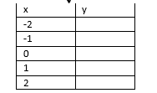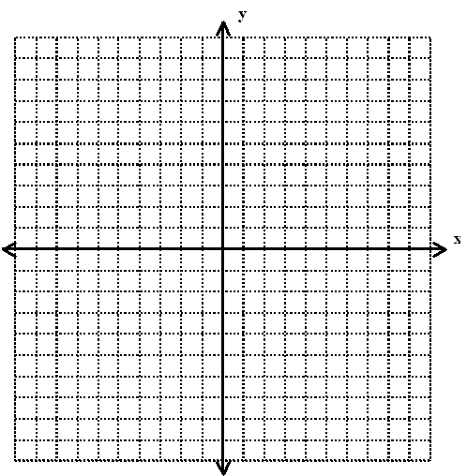Function Name: Linear Function (The Identity Function)   
General Equation: y=x  
Domain:  
Range:  
x-intercept(s):  
y-intercept(s):

Function Name: Constant Function   
General Equation: y=c, where c is a constant  
Domain:  
Range:  
x-intercept(s):  
y-intercept(s):

Function Name: Absolute Value Function   
General Equation: $y=\left|x\right|$  
Domain:  
Range:  
x-intercept(s):  
y-intercept(s):

Function Name: Quadratic Function  
General Equation: $y=x^{2}$  
Domain:  
Range:  
x-intercept(s):  
y-intercept(s):

Function Name: The square Root Function   
General Equation: $y=\sqrt{x}$  
Domain:  
Range:  
x-intercept(s):  
y-intercept(s):

Function Name: The cubic Function   
General Equation: $y=x^{3}$  
Domain:  
Range:  
x-intercept(s):  
y-intercept(s):

Function Name: The exponential Function   
General Equation: $y=c^{x}$, where c is a constant  
Domain:  
Range:  
x-intercept(s):  
y-intercept(s):

Now use the graphs from last class period and sort them by parent function. If there are any that do not match explain why.

WIN functions Notes Graph Functions Week 8 day 2

Examples- Graph each function rule and name each function by its correct mathematical name. Then state the domain, range, increasing intervals, decreasing intervals, x and y intercepts and any symmetry that you observe.

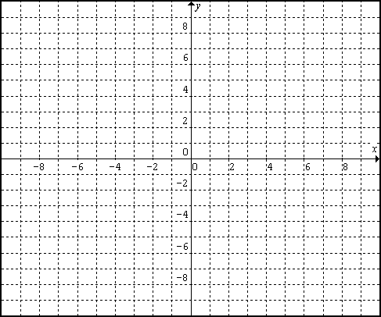Learning Target – Students will graph linear, absolute value, exponential, square root, cubic, and quadratic functions.

|  |  |  |
| --- | --- | --- |
| Mathematical name: | Domain: | Range: |
| Increasing Interval: | Decreasing interval: | X - intercept: |
| Y-intercept: | Symmetry: |  |

1**.** *y = *

2**.** *y = x*2 *+* 1 3. 



4**.**  5. 





6. **



|  |  |  |
| --- | --- | --- |
| Mathematical name: | Domain: | Range: |
| Increasing Interval: | Decreasing interval: | X - intercept: |
| Y-intercept: | Symmetry: |  |