WIN week 6 Day 2
Students will simplify algebraic expressions without a calculator using the order of operations.
P – Parenthesis
E – Exponents
M/D – Multiplication and division from left to right
A/S – Addition and subtraction from left to right
Write down the order in which you would simplify the expression.
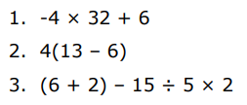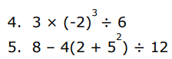
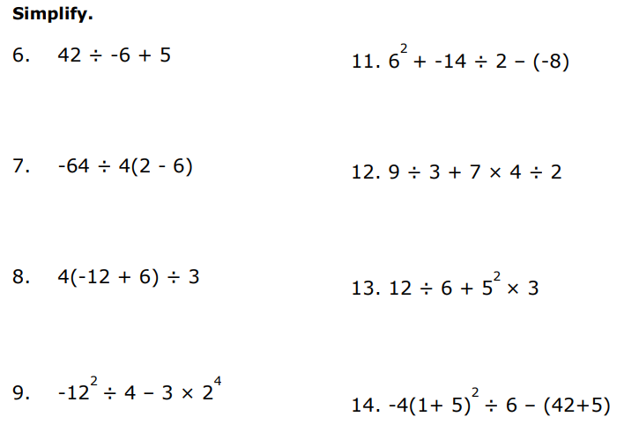

Evaluate is a lot like simplify except you need to substitute in for the variables first.
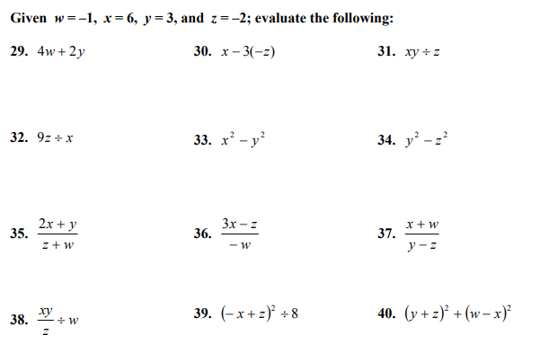

WIN week 6 Day 3
Students will simplify algebraic expressions containing variables by distributing and combining like terms without a calculator.
