WIN week 4 Day 1 – writing and graphing equations of lines
Students will graph equations of lines.
Warm up –
- Write the equation of a line in point slope form through (2,3) and (-4, 1).

- Convert you equation to slope intercept form.

- Convert you equation to standard form.

- Graphing equations in slope intercept form. Steps
- Start at the y intercept.
- “do” the slope - $\frac{rise}{run}$.
Examples
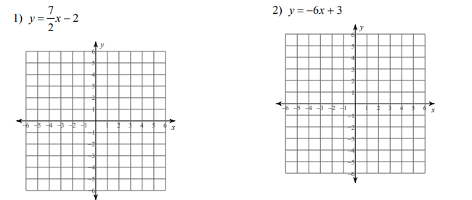

Practice
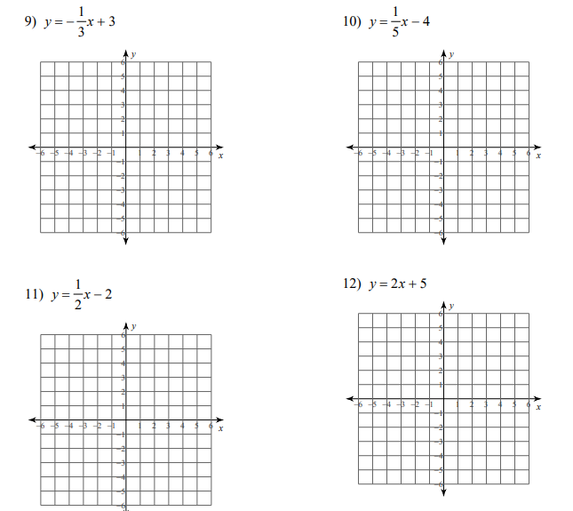
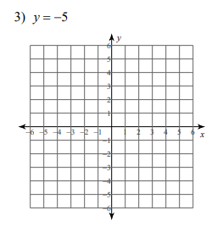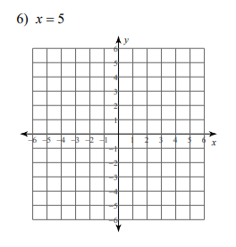

- Graphing equations in point slope form.
Two options
- Convert to slope intercept form
- OR choose the starting point $(x_{1},y_{1})$ and then “do” the slope
Examples:
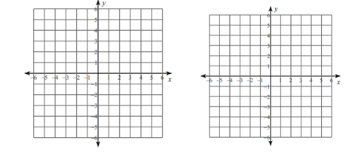
Practice:
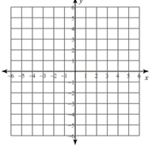

- Graphing equations in standard form.
Two options:
- Convert to slope intercept form
- Find the x and intercept.
Examples
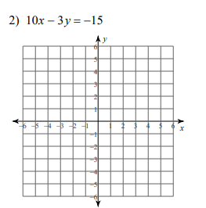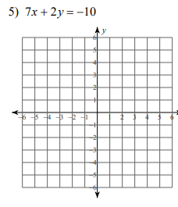
Practice:
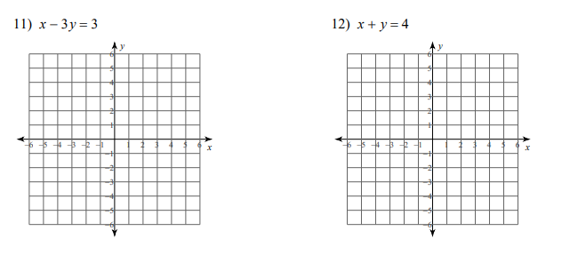
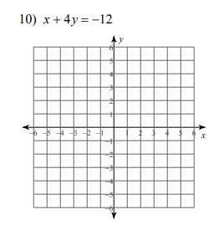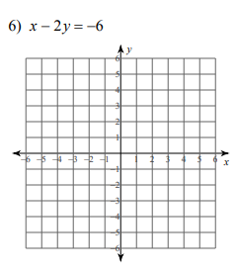
WIN Week 4 Day 2
For each graph.
- Write the equation in point slope form.
- Convert the equation to slope intercept form.
- Convert the equation to standard form.
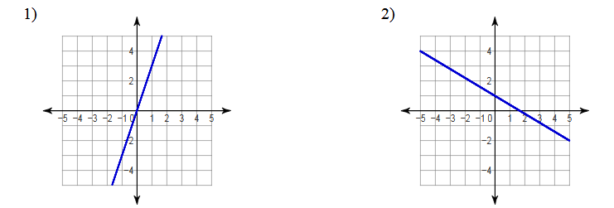

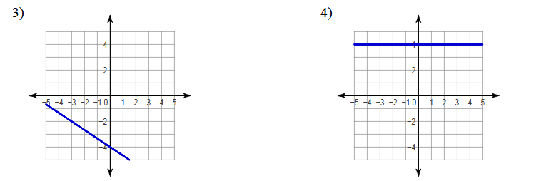
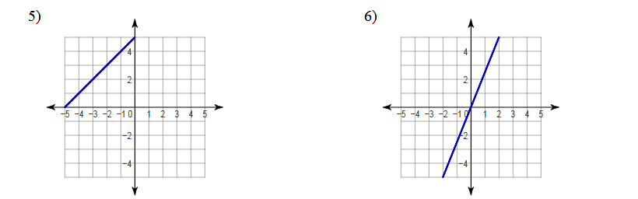

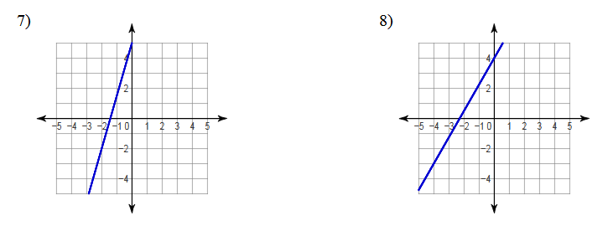

Win review – writing and graphing equations of lines
- A line has a slope of 1/3 and goes through the point (-4, 4).
  - Write the equation of the line in point slope form.

  - Write the equation of the line in slope intercept form.

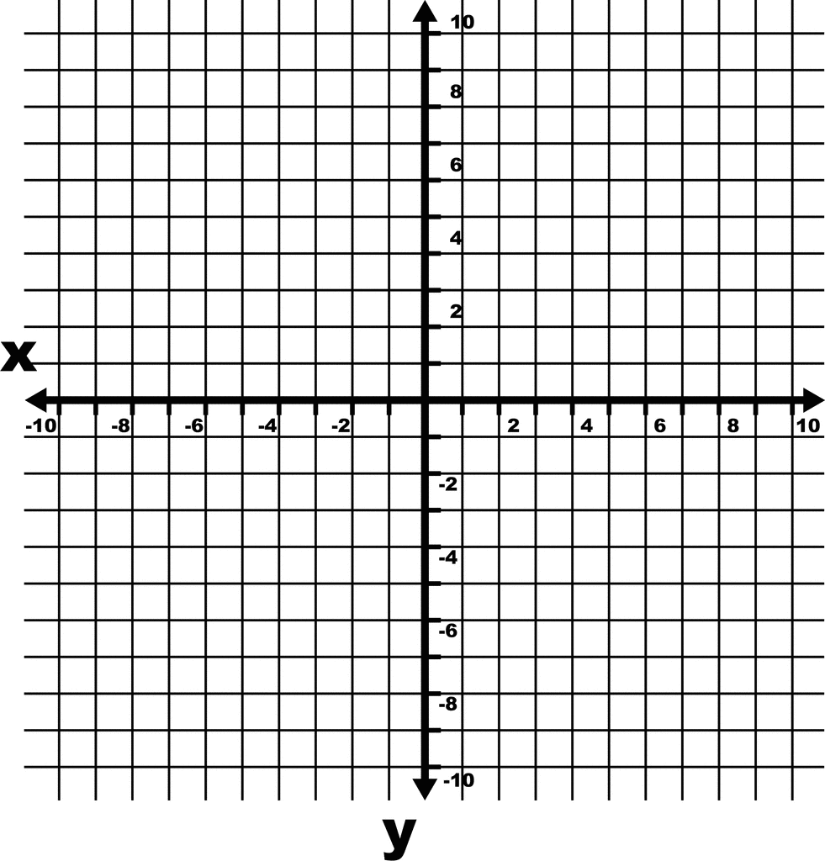
  - Write the equation of the line in standard form.

  - What is the x intercept for the line?

  - What is the y intercept for the line?

  - Graph the line.

- A line is shown.
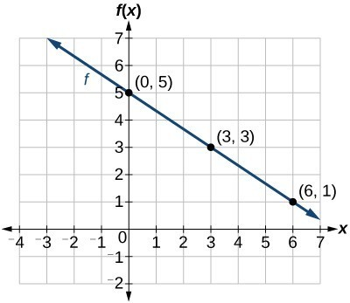
  - What is the slope of the line?

  - Write the equation of the line in point slope form.

  - Write the equation of the line in slope intercept form.

  - Write the equation of the line in standard form.

  - What is the x intercept for the line?

  - What is the y intercept for the line?

- Graph each line.
- $y=4x+1$ e. $y=-\frac{2}{5}x+2$
- $y=\frac{1}{2}x+2$ f. $a line through \left(-2,3\right) with a slope of 2.$
- $x=-1$ g. $y=4$
- $2x-3y=6$ h. $3x+6y=18$

