WIN week 3 day 1 writing equations of lines in slope intercept form
Learning Target – students will write equations of lines in slope intercept form.
The equation of a line in slope intercept form is $y=mx+b$, where m= slope and b= y intercept.
- Write the equation of a line with a slope of 3 and a y intercept of 5.

- Explain what the slope and y intercept tell you about the line in question 1.

Practice. For each question, write the equation of the line and tell what the slope and y intercept tell you about the line.
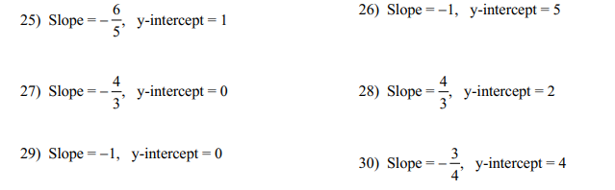

- Write the equation of the line in the graph below.
- 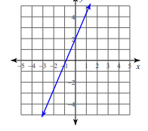 B. 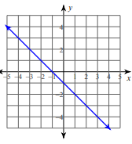

Practice: Write the equation of each line.
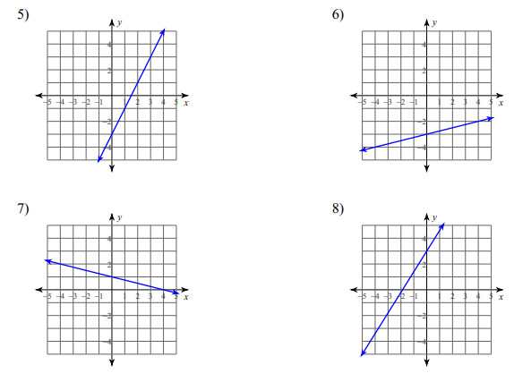
Sometimes you are not given the slope or the y intercept, so you have to find them before you write the equation.
- Write the equation of a line in slope intercept form with a slope of 2 through the point (5, -3).

Practice – write the equation of each line in slope intercept form.
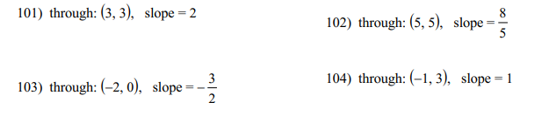
- Write the equation of a line in slope intercept form through the points (-3,-1) and (-2,-2)

Practice:

Win week 3 day 2 warm up
- Write the equation of a line in slope intercept form with a slope of 3/2 and a y intercept of -4.

- Write the equation of a line in slope intercept form with a slope of -2 through the point (-1,3).

- Write the equation of a line in slope intercept form through the points (-4,-3) and (4,2).

- Check this with Mrs. Blanton and then Kahn academy work day.

Win week 3 day 3 writing equations of lines in point slope form
Students will write equations of lines in point slope form.
Another form for the equation of a line is point slope form $y-y_{1}=m(x-x_{1})$ where m is the slope and $\left(x_{1}, y_{1}\right)$is a point on the line. This form of the equation of a line is easier to use when you are given a point and slope and can be converted into slope intercept form.
- Write the equation of a line in point slope form with a slope of 3 through the point (-2,1).

Practice:
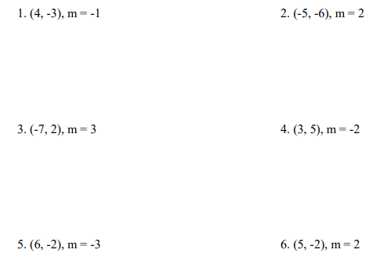

- Write the point slope form of the equation of a line through the points (-1,3) and (4, -7).

Practice:

To graph the equation of a line it is helpful to convert the line to slope intercept form.
- Write the equation of a line in point slope form through the point (-5,1) with a slope of 2. Then convert you equation to slope intercept form.

Practice – convert to slope intercept form. Name the slope and y intercept of each line.

- Write the equation of the given line in point slope form.
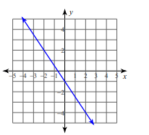

Win week 3 day 4
- Write the equation of the line through (-7, -2) and (-6, 3) in point slope form.

- Convert the equation to slope intercept form.

- Name the slope and y intercept of the equation.

- Check this in with Mrs. Blanton and then kahn academy work day.

Win week 3 day 5 Standard form
Students will convert equations of lines to standard form.
The equation of a line in standard form is Ax+By=C. The following must be true
- No fractions or decimals
- A must be positive
- The GCF of A, B and C must equal 1.
Examples
- $y=\frac{4}{5}x-5$ 2. $2x=4y+8$ 3. $y-1=\frac{2}{3}(x-4)$

Practice:
