WIN – week 1 day 2 – Order of operations mini lesson
Learning Target: Students will evaluate expressions using the order of operations.
To evaluate an expression means to find its value.
- Evaluate 4*3+2*5.
Class discussion. Who got 70? Who got 22?
- I need to find the total Area of the two rectangles below. What process should I follow?
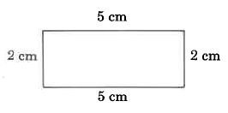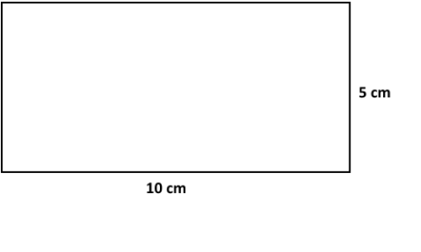

When we evaluate expressions we follow the order of operations – PEMDAS
P – Parenthesis – evaluate operations inside of grouping symbols first
E – Exponents – Evaluate all the powers
MD – Multiply and Divide from left to right
AS – Add and Subtract from left to right

Practice #15-35 odd

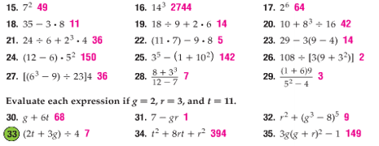

WIN Week 1 Day 3 Multstep equations
Learning target: Students will solve multistep algebraic equations
Equations that require more than one step to solve are called multistep equations. To solve such an equation we must use an inverse to undo each step by working backward.
Examples:
Solve each.
- $11x-4=29$

- $\frac{a+7}{8}=5$

- How is the process of solving #1 different from solving #2?

You try.
- $2a-6=4$ 5. $\frac{n+1}{-2}=15$

- Alice is buying a pair of water skis that are on sale for 2/3 of the original price. After he uses a $25 gift card, the total cost before taxes is $115. What was the original price of the skis? Write and solve an equation to help you solve the problem.

Consecutive integers are integers in counting order such as 4, 5, and 6. You can use the algebraic expressions n, n+1, and n+2 to represent them. How could you produce consecutive even integers?
- Find 3 consecutive integers with a sum of 21.

- Find three consecutive integers with a sum of -51.

Practice:
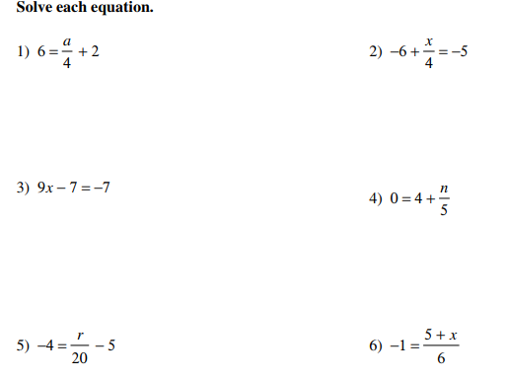

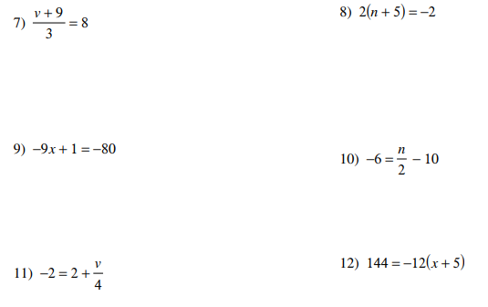

13. Find three consecutive integers with a sum of 54.

WIN Week 1 Day 3 Solving equations with variables on both sides
Learning Target; Students will solve equations with the variable on both sides and equations involving grouping symbols.
To solve an equation with variables on both sides of the equal sign, use the Addition or Subtraction Property of equality to write an equivalent equation with the variable terms on one side. Then isolate the variable.
Example
- Solve 2+5k=3k-6. Be sure to check your answer/

You try:
- $5a+2=6-7a$ 3. $3w+2=7w$

4. $8+5c=7c-2$ 5. $\frac{x}{2}+1=\frac{1}{4}x-6$

If equations contain grouping symbols (such as parenthesis or brackets) use the distributive property to remove the grouping symbols then solve.
Example
Solve $6\left(5m-3\right)=\frac{1}{3}(24m+12)$

You try: Solve each of the following
6. $8s-10=3\left(6-2s\right)$ 7. $7\left(n-1\right)=-2(3+n)$

The equations we have solved so far all have one solution, or one number that when substituted for the variable, makes the equation true. These equations are SOMETIMES true. Attempting to solve the equations will result in a single value.
Some equations have no solution. That is, there is no value of the variable that will make the equation true. So these equations are NEVER true. Attempting to solve the equation will result in a FALSE statement.
Some equations are true for all values of the variable. These equations have infinitely many solutions and are ALWAYS true. These equations are called identities. Attempting to solve the equation will result in a true statement.
Number of solutions | When the equation is true | What it looks like  Example | Represent the solution
1 | Sometimes | x=7 | x=7
0 | Never | 5=-14 | No solution
Infinitely many | Always | 5=5 | Infinitely many solutions OR  All real numbers

- Solve
- $5x+5=3\left(5x-4\right)-10x$ b.$3\left(2b-1\right)-7=6b-10$

Practice
