WIN Week 5 – Operations with Integers
Students will add and subtract integers without calculators.
Warm up:
- What is an integer?
- What does it mean to add?
- What does it mean to subtract?
- What is a negative number?
- Give an example of a real situation that needs a negative number to make sense.
THE RULES
- Same sign means add the numbers and keep the sign.
- Different sign means subtract and keep the sign of the larger number.
Why the rules work:
- 
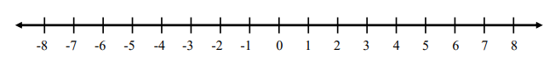
- 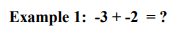
Practice using the rules:
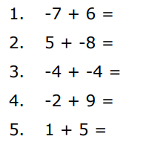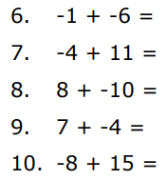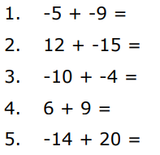

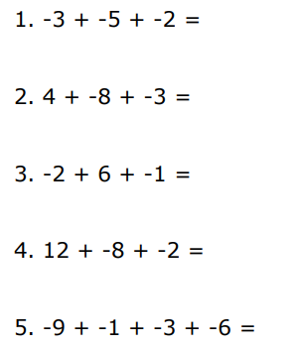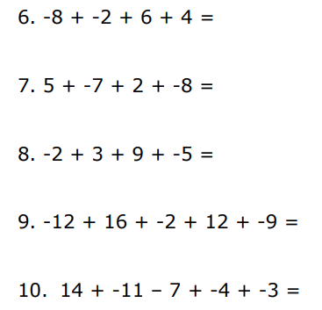

Applications

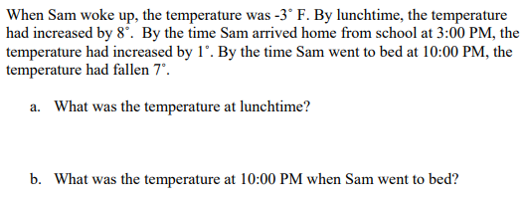

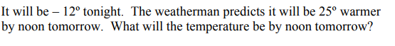

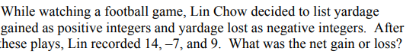
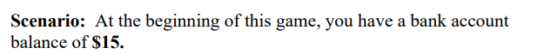
Question: - How much do you have at the end?
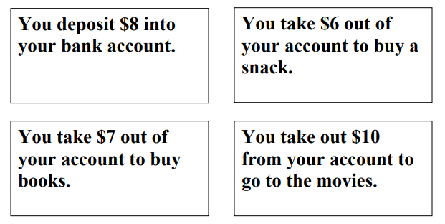
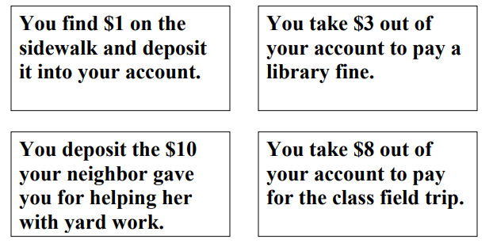

Week 5 Day 3 Multiplying and Dividing Integers
Students will multiply and divide integers without a calculator.
Warm up
Take a look at the examples below. What do you notice about the signs of the answers, compared to the signs in the problems?
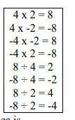
The Rules
- Same sign – answer is positive.
- Different signs – answer is negative.
Examples:
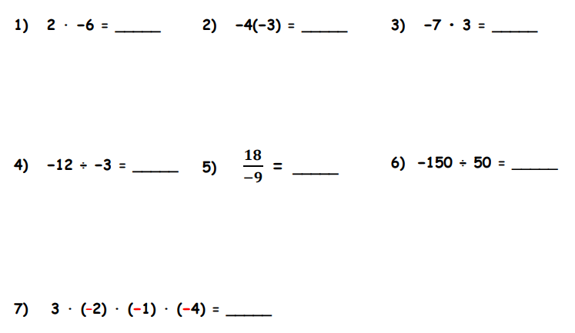

Practice:
