WIN Week 2 Day 1 – Kahn Academy Work Day

Warm up

Solve.

1. 2.

3. 4.

5.

WIN Week 2 Day 2

Learning Target – Students will translate sentences into algebraic expressions and equations.

An **algebraic expression** consists of sums and/or or products of numbers and variables.

In the algebraic expression 2d+3, the letter d is called a **variable**. It varies because it represents an unknown value. Why do you think it’s called a variable?

A **term** of an expression may be a number, variable, or product/quotient of numbers and variables. The example 2d+3 has two terms, 2d and 3. The term that contains the variable is called the variable term and the term without is called the constant term. Why do you think it’s called a constant?

In an expression containing multiplication, the quantities being multiplied are called **factors**, and the result is the **product**.

An expression like $x^{n}$ is called a **power**. The **exponent** (little number) indicates the number of times the **base** is multiplied by itself. The expression above is read x to the nth power. x is the base and n is the exponent. What if no exponent is shown?

Sometimes we are given a verbal expression and asked to translate it into an algebraic expression, like in a word problem. The chart below contains some common phrases to help you. You can add any to it that you learn throughout the lesson.

|  |  |
| --- | --- |
| Operation | Phrases |
| Addition | More than, sum, plus, increased by, added to |
| Subtraction | Less than, subtracted from, difference, decreased by, minus |
| Multiplication | Product of, multiplied by, time, of |
| Division | Quotient of, divided by |

Write an algebraic expression to represent each verbal expression

1. 2 more than 4 times the cube of a number
2. The quotient of five less than a number and twelve.
3. A number t more than 6
4. 10 less than the product of 7 and f

Sometimes we will write equations rather than expressions. Equations must contain an equals sign. Write an algebraic equation to represent each verbal equation.

1. Twelve more than a number is 17.
2. Five less than two times a number is the same as 7.
3. The sum of three times a number and 4 is 19.
4. Three times the sum of a number and 4 is 19.

Write a verbal sentence to represent each expression.

1. 6x
2. N+15

$3x^{4}$

$5z^{2}+16$

$\frac{1}{2}a-\frac{6b}{7}$

Write a verbal sentence to represent each equation.

$2x-3=1$

$2\left(x-3\right)=1$

1. Mr. Matinez orders 250 keys chains printed with his athletic team’s logo and 500 pencils printed with their Web address. Write an algebraic expression that represents the cost of the order. Be sure to define your variables.
2. One half of a number is 24. Write an equation to represent the situation and determine the number.
3. The product of a number and 2.4 is 0.48. Write an equation to represent the situation and determine the number.
4. Eight more than three times a number is 29. Write and equation and use it to find the number.

WIN Homework Week 2 Day 1

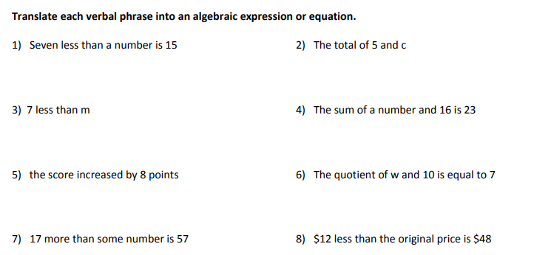

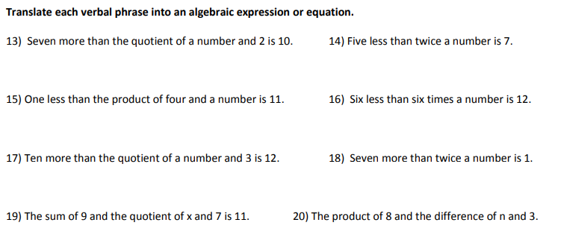

WIN Week 2 Day 3

Kahn Work time – first half of class

Students will solve word problems involving multistep equations.

1. 14. Alex and Cassie saved money to go on their honeymoon. Cassie works for an airline, so she can fly for free. Alex’s ticket will cost $265. Alex has saved $50 more than Cassie. They have exactly enough for the airline ticket. How much money did each person save?
2. Mrs. Blanton is buying porch furniture. She has budgeted $1500. She already spent $400 on a table. Her husband says she has expensive taste because each chair she picked out costs $220. How many chairs can she afford to buy? Write and solve an equation to answer the question.
3. Tickets for a fundraiser are $14 if purchased ahead of time and $25 if purchased at the door. The total amount raised from all the tickets was $625. If eleven tickets were purchased at the door, how many tickets were purchased ahead of time?
4. On Friday you raked leaves for 4 neighbors, on Saturday you raked leaves for 5 neighbors and on Sunday you raked leaves for 3 neighbors. You were paid a total of $135. Write and solve an equation to determine how much money you earned per house.
5. The Hershey company donated candy bars to your school for a fundraiser. You set a personal goal of raising $200 for your school and you met that goal. You sold a total of 120 candy bars and one neighbor gave you a $20 donation. Write and solve an equation to determine how much each candy bar sold for.

HW WIN Week 2 Day 3

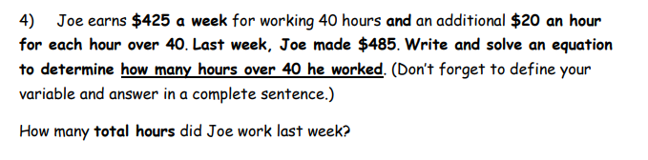

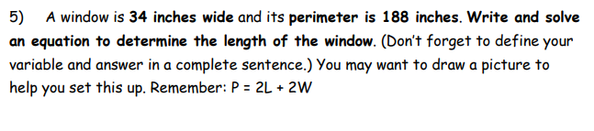

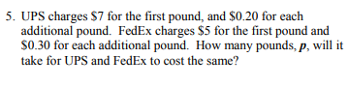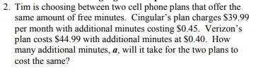

WIN Week 2 Day 4 Review

**Solve the equation.**

1.  2.  3. 

4.  5.  6. 

**Write and solve an equation.**

1. You owed $34 to your sister. You paid *x* dollars back and you now owe $12. How much did you pay back?
2. You estimate that you spend $115 on groceries each month. How much money do you spend on groceries each week?

**Solve the equation.**

1.  10.  11. 

12.  13.  14. 

Solve each problem.

15. Mary Alice and her friends are celebrating 4th of July. They spend $50 on fireworks. They bought 1 “sparkle spectacle” for $21 and 4 “fantastic fireworks”. How much did each “fantastic firework” cost?

16. Mary Alice is buying a prom dress. The sale price of the dress is $190. The dress is on sale for five sevenths of the original cost. What is the original cost of the dress?

17. Mary Alice is saving to buy a car. She is buying her neighbor’s used Altima so her car will cost $2600. She earns $110 per week. Before she can buy the car she must pay the first six months of insurance for $400. How many weeks will pass before she has enough money to buy the car?