WIN Week 10 Solving Systems of Equations by Graphing
Learning Target – Students will solve systems of equations graphically
A system of equations is two or more equations with the same variables. To solve a system of equations you need to find the ordered pair that satisfies both equations.
Three ways to solve systems
- Graphing
- Substitution
- Elimination
A. Graphing Method – the intersection of the graphs of the two equations represents the point at which the equations have the same x value and same y value. Thus, the ordered pair represents the solution common to both equations. This ordered pair is called the solution to the system of equations.
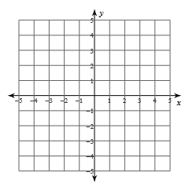
Example:

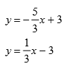

- When would the graphs have no solution?

- When do the graphs have all real solutions?
Practice:
- 5. 6.
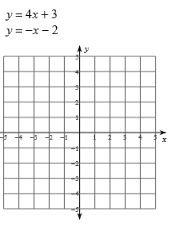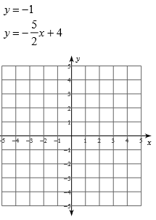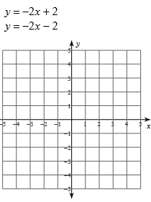
If y is not isolated in a system you will have two options:
- Graph using the x and y intercept
- Graphing by converting to slope intercept form – isolate y.

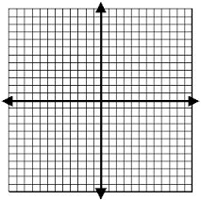
Example: Solve the system by graphing:
$3x-2y=-6$
$x+y=-2$

Practice
7. 8. 9.
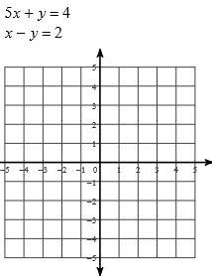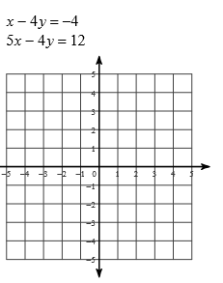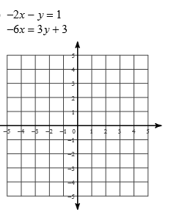

Practice
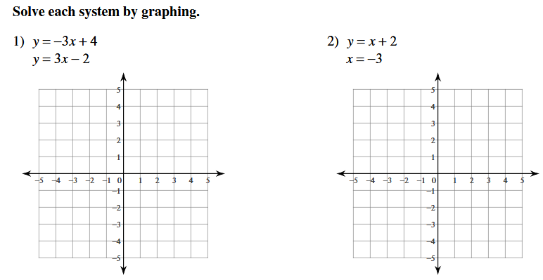
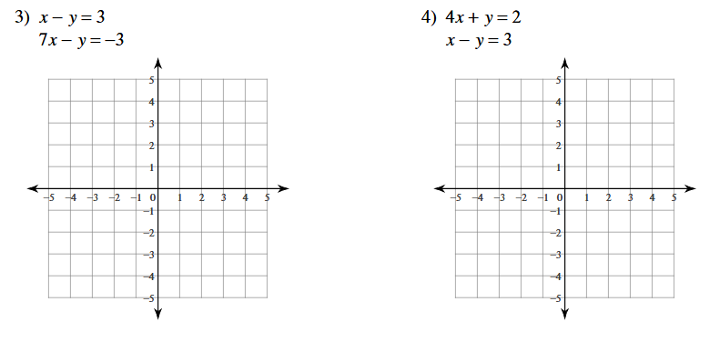

WIN Week 10 Solving systems using substitution
Learning Target – Students will solve systems of equations algebraically using the substitution method.
Often, graphing is not the best method to find solutions to linear inequalities. This is especially true when the solutions are noninteger values. Systems of linear equations can be solved algebraically.
B. Substitution Method – Create an equation that just has one variable for you to isolate by solving one equation for one of the variables and then substitute into the other equation. Then solve your equation.
1. What does the word substitute really mean? Think of a situation where you have substituted something before. Describe the situation to your neighbor. Write their example below.

Example:
2. Solve the system by substitution:
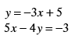

You try: Solve the system by substitution
3. 4.
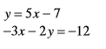
$y=3x-8$
$2x+y=22$

5. $y=3x+1$ 6. $y=2x+3$
$4y=12x+3$ $3y-6x=9$

Example: How is this system different from the systems you solved on the previous page?
Solve the system by substitution:
$2x+3y=8$
$x-y=2$

Practice Solve the system by substitution.
1. 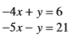 2. 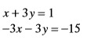

- $x+2y=6$ 4. $4x-3y=13x-4y=28$ $6y-8x=-2$

WIN WEEK 10 Solving Systems of Equations using Elimination
Learning Target – Students will solve systems algebraically using elimination.
- What does the word elimination mean? Tell your partner a time when you have eliminated something. Write their example below.

C. Elimination Method- Combine the two equations to eliminate one of the variables so that you can isolate the other variable.
Example:
Solve using elimination
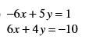

Step 1. Write the system so like terms are aligned.
Step 2. Add the equations, eliminating one variable. Then solve the equation.
Step 3. Substitute the value from step 2 into one of the equations and solve for the other variable.
Step 4: Write the solution as an ordered pair.
Practice – You try – Solve the system using elimination.
- 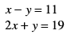 2. 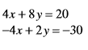

3. $4y+3x=22$ 4. $2t+5r=6$
$3x-4y=14$ $-9r-2t=-22$

5. The sum of two numbers is -10. Negative three times the first number minus the second number equals 2. Find the numbers.

6. negative three times one number plus five times another number is -11. Three times the first number plus seven times the other number is -1. Find the numbers.

7.Four times one number minus three times another number is 12. Two times the first number added to three times the second number is 6. Find the numbers.

WIN WEEK 10 Solving systems of elimination involving multiplication
Learning Target: Students will solve systems of equations using elimination.

Example: How is solving the system below using elimination different from yesterday?
Solve using elimination:
$5x+2y=340$
$3x-4y=360$

Step 1: Multiply at least one of the equations by a constant to get the two equations to contain opposite terms.
Step 2: Add the equations, eliminating one variable. Then solve the equation.
Step 3: Substitute the value from step 2 into one of the equations and solve for the other variable.
Step 4: Write the solution as an ordered pair.

Practice – you try – solve using elimination
4. 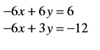 5. 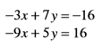

6. 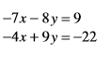 7. 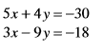

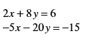
8. 9. $8x-4y=6$

8. When is elimination most convenient?

9. When is substitution the most convenient?

10. Which method do you prefer? Why?
Solve each system below using the method that is most convenient:
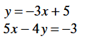

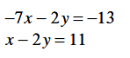

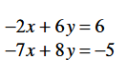

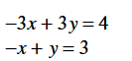

WIN WEEK 11 Applications of Systems of Equations.
Learning Target: Students will apply their knowledge of solving systems of equations.
Define variables, set up a system of equations, and solve each problem.
- The cost of 5 boxes of envelopes and 6 boxes for note paper is$16.75. Three boxes of envelopes and 4 boxes of note paper cost $10.75. Find the cost of each box of envelopes and each box of note paper.

- Suppose you bought eight oranges and one grapefruit for a total of $4.60. Later that day, you bought six oranges and three grapefruits for a total of $4.80. What is the price of each type of fruit?

- Harold had a summer lemonade stand where he sold small cups of lemonade for $1.25 and large cups for $2.50. If Harold sold a total of 155 cups of lemonade and collected a total of $265, how many cups of each type did he sell?

- Kerry asked a bank teller to cash a $390 check using $20 bills and $50 bills. If the teller gave her a total of 15 bills, how many of each type of bill did she receive?

- The sum of two numbers is 63. The difference of the same two numbers is -31. What are the two numbers?

- Last year, a baseball team paid $20 per bat and $12 per glove, spending a total of $1040. This year, the prices went up to $25 per bat and $16 per glove. The team spent $1350 to purchase the same amount of equipment as last year. How many bats and gloves did the team purchase each year?

- Of the 17 species of penguins in the world, the largest species is the emperor penguin. The smallest is the Galapagos penguin. The total height of the two penguins is 169 cm. The emperor penguin is 22 cm more than twice the height of the Galapagos penguin. Find the height of each penguin.

- Ace rental car rents a car for $45 and $0.25 per mile. Star rental car rents a car for $35 and $0.30 per mile. How many miles would a driver need to drive before the cost of renting a car at Ace Rental Car and renting a Car at Star rental car were the same?

Practice 2 Variable Systems Word Problems
For each problem work together with your partner. Each person should show all work on a separate sheet of paper.
- Define your variables – let statement
- Write a system of 2 equations
- Solve the system
- Write your answer as a sentence.
- Go to www.desmos.com, type in your two equations and look for their intersection to check your answer.
1) A student has some $1 bills and $5 bills in his wallet. He has a total of 15 bills that are worth $47. How many of each type bill does he have?
2) For $56.48, you purchased 72 pens and highlighters combined from a local bookstore. Each highlighter cost $1.09 and each pen cost $0.69. How many pens were purchased?
3) There are a total of 15 apartments in two buildings. The difference of two times the number of apartments in the first building and three times the number of apartments in the second building is 5.
a. Write a system of equations to model the relationship between the number of apartments in the first building f and the number of apartments in the second building s.
b. How many apartments are in each building?
4) The sum of two numbers is 36. The difference in the two numbers is 8. Find the numbers.
5) The perimeter of a rectangle is 32 cm. The length is 1 cm more than twice the width. Find the dimensions of the rectangle.
6) The perimeter of a rectangle is 42 m. The length is 3m more than twice the width. Find the dimensions of the rectangle.
7) Three times one number added to 5 times another number is 58. The second number minus the first number is 2.
8) Suppose Ken has 25 coins in nickels and dimes only and has a total of $1.65. How many of each coin does he have?
9) Terry has 2 more quarters than dimes and has a total of $6.80. The number of quarters and dimes is 38. How many quarters and dimes does Terry have?

