Geometry Unit 7 Review

1. 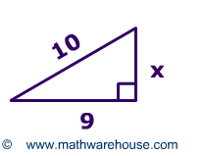Find x in each triangle. Leave your answer in simplest radical form where appropriate.   
     
     
     
     
     
    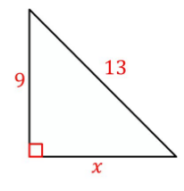
2. In right triangle ABC where B is the right angle, AB is 10, BC is 4 and AC is 16 find cos C.(Hint: draw a picture if one is not given)
3. Find the value of x.

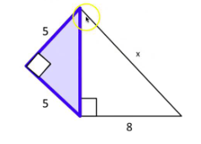

1. The tangent of an angle in a right triangle is 4/7. What is the cosine of that same angle?
2. Find the angle of elevation of the kite.  
   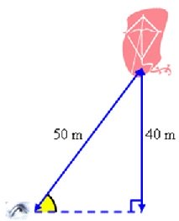
3. A triangle has side lengths of 12 cm, 27 cm, and 32 cm. Classify it as acute, obtuse, or right. Explain.
4. Find the length of the missing sides

$$4\sqrt{2}$$

1. Solve for x. Round to the nearest thousandth.

22

5.5

1. 
2. A snowball rolls down a hill that is 23 feet tall. If the angle of the hill to the ground is 50°, how far did the snowball roll?
3. Find AC and BA.

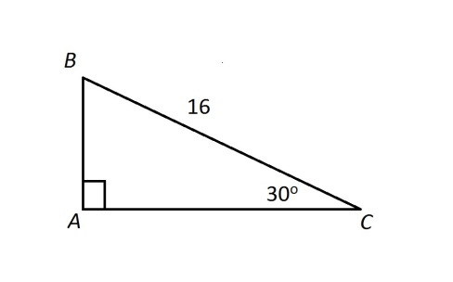

1. Write the ratios for $\sin{θ,\cos{θ, and\tan{θ.}}}$

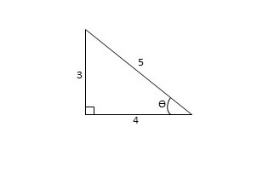

1. 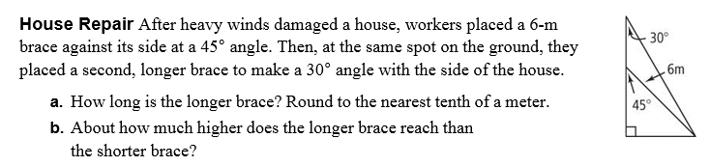
2. 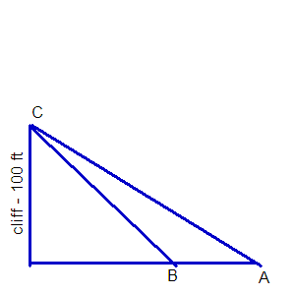Albert is standing at point A. He takes a sighting to the top of a cliff, (point C). The angle of elevation is 30 degrees. Becky is standing at point B and takes a sighting to the top of the same cliff, (point C). The angle of elevation is 45 degrees. If the cliff is 100 feet high, find the exact distance between Albert and Becky.

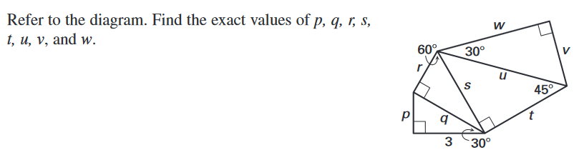

1. 
2. Find the value of w, then x. Round to the nearest tenth.
3. 
4. 
5. Find the values of x and y for the kite below

3x+1

10y+2

8x-18

x+11

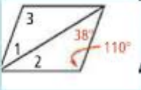

1. Find the measure of each numbered angle for the parallelogram.
2. Identify the hypothesis and conclusion of the conditional below.

If it floods, then school will be canceled.