Geometry Unit 8 Day 1 and 2 Area of Parallelograms and triangles
Learning Target – Students will find the area of parallelograms and triangles.
Investigation
- Cut out a rectangle from grid paper by cutting along grid lines.
- Record the base, height and area of the rectangle.
- Cut out a right triangle from one end of the rectangle. Tape the triangle to the opposite end of the rectangle to form a parallelogram.
- Compare and contrast the original rectangle with the parallelogram you formed.
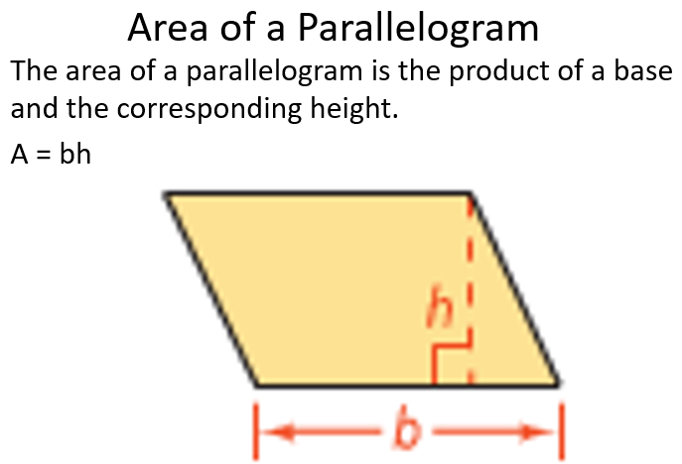
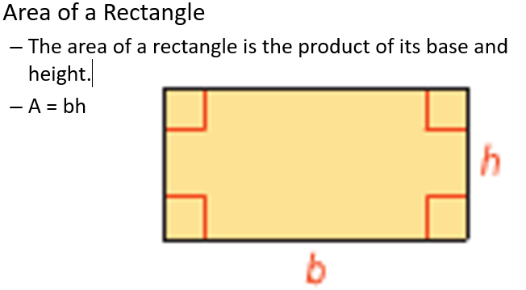

You Try:
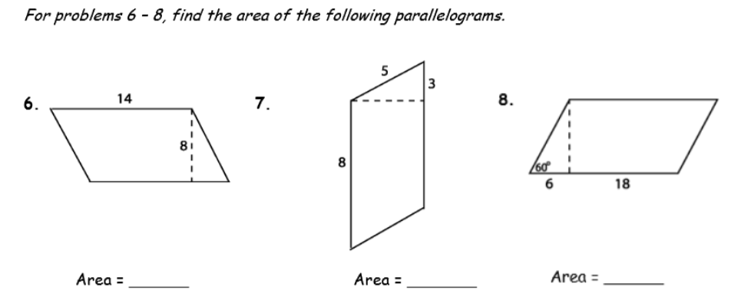

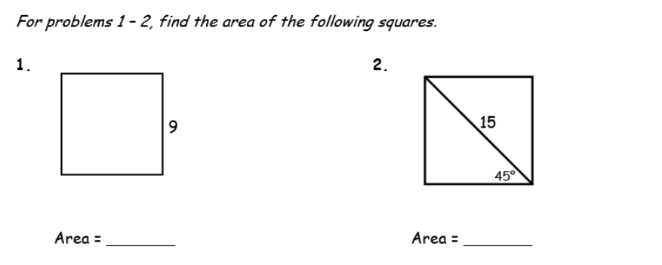

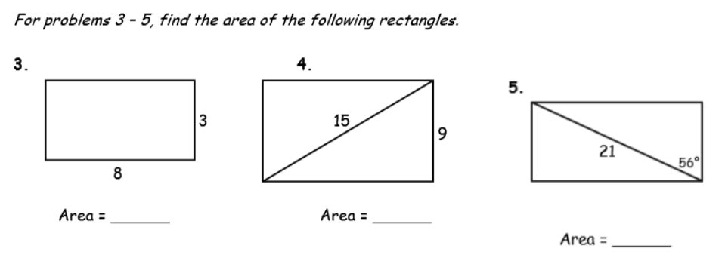
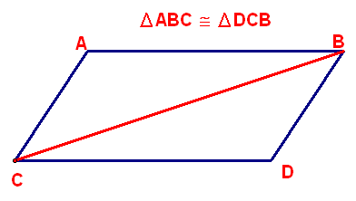
You know the property of a parallelogram that says a diagonal divides it into two congruent triangles.
- Why is this true?
- How could this property help you determine the formula for the area of a triangle?
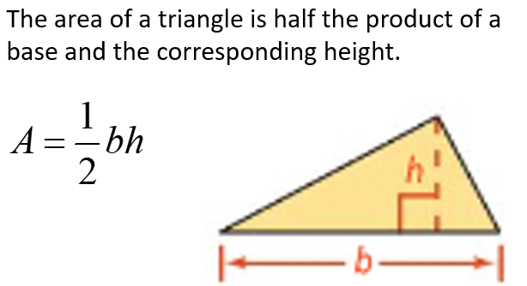
Find the area of:
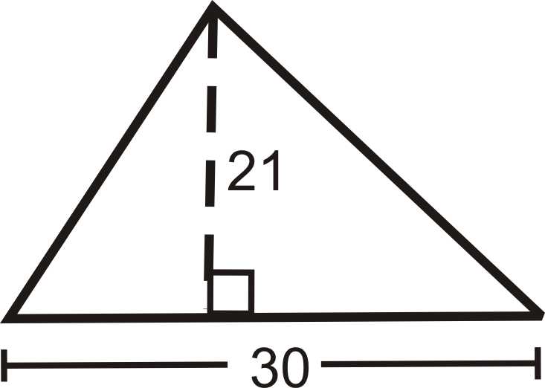

- Find each area.
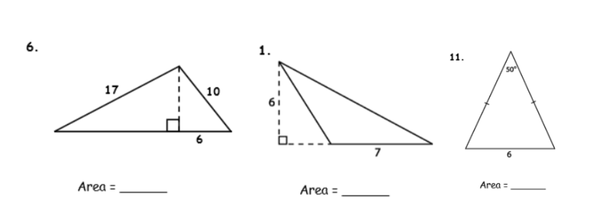

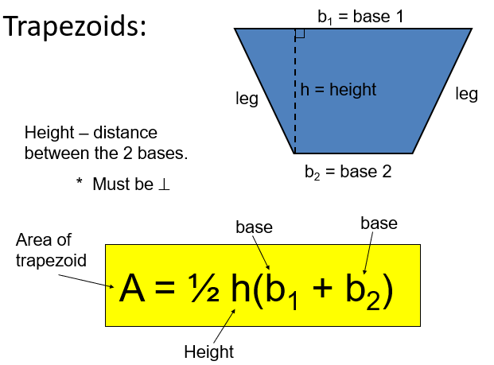
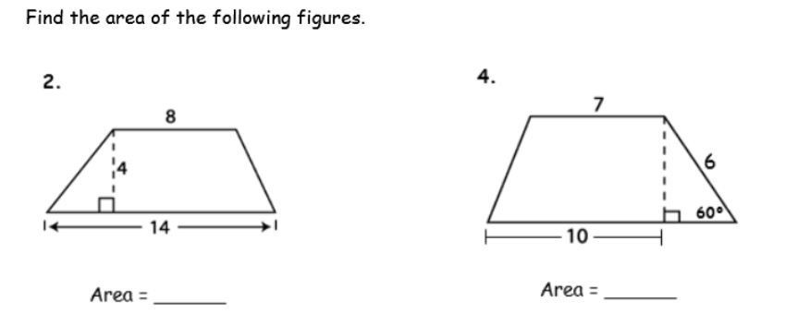


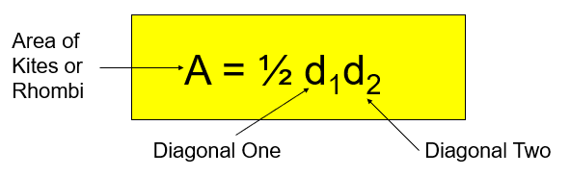
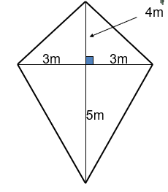
Find each area.
- 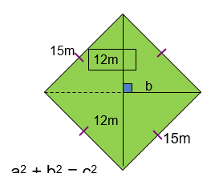 2.

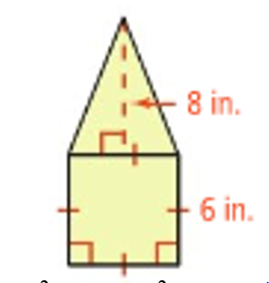
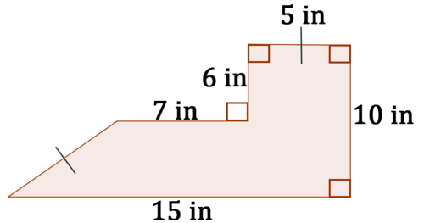

3. 4.

5. 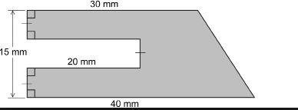 6. 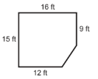

f. The area of a parallelogram is 24 in². The height is 6 in. Find the length of the base.

g. An isosceles right triangle has area of 98 in². Find the length of each leg.

Geometry Unit 8 Day 1 and 2 HW
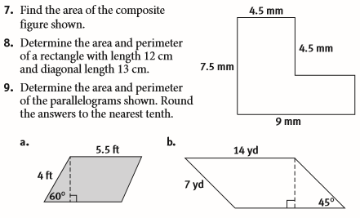

15. The cost for a table top is $8.50 per square foot.
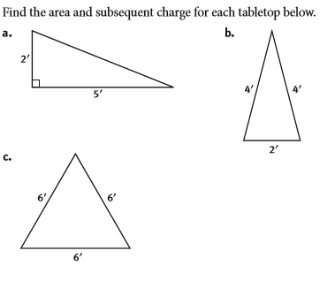
16. 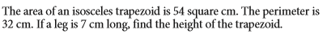

Find each area.

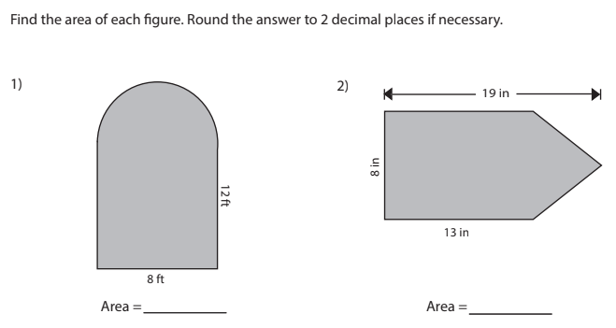
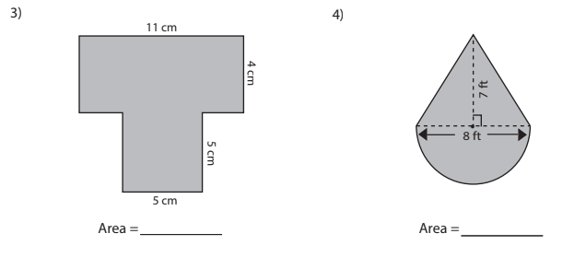
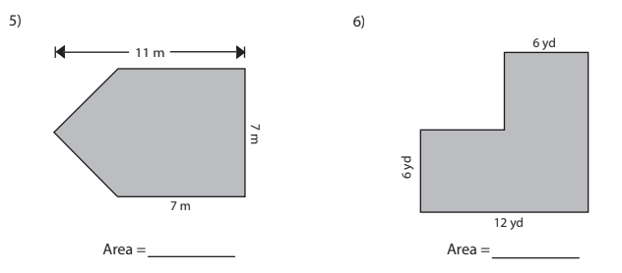

Geometry Unit 8 Day 3 Area of regular polygons
Learning Target- Students will find the area of regular polygons
What does it mean for a polygon to be regular?

The polygon below is a regular octagon with a perimeter of 64 m. Segment SR has a length of 19.31 m. Find the area of the polygon.
Show all work. Be prepared to share your results with the class.

Based on your results, write a method for determining the area of a regular polygon. Be prepared to share your method with the class.

Formula for find the area of a regular polygon =

ABCDEF below is a regular hexagon with a perimeter of 60cm. Find the area of ABCDEF.
Show all work. Be prepared to share your solution with the class.

How does the problem on the front of the page differ from the problem on the back of the page? How are they the same?

Do together
- Find the area of a regular pentagon with a radius of 9 m.

You try
- Find the area of a regular octagon with a radius of 20 inches.

- Error Analysis To find the area of the regular hexagon at the right with apothem$2\sqrt{3}$, a classmate uses the value 12 for the perimeter. What is your classmate’s error?
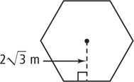

Geometry Unit 8 day 3 HW

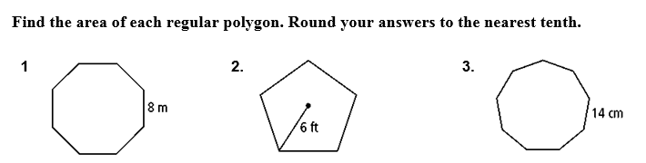

Geometry Unit 5 Day 6 Area on coordinate grid
Learning Target – students will use the coordinate grid to find area.
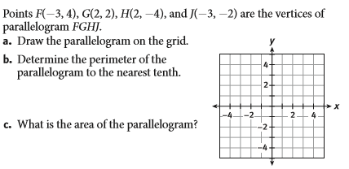

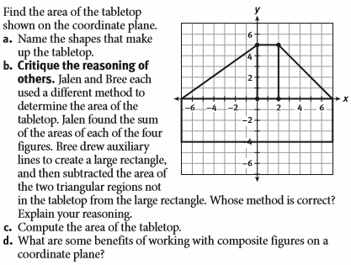

- Find the area of

Geometry Unit 8 Day 6 HW

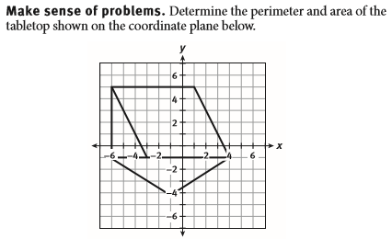
Find the area of:
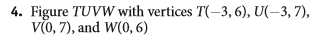
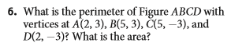

Geometry Unit 8 Day 7 Circumference and Arc Length
Learning target – Students will find the circumference of a circle and the length of an arc.
- A _________ is a set of points equidistant from a given point called the __________.
- A radius is a segment that has one endpoint at the _________ and the other endpoint on the __________.
- A diameter is a segment that contains the __________ of the circle and has both endpoints on the ________.
- A central angle is an angle whose ________ is the center of the circle.
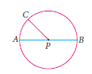
- Congruent circles have congruent radii.
- Name a radius.
- Name a diameter
- Name the circle.
- Name a central angle.

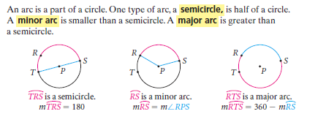
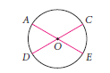
- Identify a minor arc.
- Identify a major arcs that contains point A.
- Identify a semicircle.

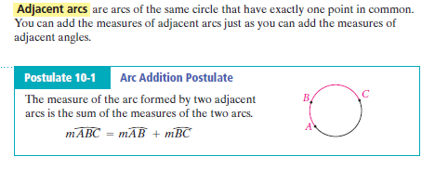
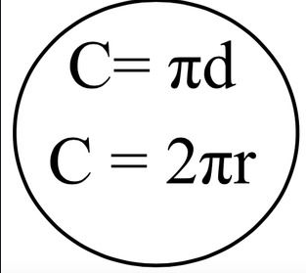
- Find the measure of each arc.
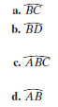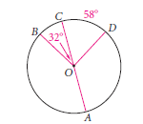
- What is circumference?
- Why are the two formulas for circumference the same?
- 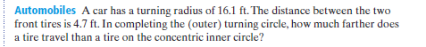

- The measure of an arc is in degrees, however the length of an arc is a fraction of a circles circumference. So what unit would it be measured in?
- If an arc is 60 degrees, what fraction of the entire circle does that represent?

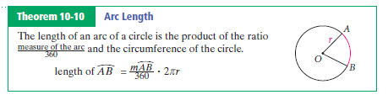

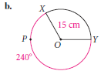
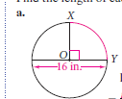

Geometry Unit 8 Day 7 HW

The circumference of a circle is 100π.
54. find the diameter of the circle.
55. Find the radius of the circle.
Geometry Unit 8 Day 8 Area of sectors
Learning Target - Students will find the area of sectors of circles
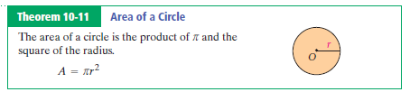

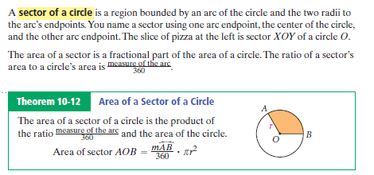
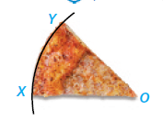

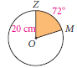

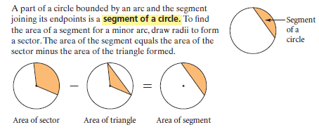
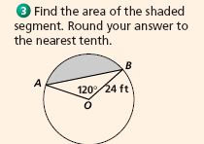

Geometry Unit 8 Day 8 HW

Geometry Unit 8 Day 10 Geometric Probability
Learning Target – Students will find geometric probability
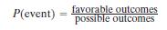
Geometric probability
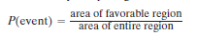
Example:
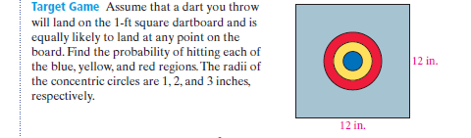

You try:

Geometry Unit 8 Day 10 HW
- Find the probability that a dart thrown at the target will land in the shaded region.

Outer white ring?

