Geometry Unit 7 Day 1 The Pythagorean Theorem and It’s Converse

Learning Target – Students will use the Pythagorean theorem to solve problems and it’s converse to classify triangles.

Geometry Activity 20 – The Pythagorean Theorem and it’s Converse

**The Pythagorean Theorem** – If a triangle is a right triangle, then the square of the hypotenuse is equal to the sum of the squares of the legs.

1. Explain how this theorem translates into the equation that use today.

Use the Pythagorean theorem to find the unknown side of each triangle. Leave your answers in simplest radical form.

1. 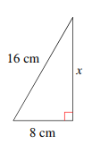 3. 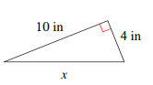 4. 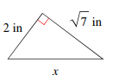

5. How high up a vertical wall will a 24 foot ladder reach if the foot of the ladder is placed 10 feet from the wall? Draw a sketch and show the calculations to support your answer.

6. Find the area of a rectangular rug if the width of the rug is 13 feet and the diagonal measures 20 feet. Draw a sketch and show the calculations to support your answer.

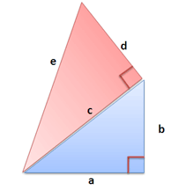

7. In the diagram a is congruent to b. a=4 inches and d= 7 inches. Find the length of e.

8. A **Pythagorean Triple** is a set of three nonzero whole numbers that satisfy the Pythagorean Theorem. Explain why the numbers 3, 4, and 6 do not form a Pythagorean Triple, but the numbers 5, 12, and 13 do.

9. Write the converse of the Pythagorean theorem. Is the converse true?

10. So we can use the converse of the Pythagorean theorem to determine whether a triangle is a right triangle. Write your notes about how in the space below.

11. Use the Converse of the Pythagorean theorem to determine whether each of the following sets of side lengths forms a right triangle. If a right triangle is not possible, tell whether an acute or obtuse triangle can be formed. Show the method you use to determine your answers.

a. 12, 34, 37

b. $\frac{6}{7},\frac{8}{7}, \frac{10}{7}$

c. 20, $\sqrt{42},$ 21

Geometry Unit 7 Day 1 HW

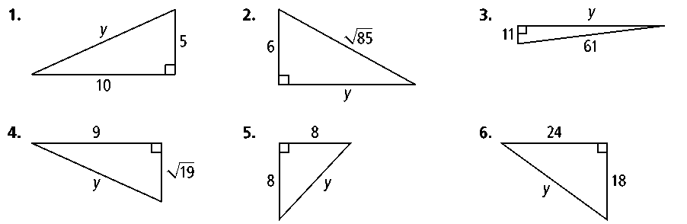**Find the value of *y.* Express in simplest radical form.**

**1. 2. 3.**



**4. 5. 6.**

**The lengths of the sides of a triangle are given. Classify each triangle as *acute, right,* or *obtuse.***

**7.** 3, 8, 10 **8.** 4, 5, 7 **9.** 12, 15, 19

**13.** A square has side length 10 yd. What is the length of a diagonal of the square? Express in simplest radical form.

**14.** A square has diagonal length 9 m. What is the side length of the square, to the nearest centimeter?

**15.** A repairman leans the top of an 8-ft ladder against the top of a stone wall. The base of the ladder is 5.5 ft from the wall. About how tall is the wall? Round to the nearest tenth of a foot.

**16.** A river runs straight through the center of a park. A man stands on one bank of the river, and his daughter stands across the river and 22 ft upstream. The man’s son swims from the man to his daughter. If the river is 11 ft wide, how far does the son swim? Round to the nearest foot.

**Is each triangle a right triangle? Explain.**

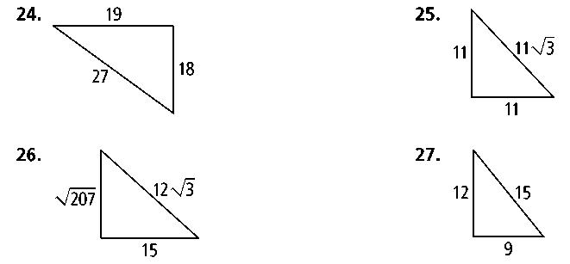**24. 25.**

**28.** A square is drawn inside a circle so that its vertices touch the circle. If the radius of the circle is 15 cm, what is the perimeter of the square?

**29.** The playing surface of a football field is 300 ft long and 160 ft wide. If a player runs from one corner of the field to the opposite corner, how many feet does he run?

Geometry Unit 7 Day 2 Special Right Triangles.

Learning Target – Students will find side lengths of 45-45-90 and 30-60-90 triangles.

45-45-90 Triangle Relationships

The four triangles below are special right triangles called 45-45-90 triangles because their angle measures are 45, 45, and 90. Each side is related to each other side.

1. If you know a leg of the triangle, how can you find the length of the other leg? Justify your answer.
2. If you know a leg of the triangle, how can you find the length of the hypotenuse? Justify your answer.
3. If you know the hypotenuse of the triangle, how can you find the length of a leg? Justify your answer.

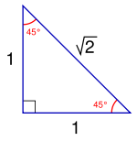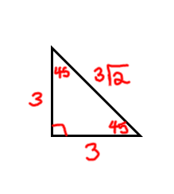

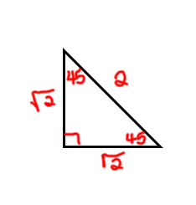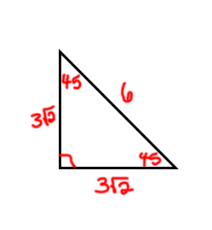

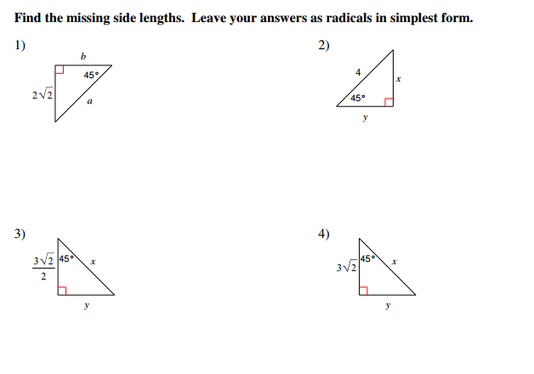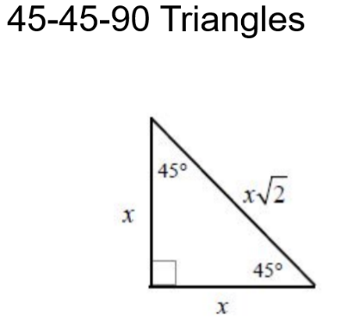

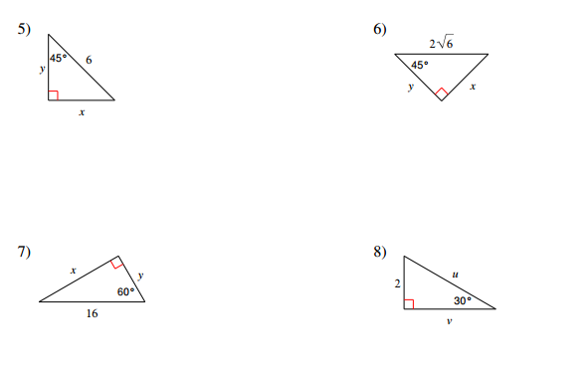

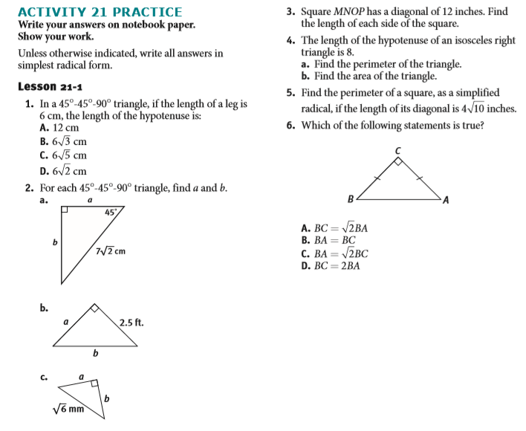

Geometry HW Unit 7 Day 2

Geometry Unit 7 Day 3 Special Right Triangles

Learning Target – – Students will find side lengths of 45-45-90 and 30-60-90 triangles.

Another type of special right triangle is a 30-60-90 triangle. These triangles have angle measures that are 30, 60, and 90 degrees. A special relationship exists between the sides of 30-60-90 triangles.

1. If I know the shortest leg of the triangle, how can I find the hypotenuse? Justify your answer.
2. If I know the shortest leg of the triangle, how can I find the other leg? Justify your answer.
3. If I know the longest leg of the triangle, how can I find the shortest leg? Justify your answer.
4. If I know the longest leg of the triangle, how can I find the hypotenuse? Justify your answer.
5. If I know the hypotenuse of the triangle, how can I find the shortest leg? Justify your answer.
6. If I know the hypotenuse of the triangle, how can I find the longest leg? Justify your answer.

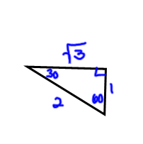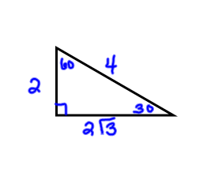

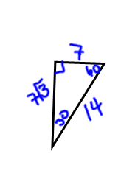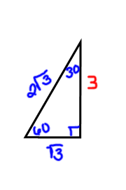

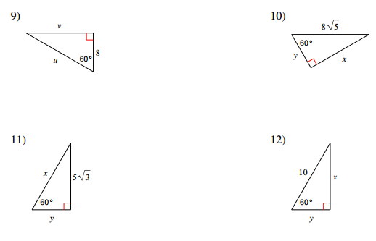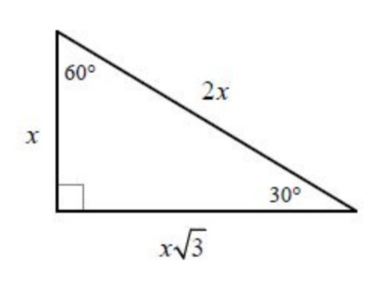30-60-90

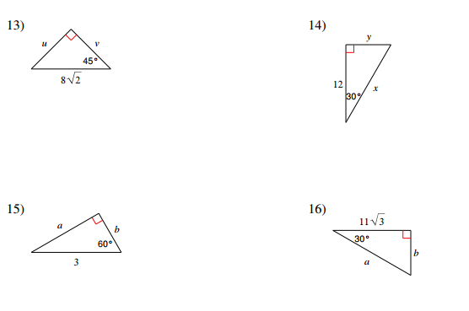

Find the area of each triangle.

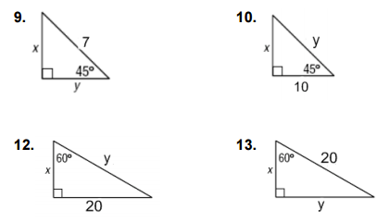

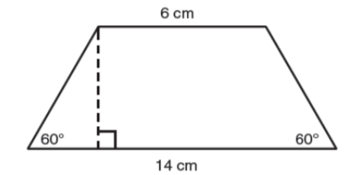14.Calculate the perimeter of the trapezoid.

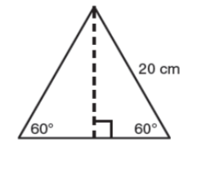

15. Calculate the area.

16. One side of an equilateral triangle is 8 inches. Find the length of the altitude.

17. The length of an altitude of one side of an equilateral triangle is $2\sqrt{3}in.$ Find the length of a side of the triangle.

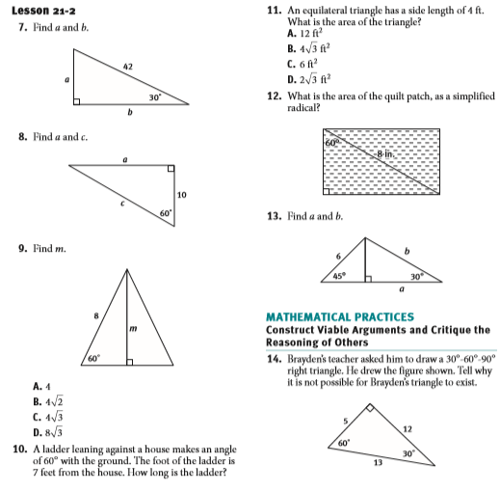

Geometry Unit 7 Day 5

Learning Target – Students will understand that similar triangles allow us to define the trig ratio.

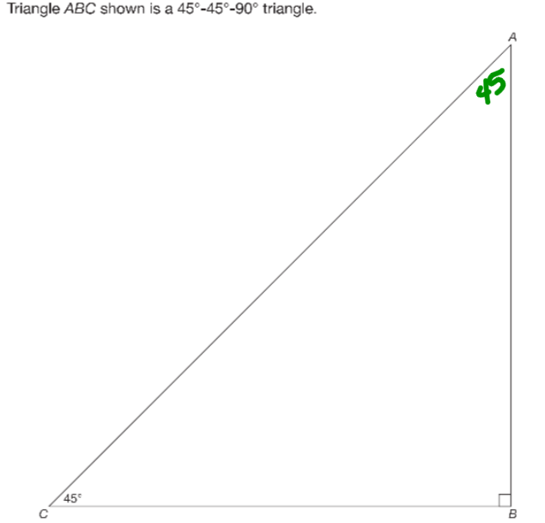

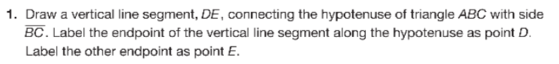

2. Explain how you know that triangle ABC is similar to triangle DEC.

1. Use a ruler to measure AB and DE to the nearest tenth of a cm. AB= ____ and DE=____. Find the other side lengths of both triangles without a ruler. CE=___ CD=_____ CB=_____ CA=____

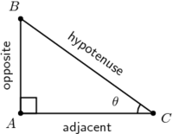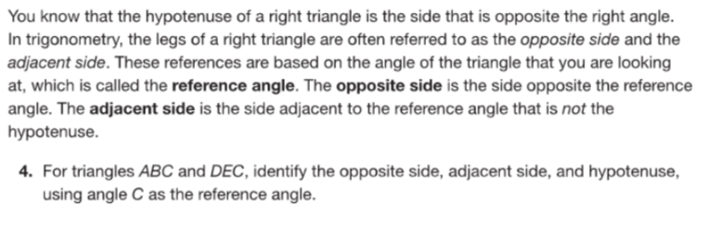

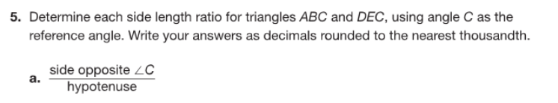

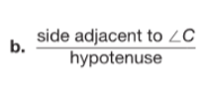

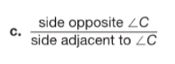

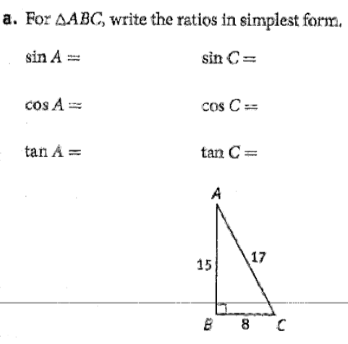**6.**

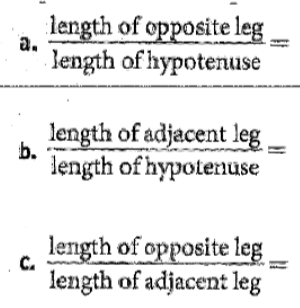

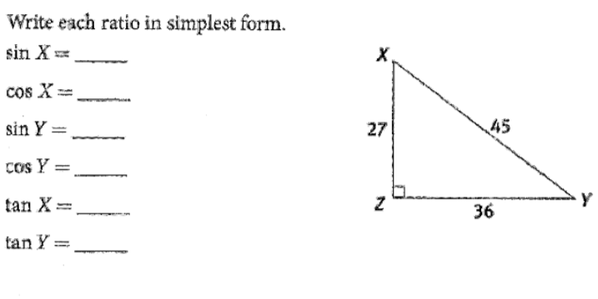**7.**

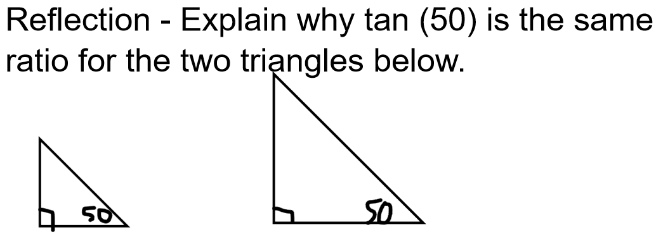

Geometry Unit 7 Day 5 HW

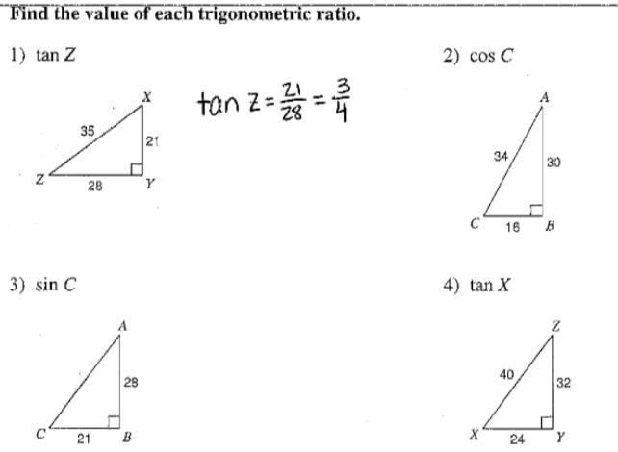

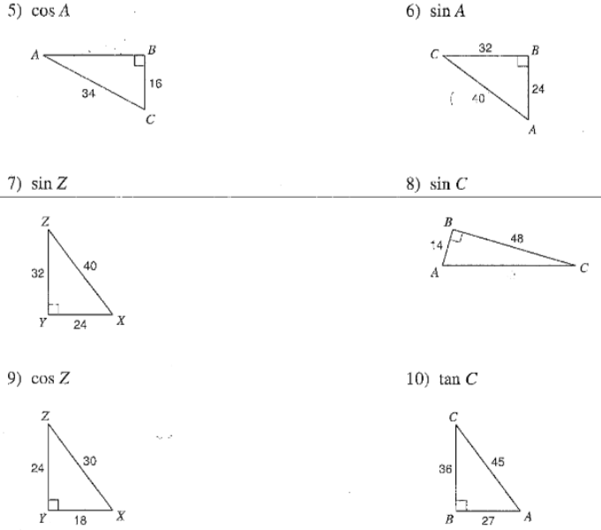

Geometry Unit 7 Day 6 Using trig ratios to find sides

Learning Target – Students will use the trig ratios to find side lengths in right triangles.

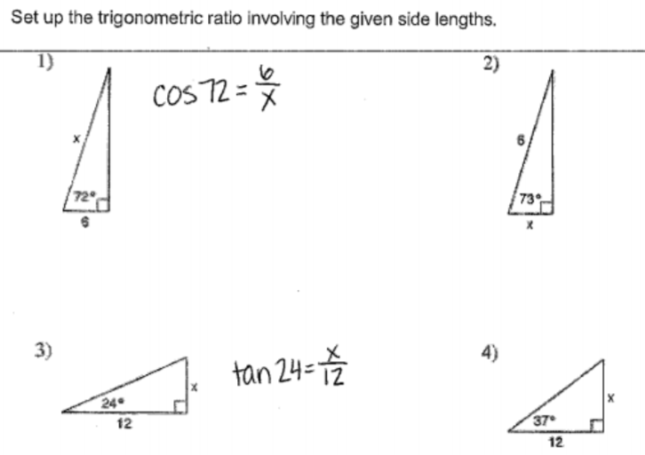

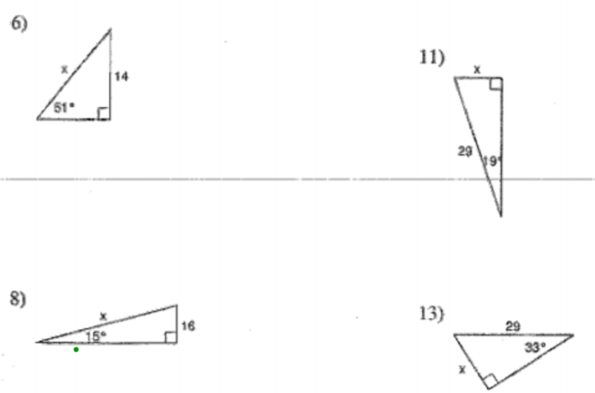

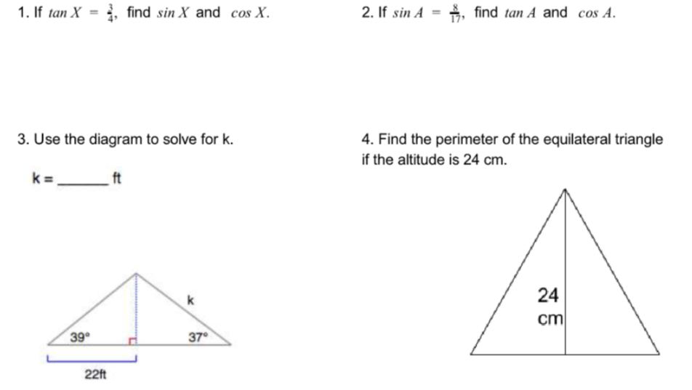

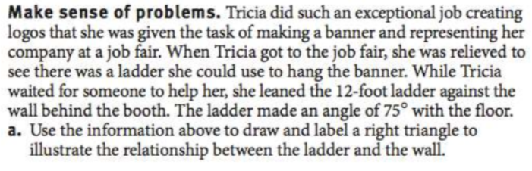

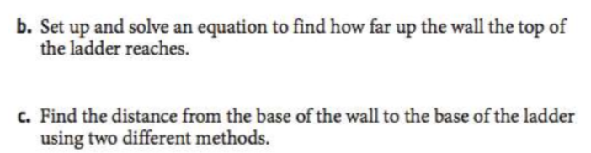

Geometry Unit 7 Day 6 HW

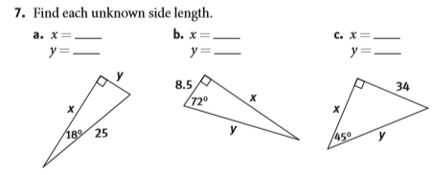

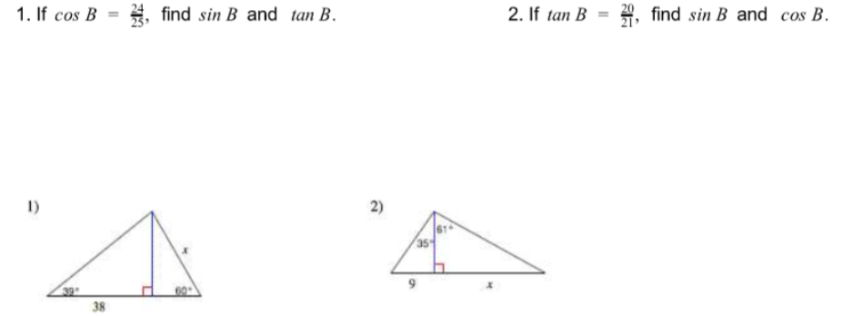

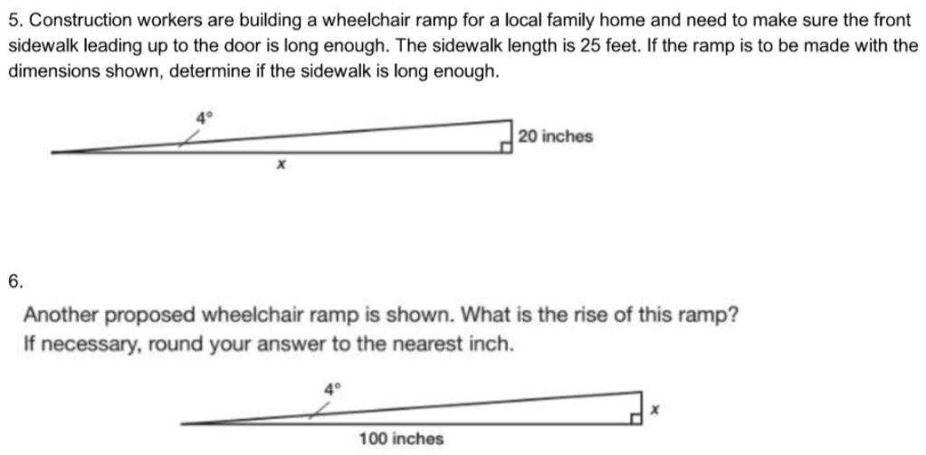

Geometry Unit 7 Day 7 Using trig ratios to find angles.

Learning Target – students will use the inverse trig ratios to calculate the angles measures of right triangles.

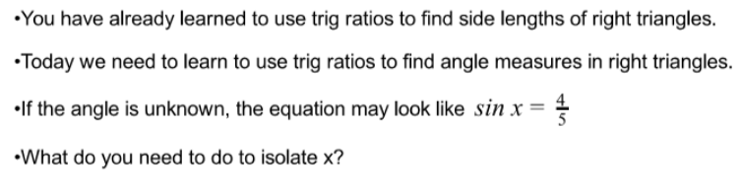

1. Example

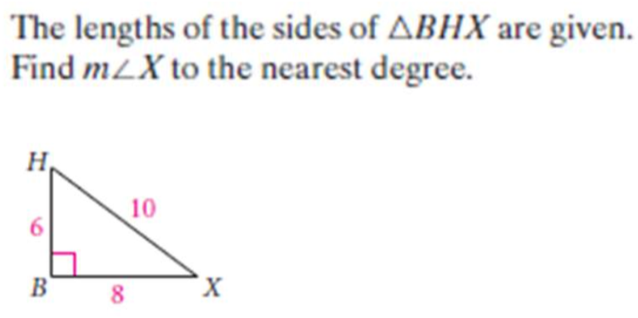

1. You try.

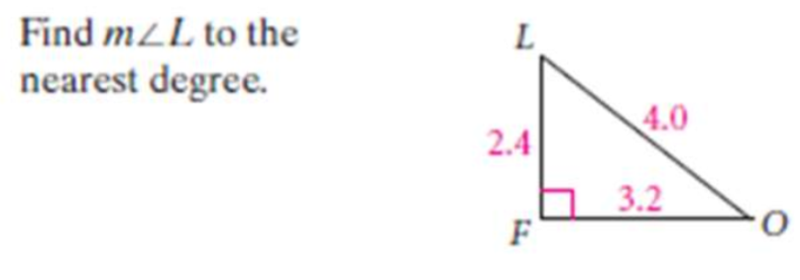

Practice

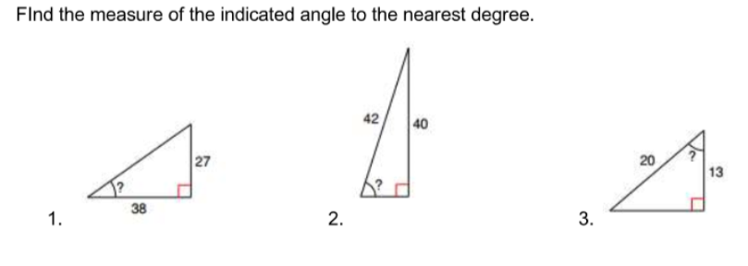

HW

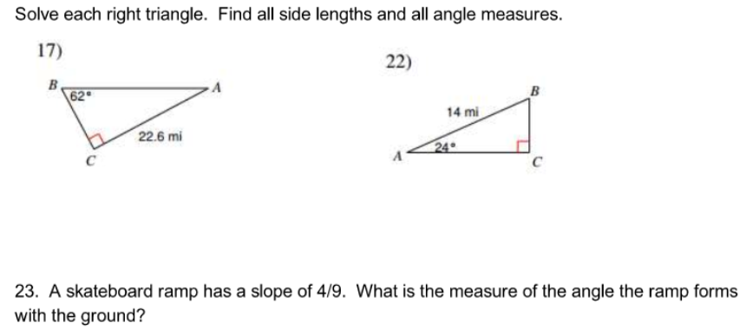

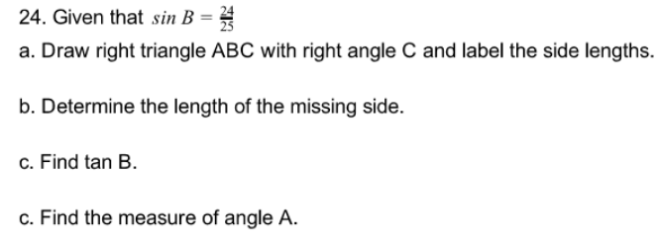

Geometry Unit 7 Day 9 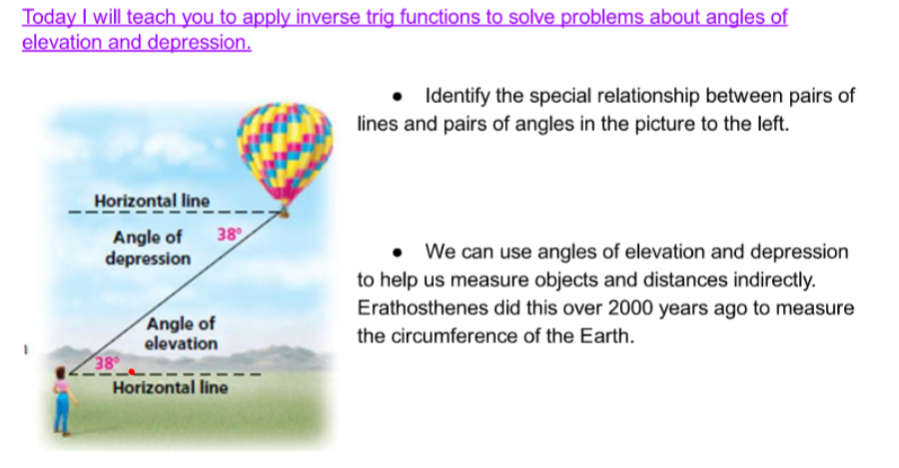

Examples

1. 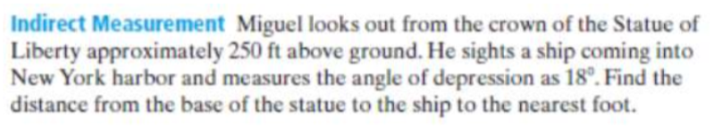
2. 

Practice

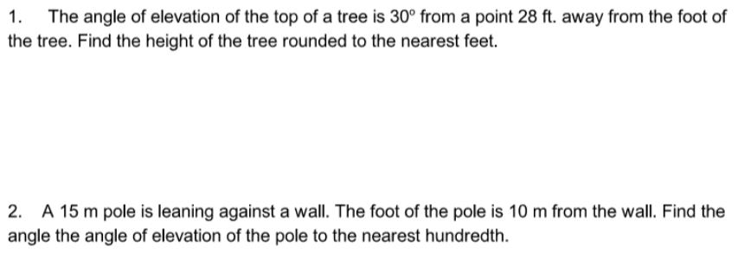

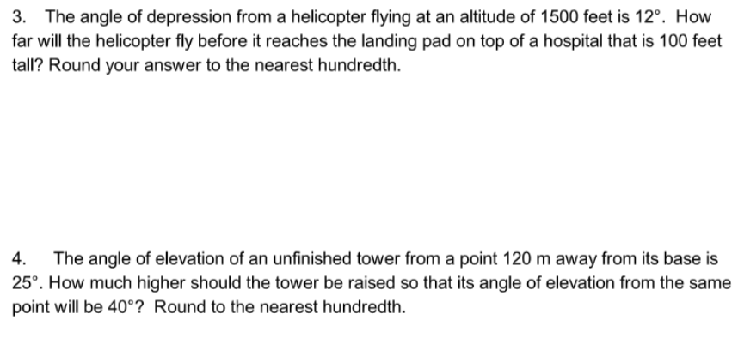

5. Describe the difference in using a trig ratio to find a side length and using a trig ratio to use an angle measure.

6. 