Geometry Unit 6 Review Similarity
- Compare and contrast similar triangles with congruent triangles.

- How does the ratio of corresponding sides compare to the ratio of perimeters for two similar triangles?

- How does the ratio of corresponding sides compare to the ratio of areas for two similar triangles?

- How does the ratio of corresponding sides compare to the ratio of volumes for two similar figures?

- The perimeter of rectangle WXYZ is 70 inches. The perimeter of rectangle of ABCD is 90 inches. What is the ratio of the area of rectangle ABCD to WXYZ?

- Are all equilateral triangles similar? Are they all congruent?
- Are all isosceles triangles similar? Are they all congruent?
- Find the ratio of the perimeters of the shapes.
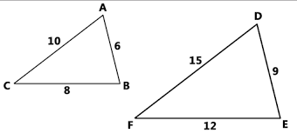
- Find the ratio of the areas of the shapes.
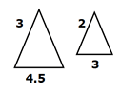
- Find the ratio of the volume of the shapes.
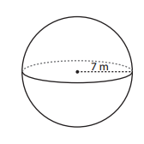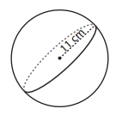
- A 6 ft tall tent standing next to a cardboard box casts a 9 ft shadow. If the cardboard box casts a shadow that is 6 ft long then how tall is it?

- Natasha places a mirror on the ground 24 feet from the base of an oak tree. She walks backward until she can see the top of the tree in the middle of the mirror. At that point, Natasha’s eyes are 5.5 ft above the ground, and her feet are 4 feet from the image in the mirror. Find the height of the oak tree.
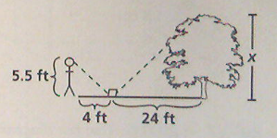
- $∆PIG\sim ∆COW$ then $\frac{IG}{GP}=$?

- One triangle has side lengths of 2, 5, 10 and another triangle has sides of lengths of lengths 6, 15, and 30. Are the triangles similar? How do you know?
- $GO∙ON=DO∙IT$, then $\frac{GO}{DO}=$?
- Are the triangles similar? How do you know?
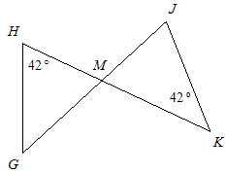
- $\frac{4}{9}=\frac{12}{x}$
- If the volume of one cube is 1000 cubic meters and the ratio of volumes between this cube and a second cube is 8/27 what is the volume of the second package? What is the length of a side of the second cube?

- If the volume of one cube is 1728 cubic meters and the ratio of volumes between this cube and a second cube is 216/1331 what is the volume of the second package? What is the length of a side of the second cube?
- A. What scale factor can be used for finding missing side lengths in the triangles below?
B. Find the lengths of PQ and PR
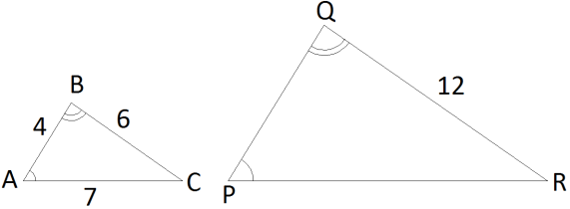
- Find x.
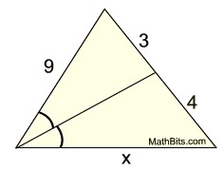
- These similar hexagons are not regular polygons. The length of a side of the shorter hexagon is 10 and the length of the side of the larger hexagon is 12. If the perimeter of the larger hexagon is 58 what is the perimeter of the smaller hexagon?

- 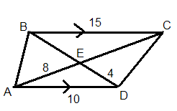Find BE

- Solve for x.
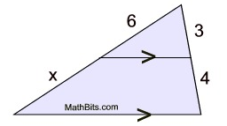
- Solve for x.
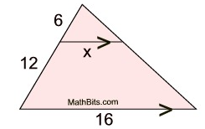
- Find x, y, and z. Use exact answers.
- Are the triangles similar? If so, write a similarity statement and name the postulate or theorem that supports your answer. Also, label the drawing and/or show work to support your answer. If the triangles are not similar, explain why.
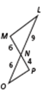
- 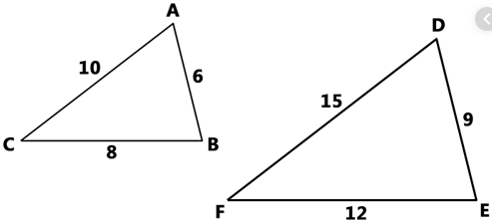
- 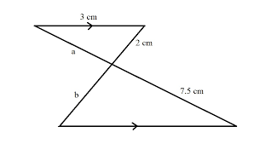 c.
- Alice places a mirror 30 feet from the base of a tree. When she stands 10 feet from the mirror she can see the top of the tree in the mirror. If her eyes are 5 ft above the ground, how tall is the tree?

