Geometry Unit 6 Day 1 Dilations

Learning Target - Students will understand dilations.

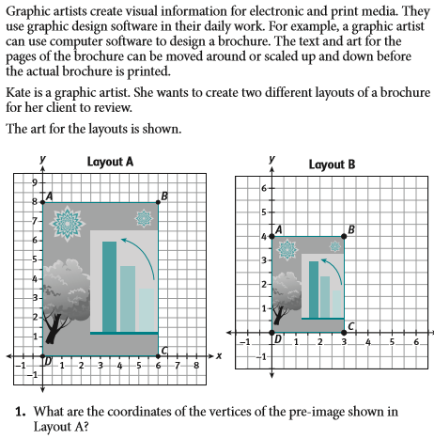

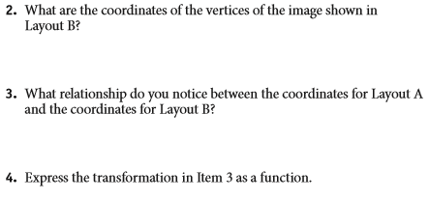

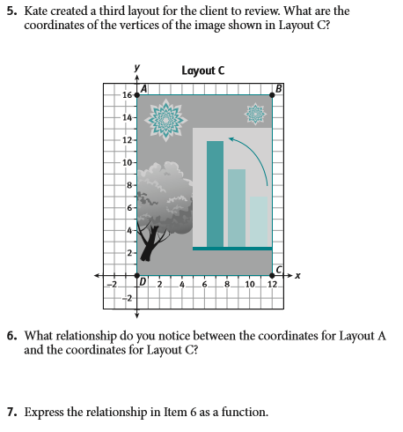

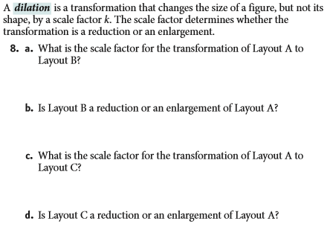

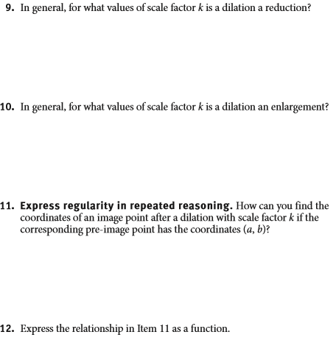

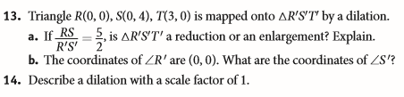

Geometry Unit 6 day 1 HW

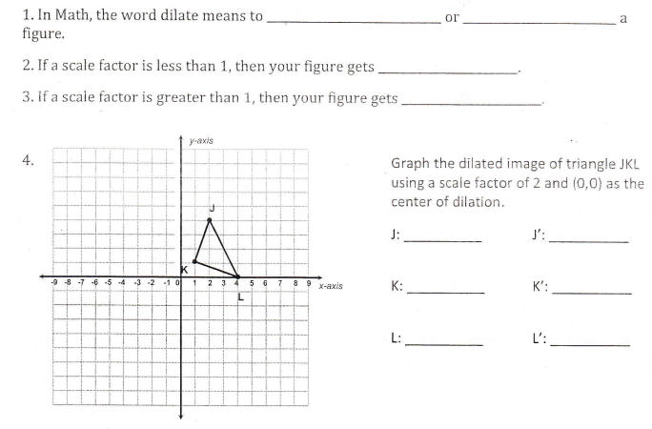

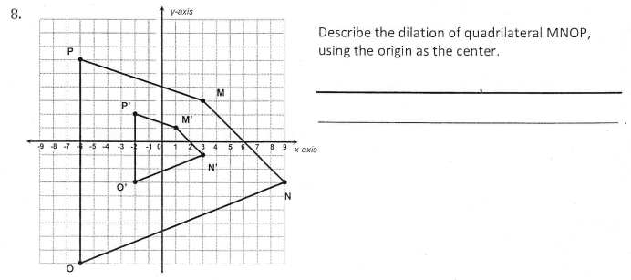

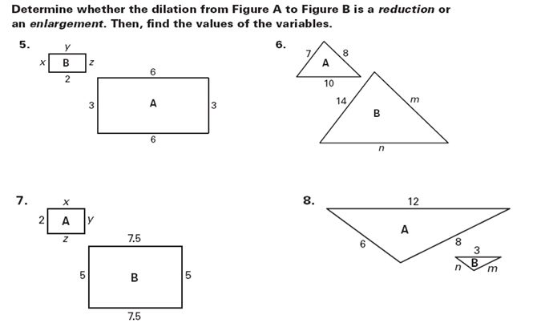

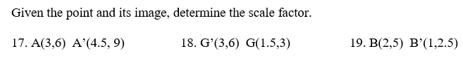

Geometry Unit 6 Day 2 Similar figures

Learning Target – Students will determine when two figures are similar using the definition of similar figures.

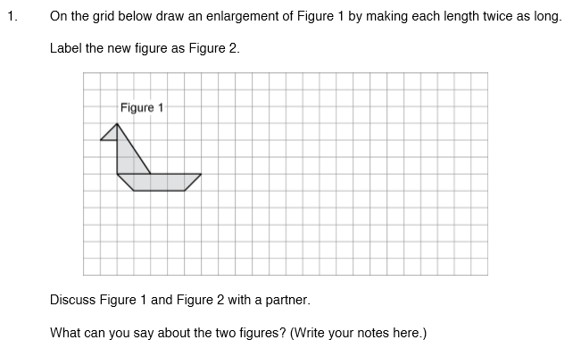

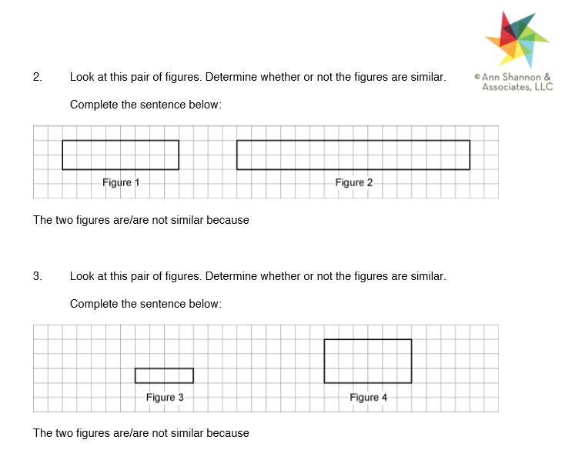

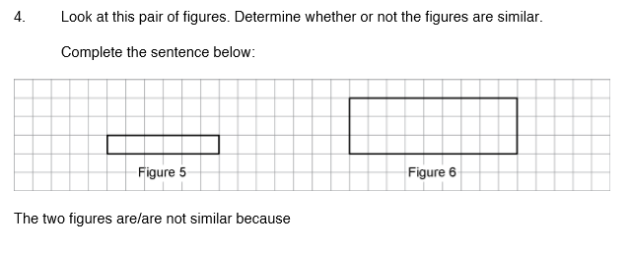

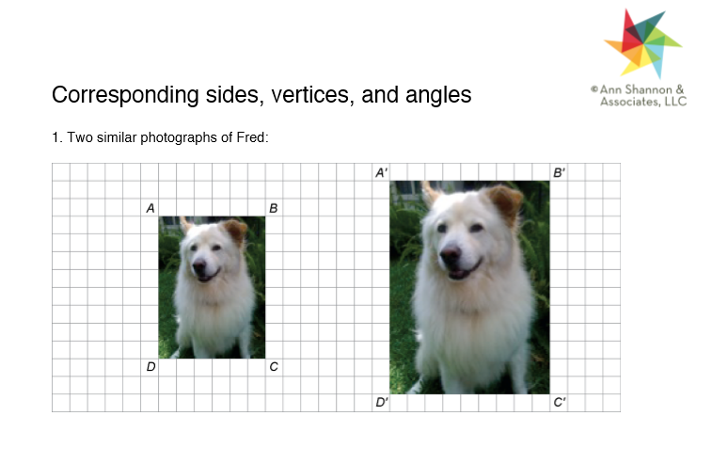

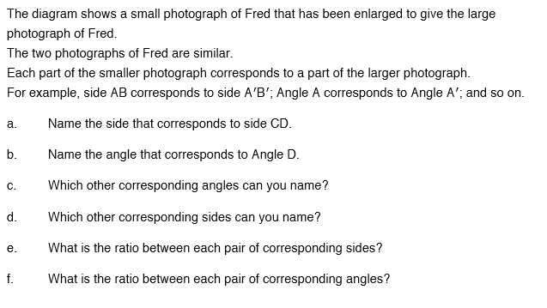

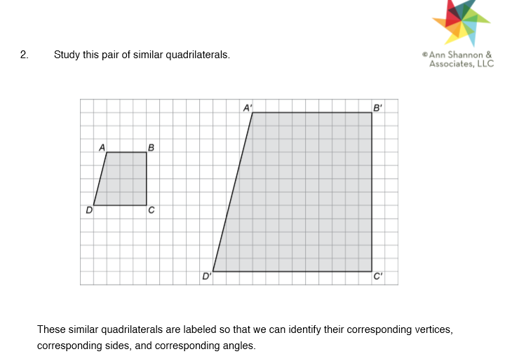

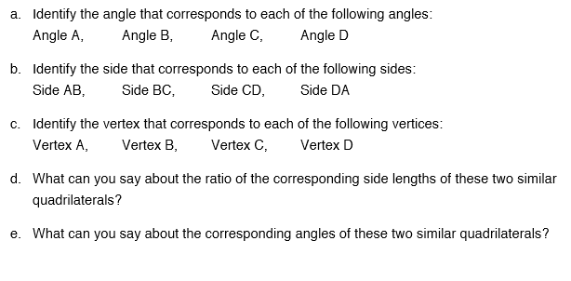

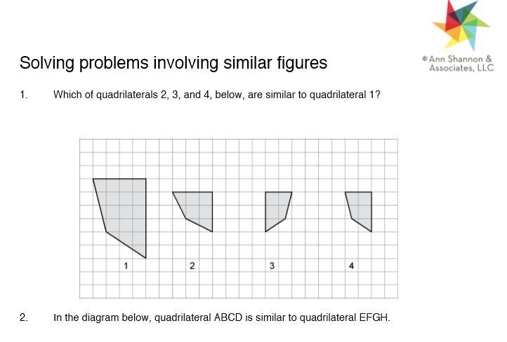

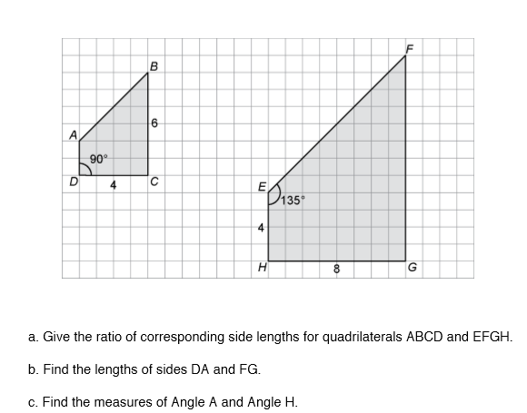

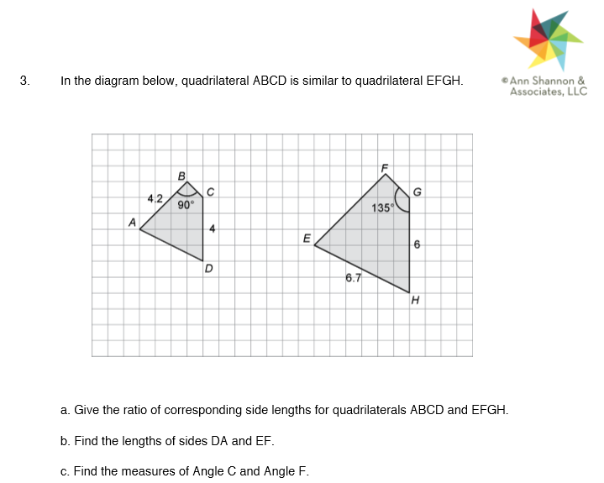

Geometry Unit 6 Day 3 Conditions for similar triangles

Learning Target – Students will prove triangles are similar.

Similar Triangles – triangles that have all pairs of corresponding angles congruent and all pairs of corresponding side lengths proportional. Similar triangles have the same shape, but not the same size.

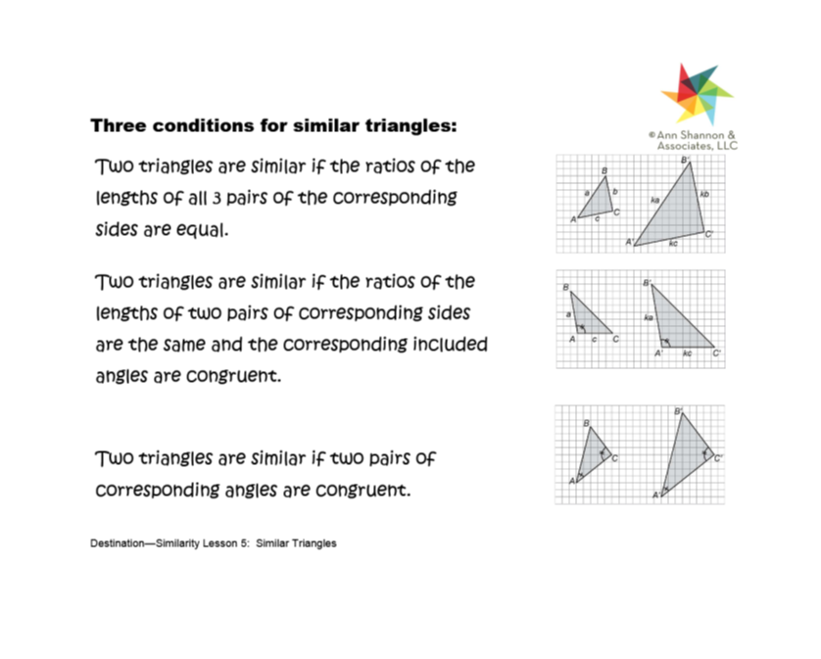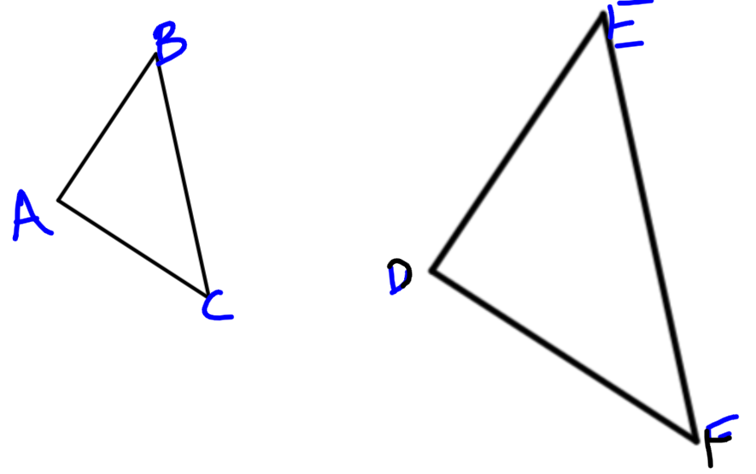

1. Write a similarity statement and use evidence to justify why the triangles are similar. If they are not similar, explain why not.
2. 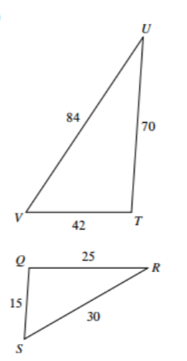

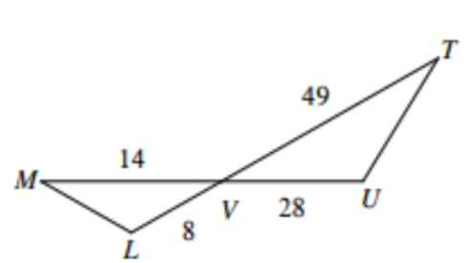

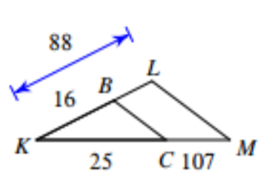

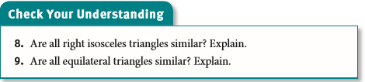

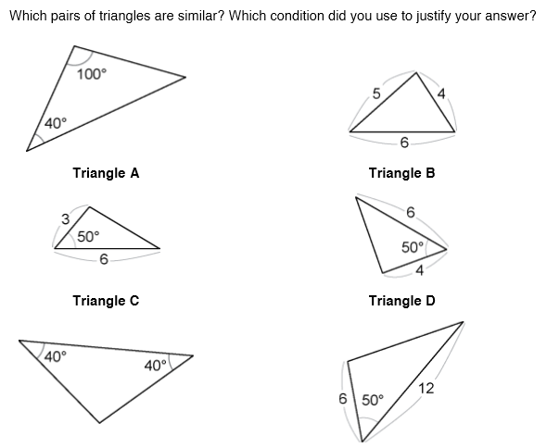

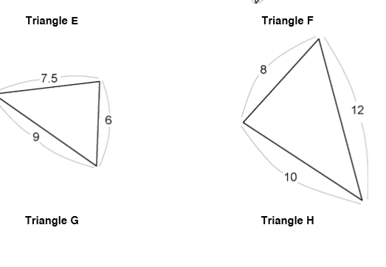

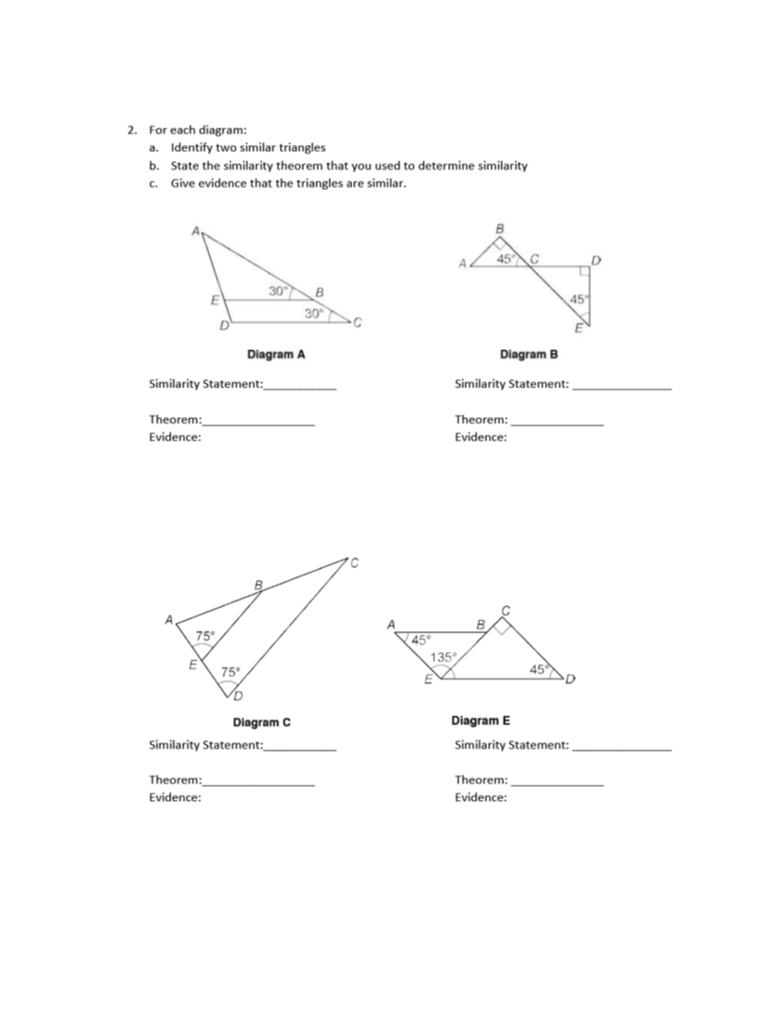

Geometry Unit 6 day 4

Learning Target – Students will use similar figures to solve problems.

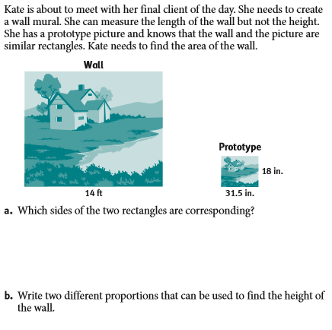

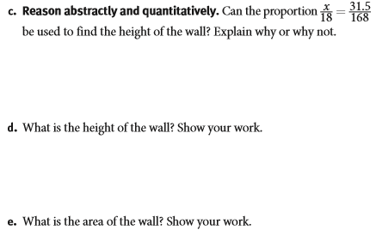

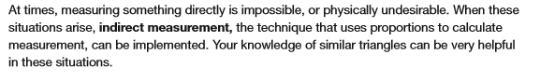

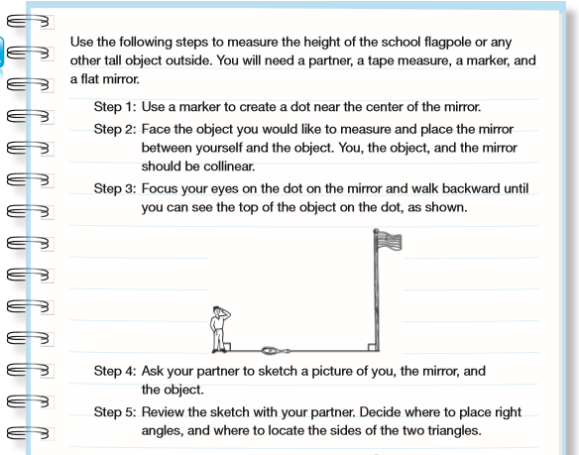 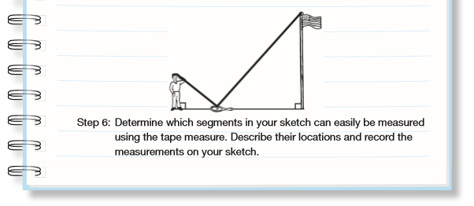

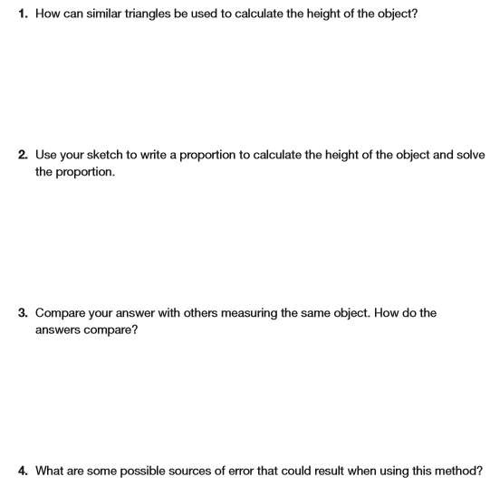

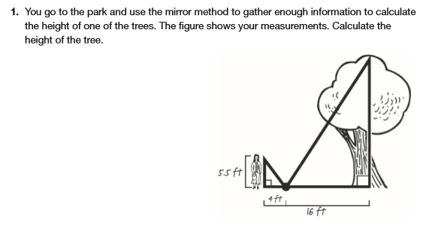

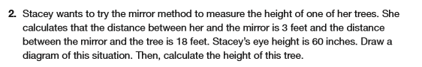

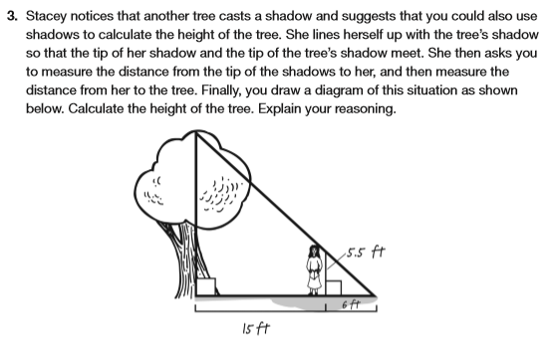

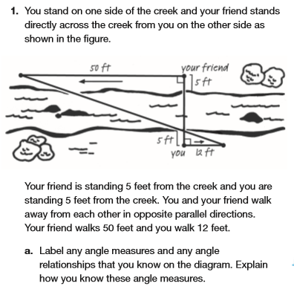







Geometry Unit 6 Day 4 HW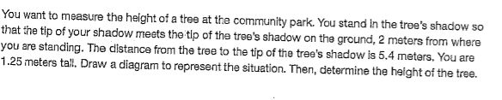

4.

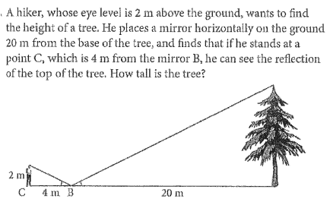

5.

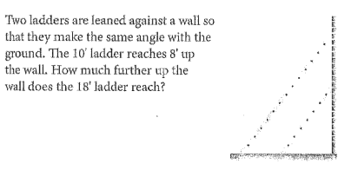

5.

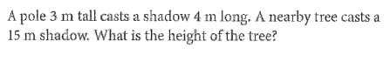

6. 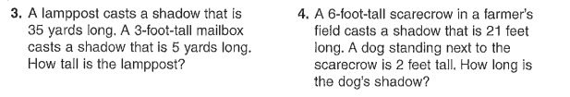

1. Find the height of the geyser.

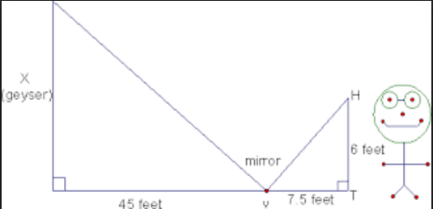

1. Find the height of the flag pole.

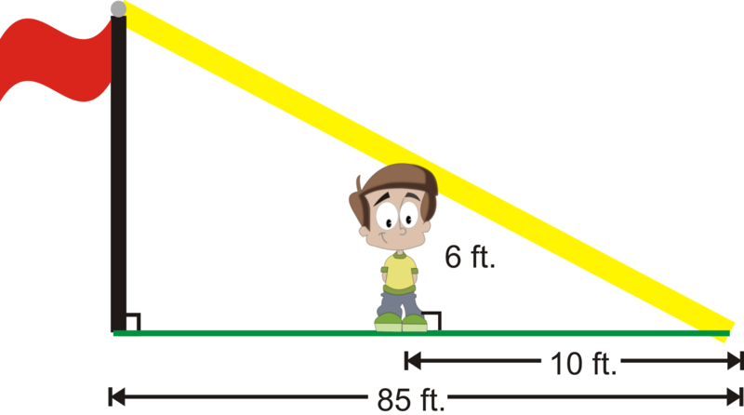

Geometry Unit 6 Day 8 Triangle Proportionality Theorem

Learning Target – Students will use the triangle proportionality theorem to solve problems.

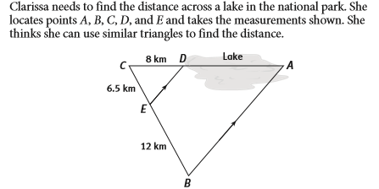

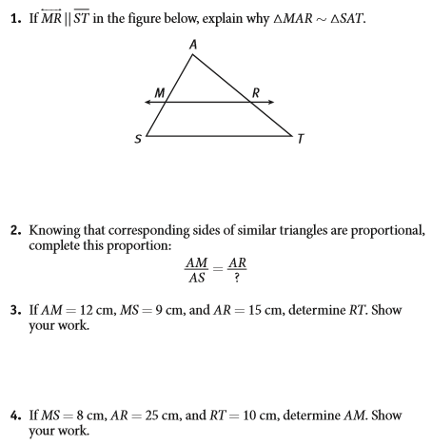

Triangle Proportionality Theorem – If a line parallel to a side of a triangle intersects the other two sides, it divides them proportionally.

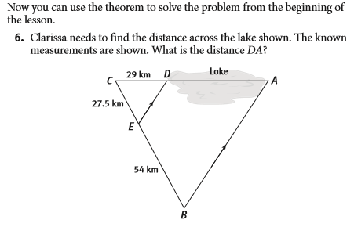

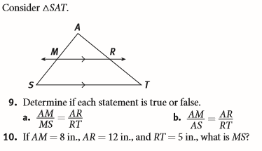

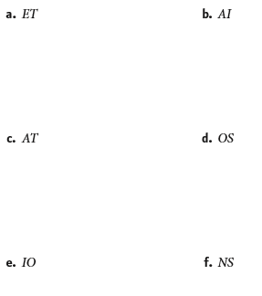Parallel proportionality theorem – If two or more lines parallel to a side of a triangle intersect the other two sides of the triangle, they divide them proportionally.

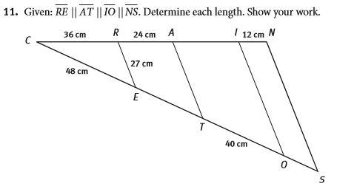

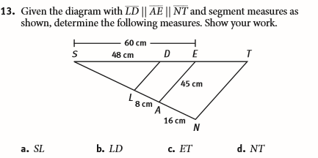

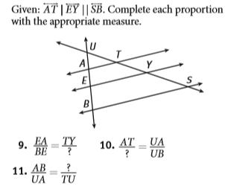Geometry Unit 6 Day 8 HW

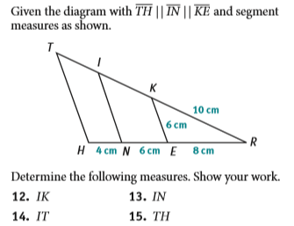

Geometry Unit 6 Day 9 Right Triangle Altitude Theorem

Learning Target – Students will identify and use relationships that exist when an altitude is drawn to the hypotenuse of a right triangle.

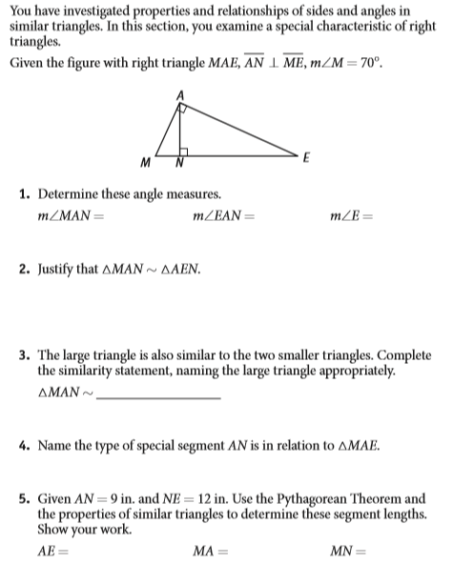

Theorem : The altitude to the hypotenuse of a right triangle divides the triangle into two triangles that are similar to the original triangle and to each other.



1. Which segment in triangle ABC is the altitude?
2. Which segment is the hypotenuse of triangle ABC?
3. Write the similarity statement for the three triangles above based off of the information in the theorem.
4. Which similarity theorem or postulate makes the above theorem true? Explain.

Definition: The geometric mean of any two numbers is the square root of their product.

1. Find the geometric mean of 9 and 2. Show all work. Write your answer in simplest radical form.

Corollary to the Theorem: The length of the altitude to the hypotenuse of a right triangle is the geometric mean of the lengths of the segments of the hypotenuse.

1. Which variable is the triangle below represents the length of the altitude to the hypotenuse.



1. Use the information in the corollary to find the value of that variable. Show all work. Leave your answer in simplest radical form.

You can still use the corollary to solve for one of the segments of the hypotenuse if you know the other segment of the hypotenuse and the length of the altitude.

1. Use the corollary to find x in the picture below.

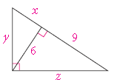

Another Corollary to the Theorem: The altitude to the hypotenuse of a right triangle separates the hypotenuse so that the length of each leg of the triangle is the geometric mean of the length of the adjacent hypotenuse segment and the length of the hypotenuse.



1. Which segment is the altitude to the hypotenuse?
2. Which labeled segment is a leg of the triangle?
3. Which labeled segment is the length of the hypotenuse segment adjacent to that leg?
4. What is the length of the hypotenuse?
5. Use the corollary above to find the length of the labeled leg of the triangle. Show all work. Leave your answer in simplest radical form.

Geometry Unit 6 Day 9 HW

**Honors Geometry Extra Practice 19.2**

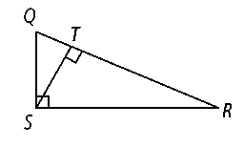**Identify the following in right Δ*QRS.***

**1.** the hypotenuse

**2.** the segments of the hypotenuse

**3.** the altitude

**4.** the segment of the hypotenuse adjacent to leg 

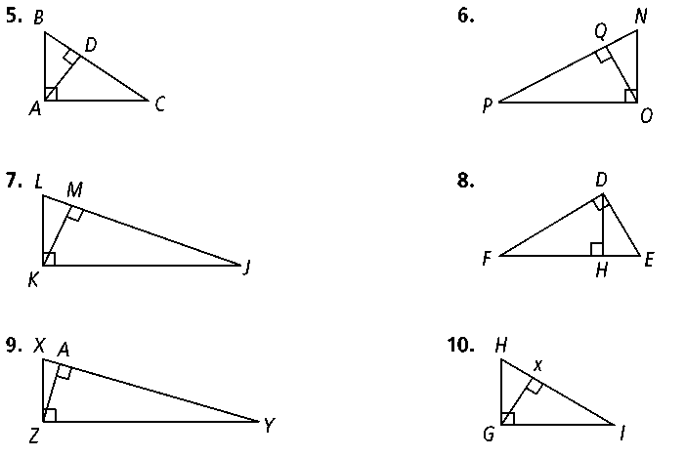

**5. Explain why the three triangles are similar.**

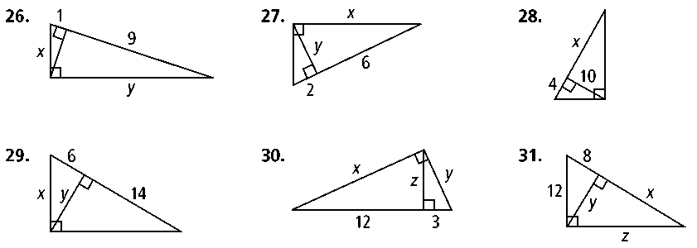**Algebra Solve for the value of the variables in each right triangle.**

**26.**

27. 28.

29.

 30.

Geometry Unit 6 Day 11 Perimeter, area and volume of similar figures

Learning Target – Students will compare perimeters, areas and volumes of similar figures.

**Perimeters and Areas of Similar Rectangles**

* On a piece of grid paper draw a 6-unit by 8-unit rectangle.
* Draw three different rectangles, each similar to the original. One smaller, two larger. Label them I, II and III

1. Use your drawings to complete the following chart:

|  |  |  |
| --- | --- | --- |
| **Rectangle** | **Perimeter** | **Area** |
| Original |  |  |
| I |  |  |
| II |  |  |
| III |  |  |

2. Use the information from the first chart to complete the following chart (simplify the ratios):

|  |  |  |  |
| --- | --- | --- | --- |
| **Rectangle** | **Similarity**  **Ratio** | **Ratio of**  **Perimeters** | **Ratio of**  **Areas** |
| I to Original |  |  |  |
| II to Original |  |  |  |
| III to Original |  |  |  |

3. How do the ratios of perimeters and the ratios of areas compare to the similarity ratios?

















Geometry Unit 6 Day 12 Perimeter, area and volume of similar figures

Learning Target – Students will compare perimeters, areas and volumes of similar figures.

* Similar Solids – Have the same shape and all corresponding sides are proportional.
* The ratio of two corresponding linear dimensions is the similarity ratio of the solids.
* Any two cubes are similar.
* Any two spheres are similar.

1. 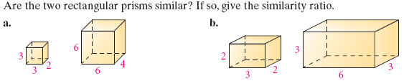

C, 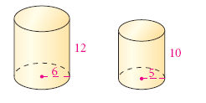

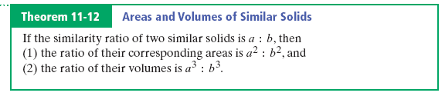

1. 
2. 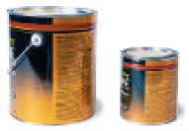

Geometry Unit 6 Day 12 HW

