Geometry Unit 5 Day 1 Developing Definitions for Quadrilaterals

Learning Target – Students will develop definitions for quadrilaterals and use them to name given quadrilaterals.

Classifying Quadrilaterals

Each picture below is a special type of quadrilateral. Use google to develop a definition that is specific to that type of quadrilateral. Write your definition and draw the picture in your vocabulary for Ch 5

Parallelogram Rhombus Rectangle Square



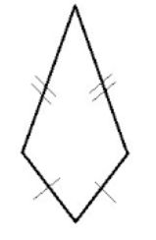Kite Isosceles Trapezoid Trapezoid

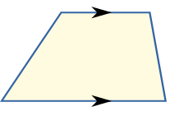

Fill in the missing names and relationships on the diagram below based on the definitions that you developed.



Justify your thinking.

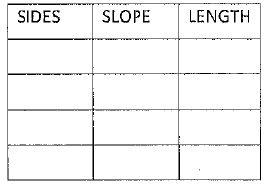



Geometry Unit 5 Day 1 HW

**1. Classify the Polygon**

a) Graph and label the quadrilateral with the given vertices.

b) Determine the most precise name for the quadrilateral. (*hint: Use distance and slope formulas)*

c) Explain your reasoning.

A (1, 2), B(3, 8), C(5, 2 ), D(3, -4)

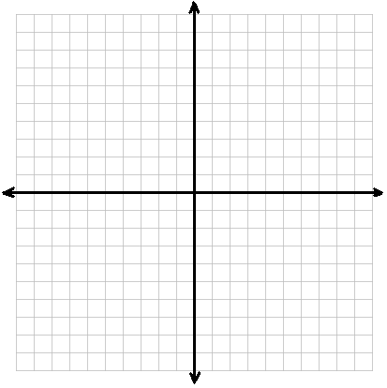

**2. Classify the Polygon**

a) Graph and label the quadrilateral with the given vertices.

b) Determine the most precise name for the quadrilateral. (*hint: Use distance and slope formulas)*

c) Explain your reasoning.

A (-2, -3 ), B(4, 0 ), C(3, 2 ), D(-3, -1 )



Geometry Unit 5 Day 2

Learning target – students will apply the properties of kites to solve problems.

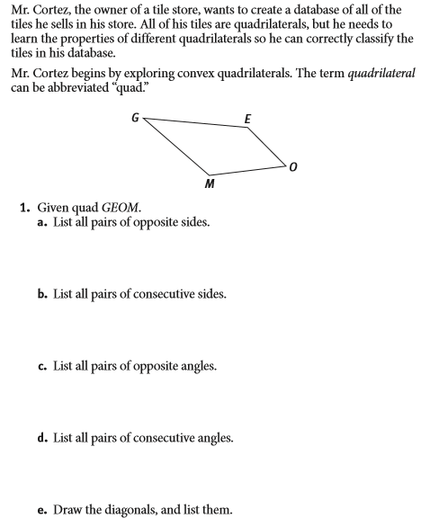





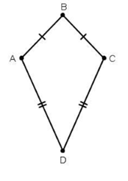

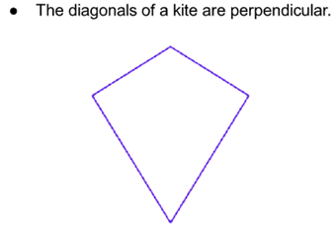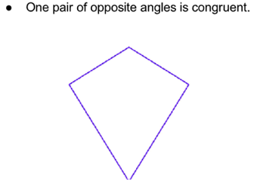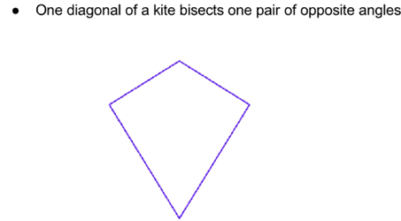

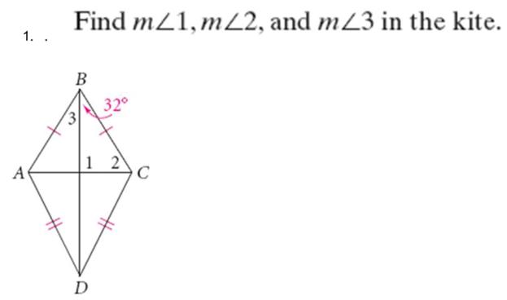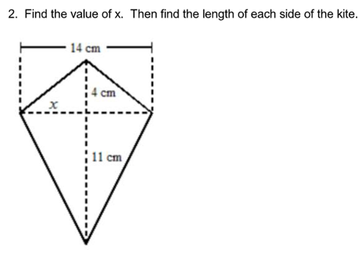

5. Explain your method.

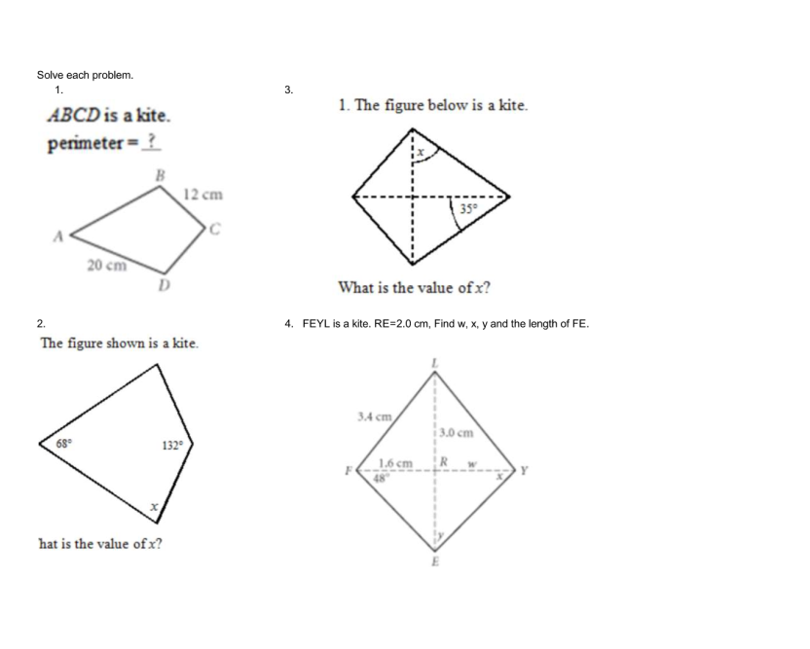

Geometry Unit 5 Day 2 HW

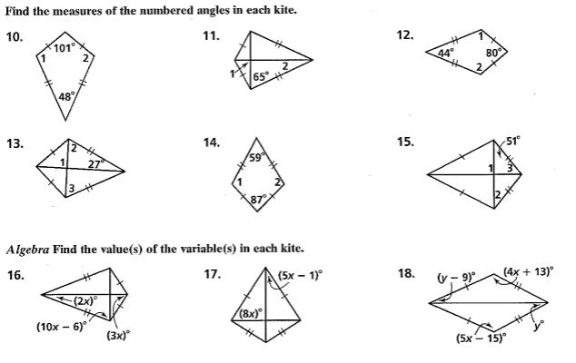

Geometry Unit 5 Day 3 Notes

Students will use the properties of trapezoids to solve problems.

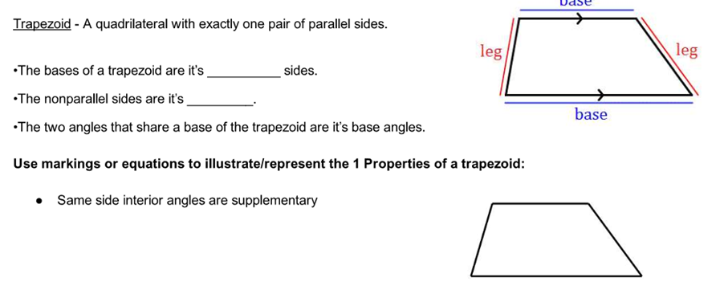

1. How does a trapezoid differ from a kite?

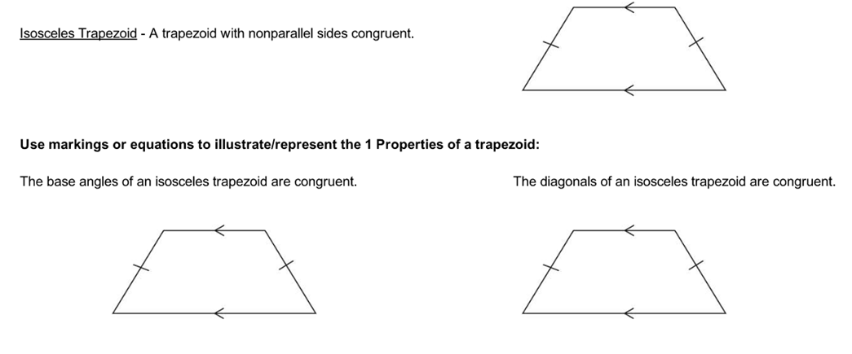

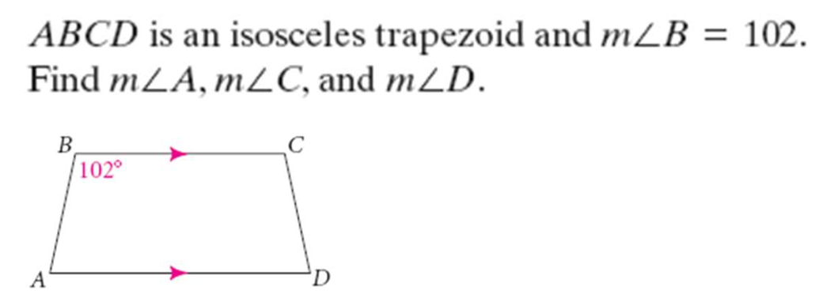

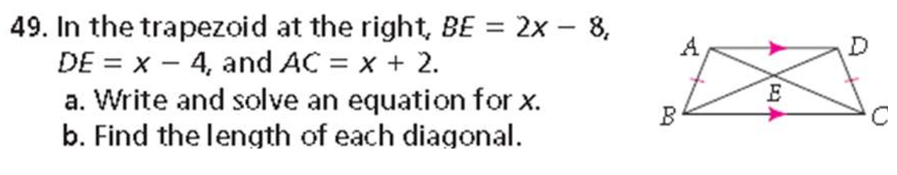

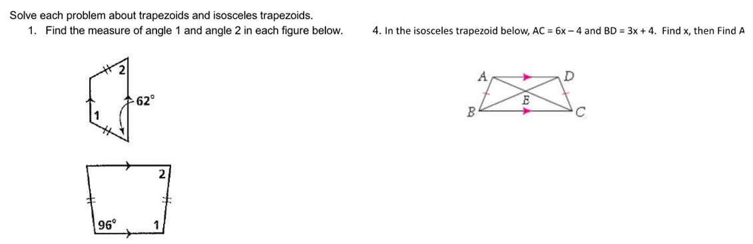

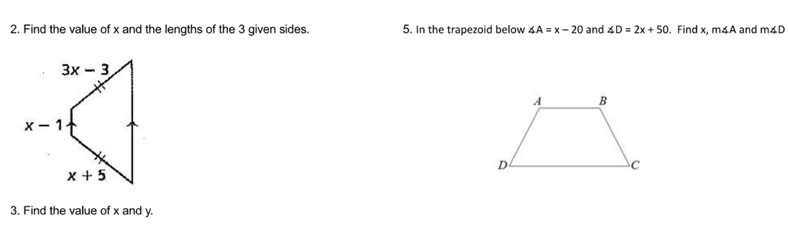

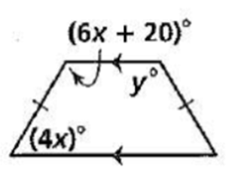

Geometry Unit 5 Day 3 HW

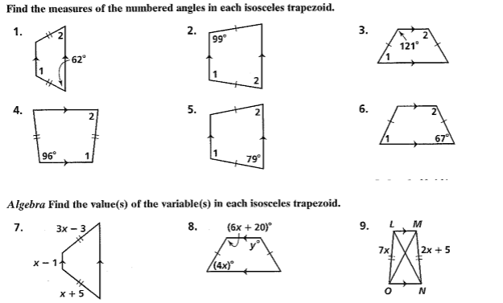

Geometry Unit 5 Day 4 The trapezoid midsegment theorem

Students will use the trapezoid midsegment theorem to solve problems.

1. Complete Glass Ceiling as review

The midsegment of a trapezoid joins the midpoints of the nonparallel opposite sides.

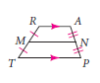2 properties

* 1. parallel to the bases
  2. Length if half the sum of the lengths of the bases.



1. 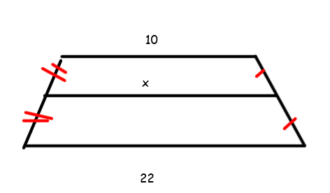Find the value of x in each.

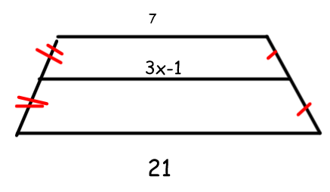

Geometry Unit 5 Day 3 HW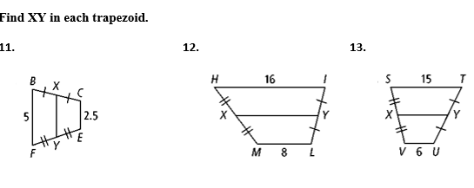

**Algebra Find the lengths of the segments with variable expressions.**

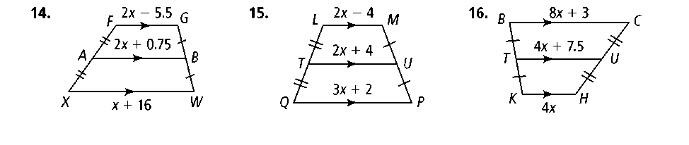 **15.**  **16.**

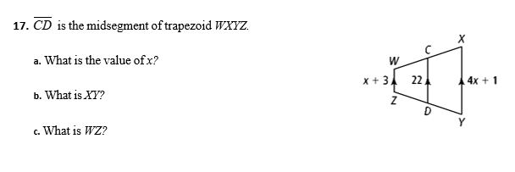

Geometry Unit 5 Day 5 Parallelograms

Learning Target – Students will use the properties of parallelograms to solve problems.

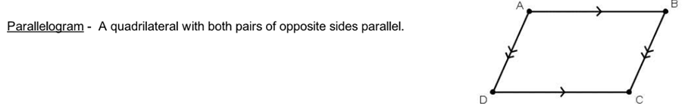

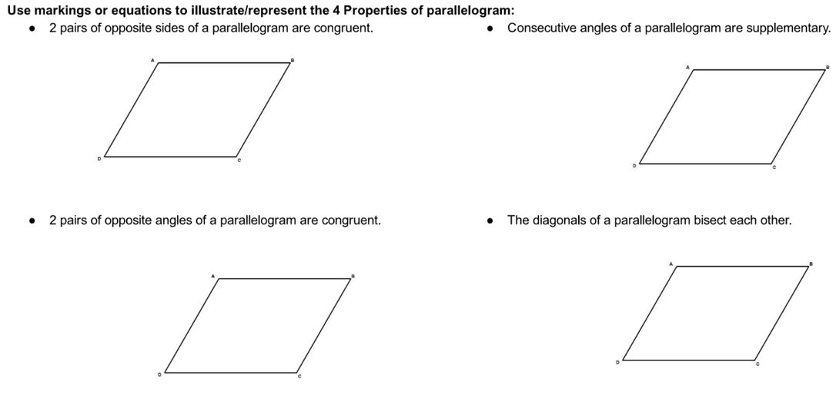

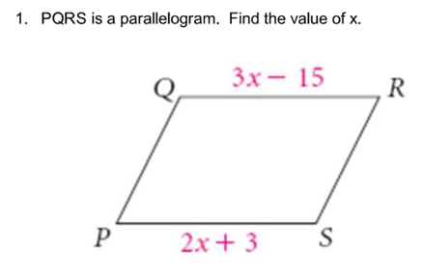 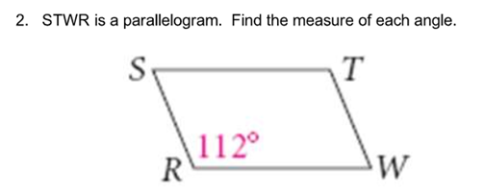

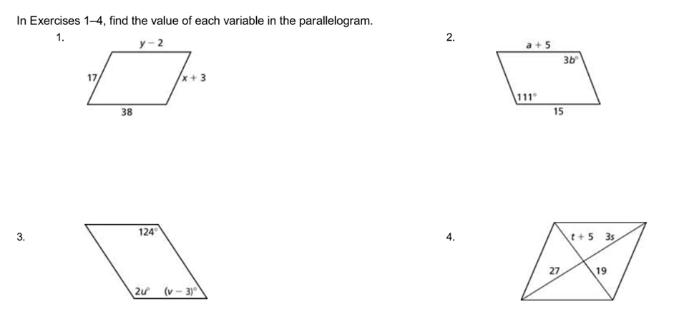



Summary – parallelogram properties

1. Opposite sides are congruent
2. Opposite angles are congruent
3. Consecutive angles are supplementary
4. Diagonals bisect each other

Geometry Unit 5 Day 5 HW

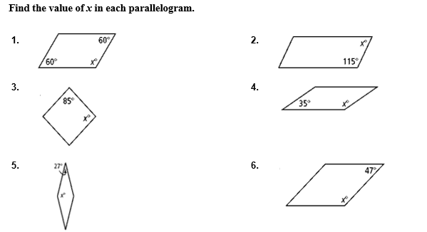

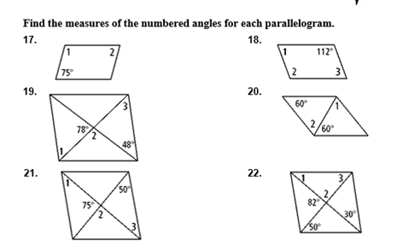

Geometry Unit 5 Day 6 Rectangles, Rhombi, and squares

Learning Target – Students will use properties of rectangles, rhombi, and squares to solve problems.

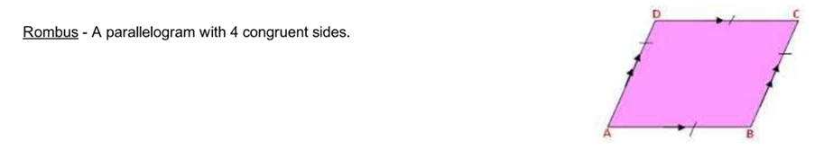

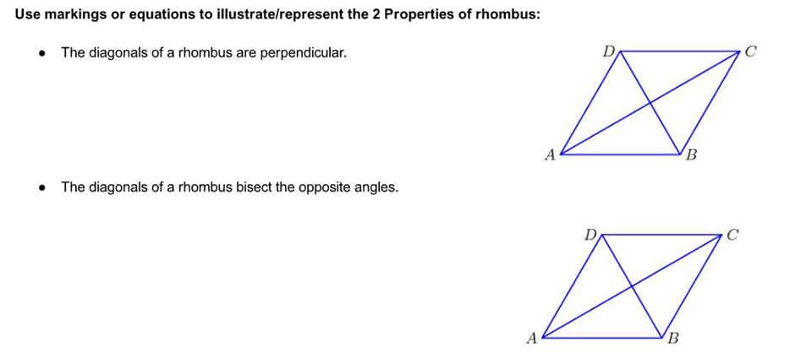

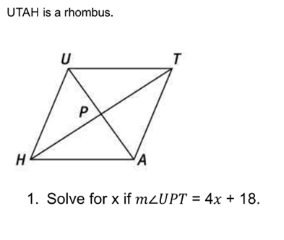



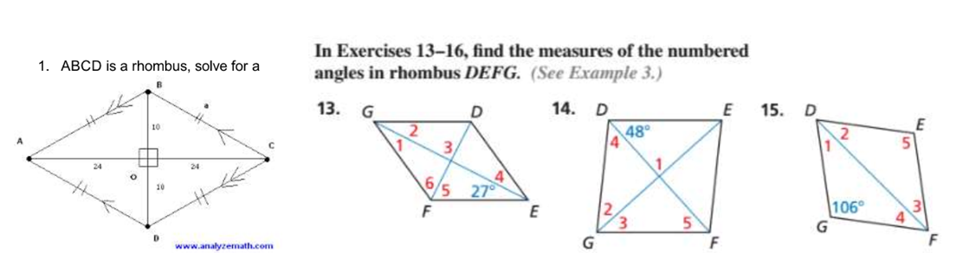



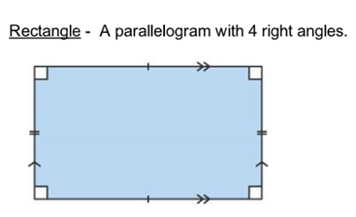 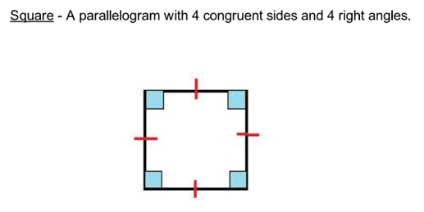

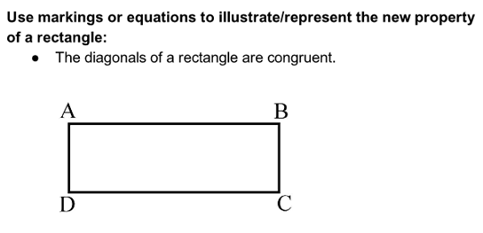 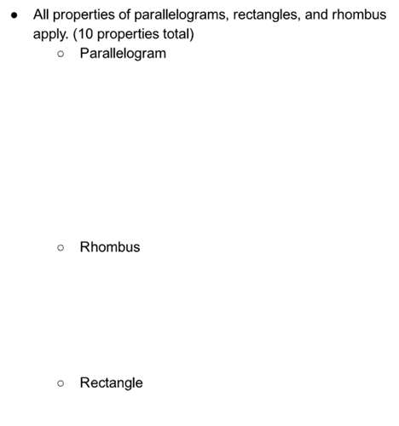

Geometry Unit 5 Day 6 HW

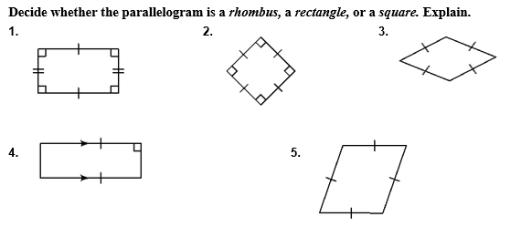

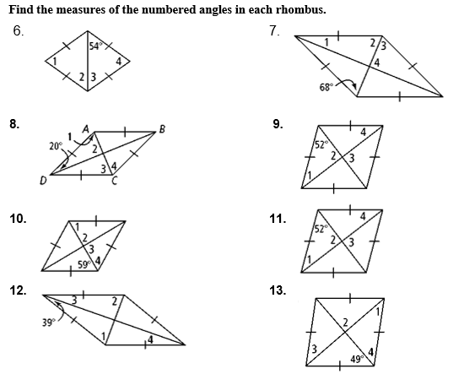

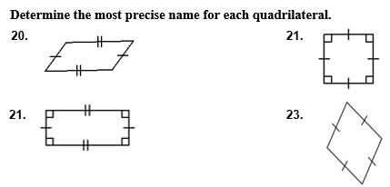

Geometry Unit 5 Day 7 Proving a figure is a parallelogram

Learning Target – Students will prove a figure is a parallelogram.

In addition to the definition of a parallelogram – both pairs of opposite sides are congruent, there are 4 other ways to prove a figure is a parallelogram.

1. If the diagonals bisect each other, then the figure is a parallelogram.
2. If both pairs of opposite sides are congruent, then the figure is a parallelogram.
3. If both pairs of opposite angles are congruent, then the figure is a parallelogram.
4. If one pair of opposite sides is both congruent and parallel, then the figure is a parallelogram.

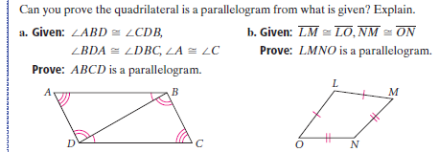

1. 

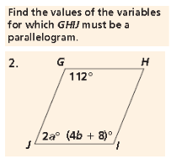

1. 



1. **Find the values of the variables that will make *ABCD* a parallelogram.**

Proving that a figure is a special parallelogram

If you know a figure is a parallelogram then you may be able to prove that it is a rectangle, rhombus or square.

1. If one diagonal of a parallelogram bisects two angles, then the parallelogram is a rhombus.
2. If the diagonals are perpendicular, then the parallelogram is a rhombus.
3. If the diagonals are congruent, then the parallelogram is a rectangle.
4. If you can show the parallelogram is both a rhombus and a rectangle, then it is a square.

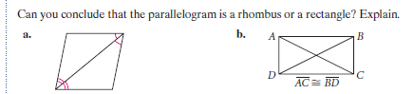

Geometry Unit 5 day 7 HW

Proofs and Practice for Activity 16

Can you prove that the quadrilateral is a parallelogram based on the the given information? Explain

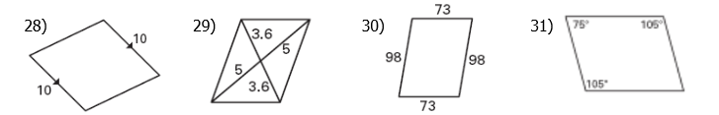

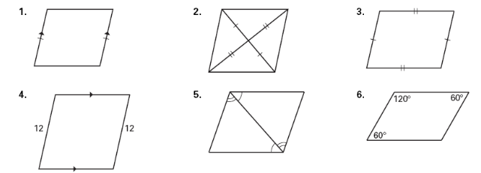

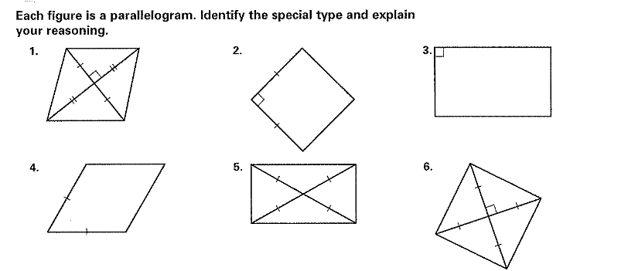

Geometry Unit 5 Day 8 Polygon Angle Sums

**Angles of a Convex Polygon investigation**

1. Complete the following table for each polygon. Choose one vertex and make all possible diagonals from that vertex.

|  |  |  |  |  |
| --- | --- | --- | --- | --- |
| **Polygon** | **Diagram: including drawn diagonals** | **Number of Sides** | **Number of Triangles** | **Sum of the Measures of the Interior Angles of the Polygon** |
| Quadrilateral |  |  |  |  |
| Pentagon |  |  |  |  |
| Hexagon |  |  |  |  |
| Heptagon |  |  |  |  |
| Octagon |  |  |  |  |
| n-gon |  |  |  | **Formula:** |

1. Look for a pattern in the measures of the interior angles. How do they relate to the number of triangles in the polygon?
2. How does the measures of the interior angles relate to the number of sides of the polygon?
3. What formula could you use to find the sum of the measures of the interior angles of a n sided polygon? Explain why this formula works. Fill in the n-gon row of the table based on your formula.
4. Use the formula you found for the **n-gon** and find the sum of the interior angles for the following polygons.
5. Decagon b) Dodecagon c) 20-gon
6. Find the number of sides of a polygon which has an interior angle sum of $2,340°$
7. Find the number of sides of a polygon which has an interior angle sum of $4,500°$
8. A **regular polygon** is both equiangular and equilateral. Assume each polygon is regular. Add and complete a column to your table titled “measure of each interior angle.”
9. Write a formula you could use to find the measure of each individual angle of a polygon with n sides.
10. Find the measure of **each interior angle** for the following regular polygons:
11. Decagon b) 15-gon c) 20-gon
12. If the measure of each interior angle of a regular polygon is $160°$, find the number of sides of the polygon.
13. *An* ***exterior angle*** *is formed adjacent to each interior angle by extending one side of each vertex of the polygon.*

|  |  |  |  |  |
| --- | --- | --- | --- | --- |
| **SHAPE** | **LINEAR PAIRS** | **TOTAL**  **(interior & exterior)** | **SUM of INTERIOR**  **(n - 2)180** | **SUM of EXTERIOR**  **(TOTAL - interior)** |
| **Triangle** |  |  |  |  |
| **Quadrilateral** |  |  |  |  |
| **Pentagon** |  |  |  |  |
| **Hexagon** |  |  |  |  |
| **N-gon** |  |  |  |  |

**CHECKPOINT:**

1. The sum of the EXTERIOR ANGLES of a polygon is always ________________.
2. What is the relationship between the number of exterior angles and number of sides?

1. What is the sum of the exterior angles of a polygon that has 387 sides?
2. What is the measure of an exterior angle if it is adjacent to an interior angle of a polygon that measures 120º?

**MEASURE of EACH EXTERIOR ANGLE of a REGULAR polygon**

***REGULAR POLYGON:*** *a polygon with all sides and angles congruent*

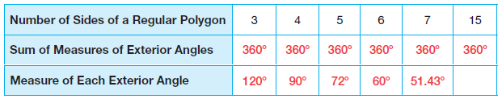

Questions:

1. If all the interior angles are congruent in a regular polygon, what does it tell you about the exterior angles?

1. If the sum of the exterior angles is always 360 degrees, how do you find the measure of EACH exterior angle?

1. Fill in the last space in the chart. (show work below)

1. Derive the formula to find the measure of each exterior angle of an n-gon.

Geometry Unit 10 Day 8 HW

