Geometry Unit 4 Day 1 Triangle Congruence

Students will use the fact that congruent triangles have congruent corresponding parts to determine unknown angle measures and side lengths.

**Congruent triangles** are triangles that have the same size and shape.

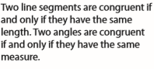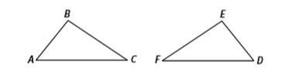

1. How could you “map” $∆ABC$ onto $∆DEF?$
2. What would be the image of each of the following after the mapping?



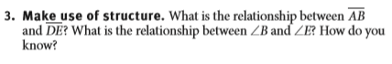

In congruent triangles, corresponding pairs of sides are congruent and corresponding pairs of angles are congruent. These are called *corresponding parts.*

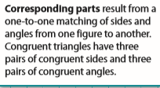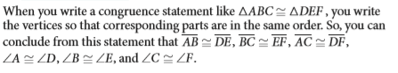

1. $∆ABC≅∆JKL$. Name the six pairs of corresponding parts.

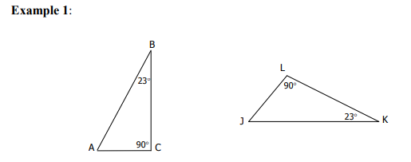

1. You try: $∆PQR≅∆CBA$ Name the six pairs of corresponding parts.
2. 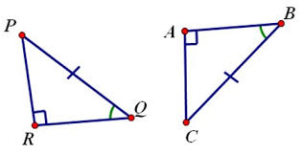

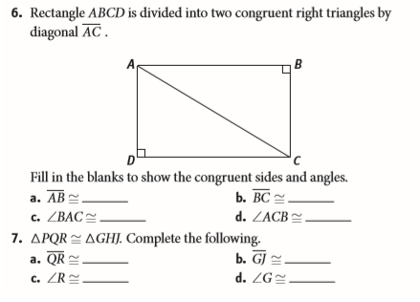

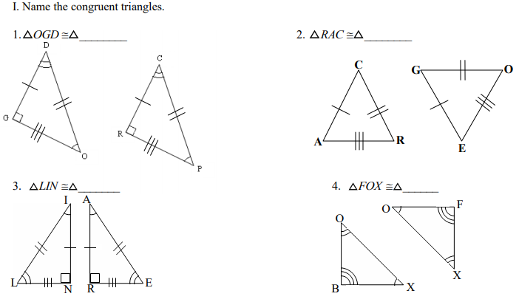

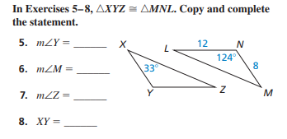5. 6.

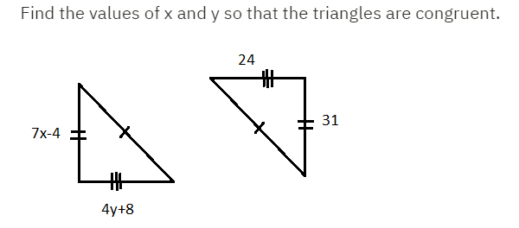

Geometry Unit 4 Day 1 HW

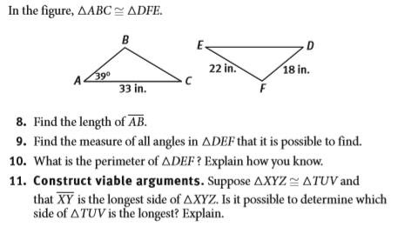

Find the value of x and y.

1.

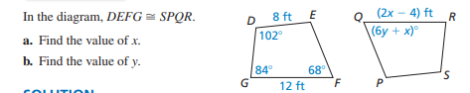

2.

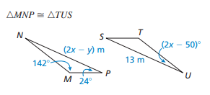

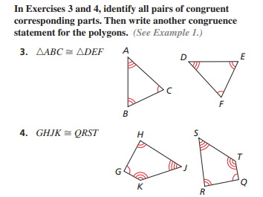

Geometry Unit 4 Day 2 Congruence Criteria

Students will develop criteria for proving triangles congruent.

DO Mystery Triangle!

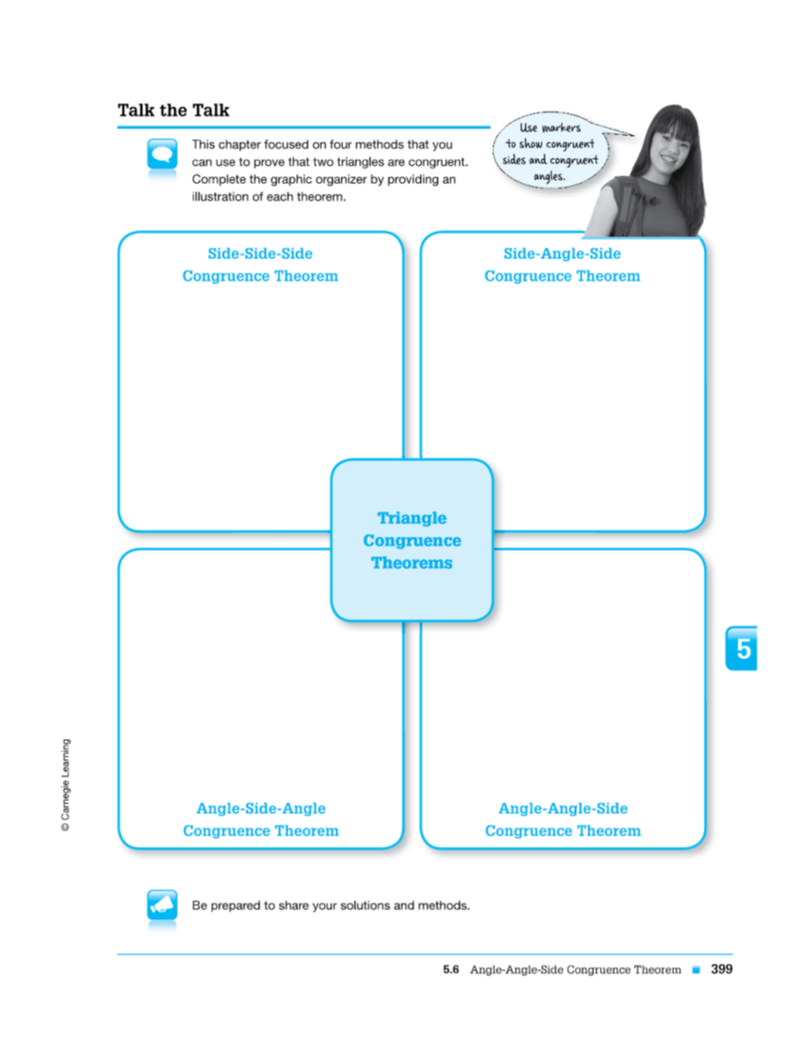

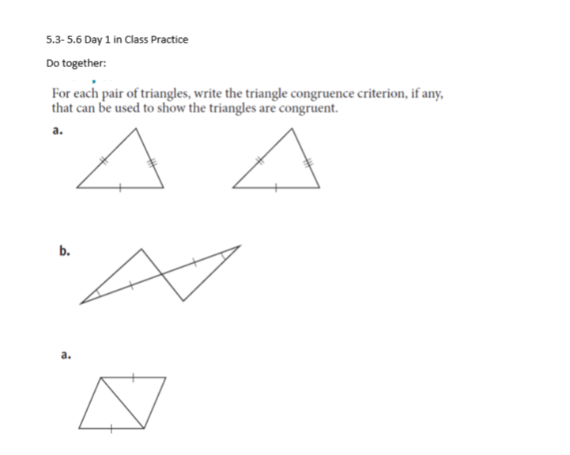

b. 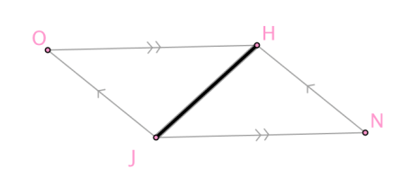

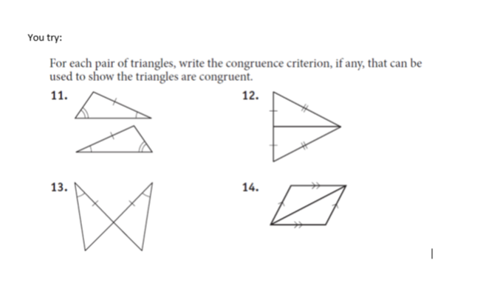

Geometry Unit 4 Day 3 SSS and SAS

Learning Target - Students will prove two triangles are congruent using SSS and SAS.

1. Two triangles are congruent. How many pairs of congruent parts exist?
2. Do you need to know that all of them are congruent before you can prove the two triangles are congruent?

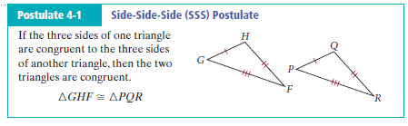

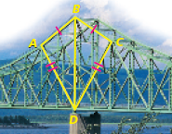

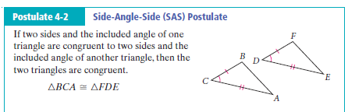

1. What is an included angle?

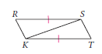

1. 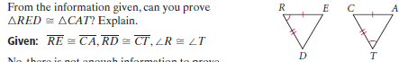

7.

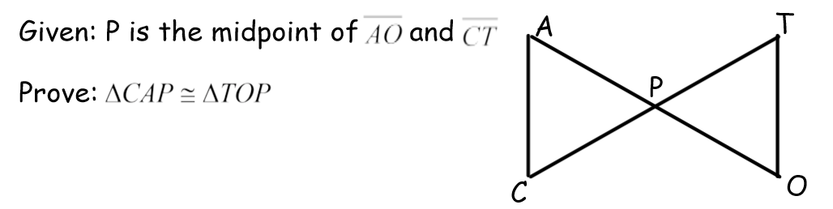

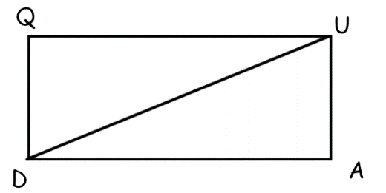8. Given $QU≅AD;QU∥AD$

Prove: $∆QUD≅ADU$

Geometry HW Unit 4 Day 3

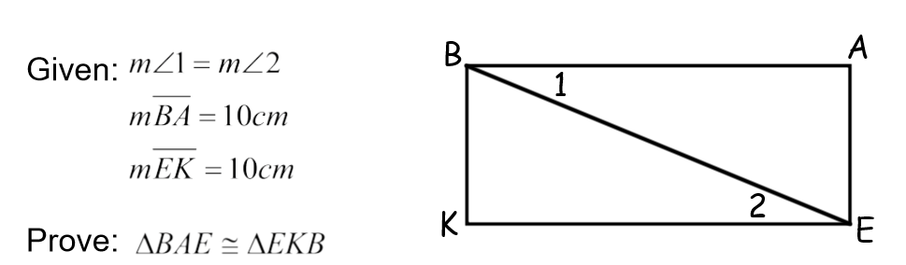

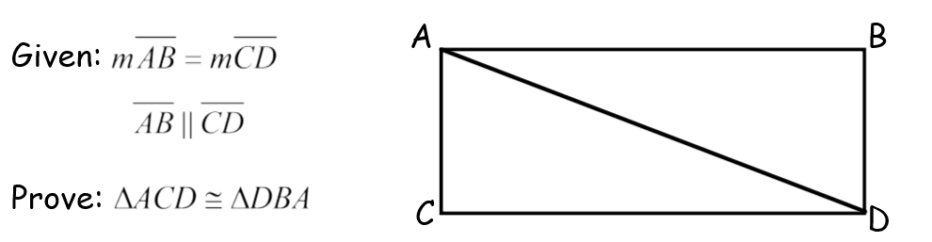

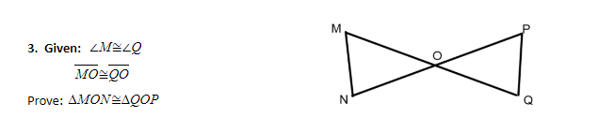

4.

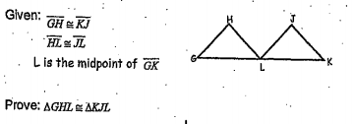

Geometry Unit 4 Day 4 Triangle Congruence by ASA and AAS

Learning Target – Students will prove triangles congruent by ASA and AAS.

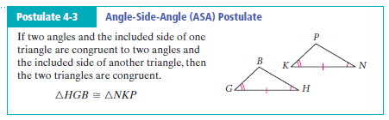

1. What is an included side?
2. 

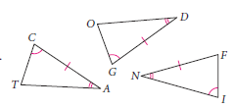

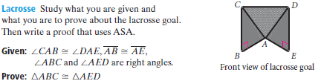

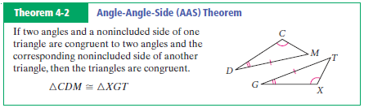

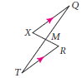

Geometry Unit 4 Day 4 HW

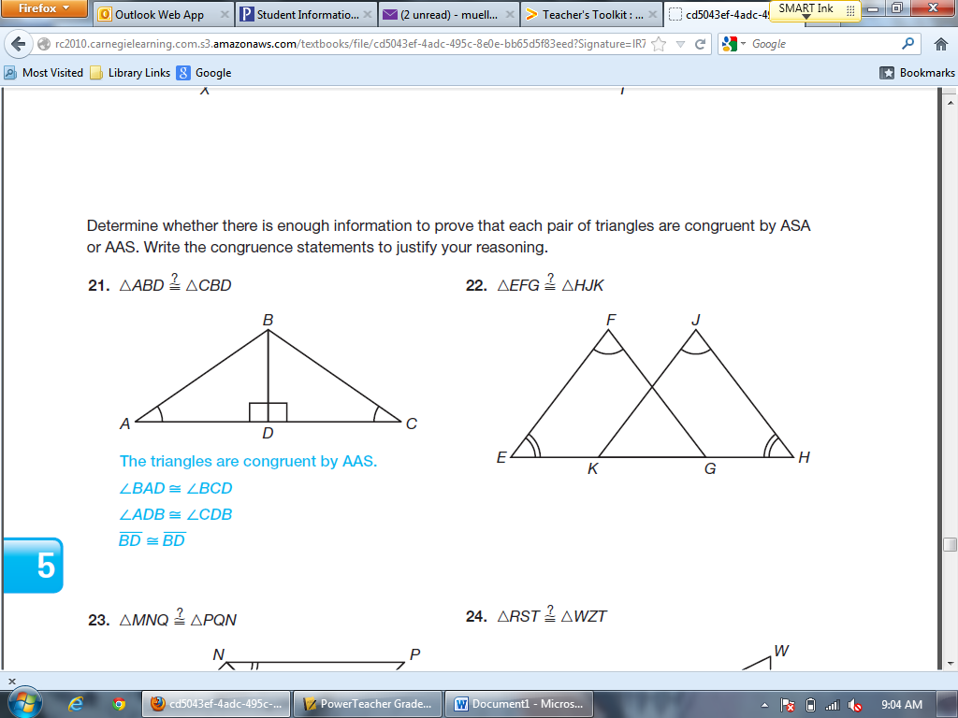

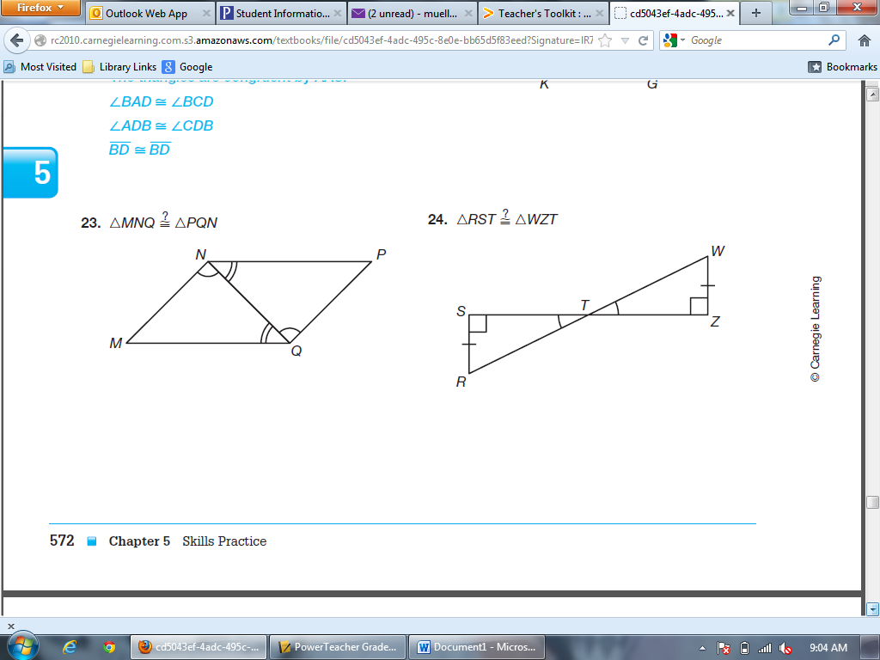

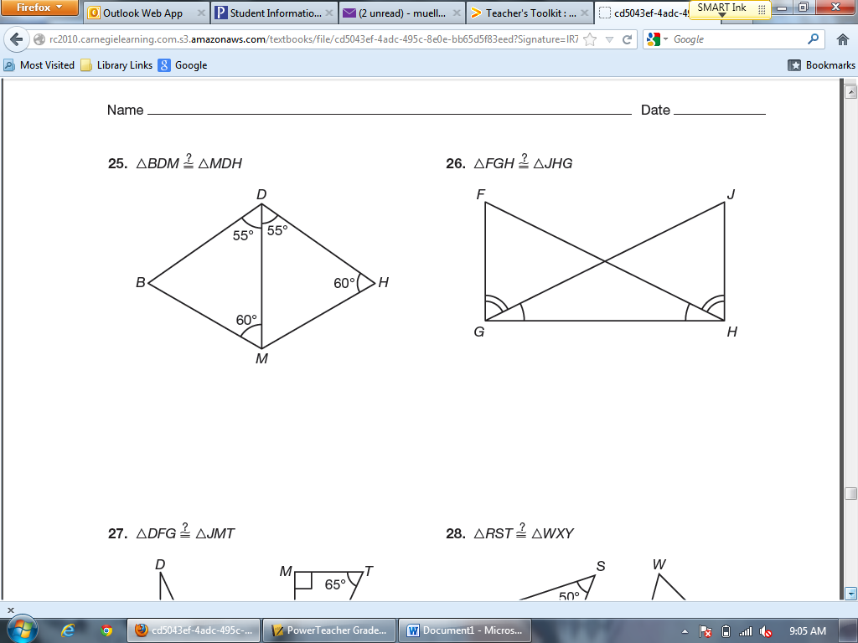

**For each question below:**

**a) State which triangle congruence method, if any, can be used to prove the**

**triangles are congruent. If none, write *none*.**

**b) *IF* the triangles are congruent, complete the congruence statement.**



**16.** **17.**

 

**18. 19.**

 

1. 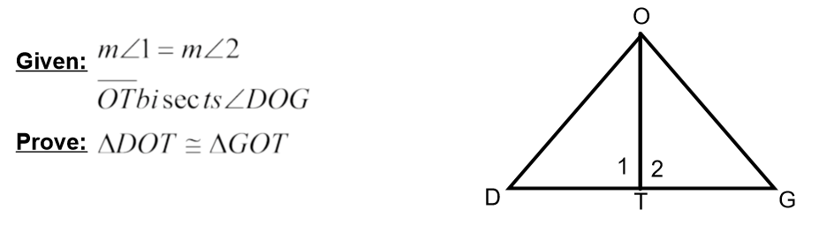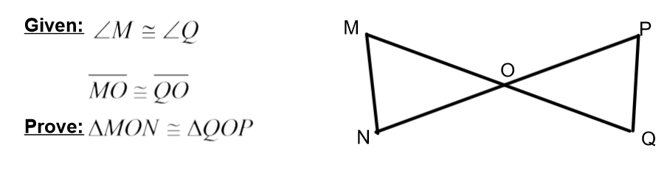

Geometry Unit 4 Day 6 CPCTC

Students will prove corresponding parts of congruent triangles are congruent.

* We have learned to use three pairs of corresponding congruent parts to show that two triangles are congruent.
* 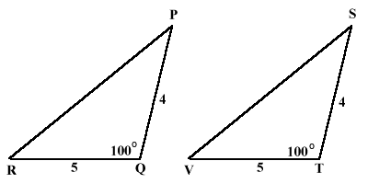Once we have proven the two triangles are congruent, we can conclude that their other three pairs of corresponding parts are congruent as well, this is called CPCTC.
* CPCTC – Corresponding Parts of Congruent Triangles are Congruent

1. How do you know the triangles are congruent?
2. Since the triangles are congruent, what else do you know is congruent?

3.

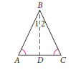4. 

1. Given: Circle M ; ZY $≅WX$

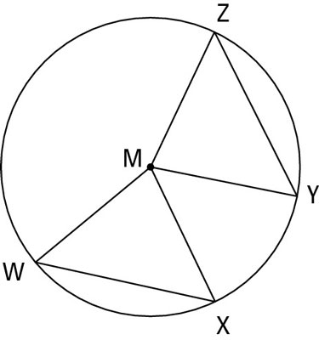Prove: $∆MZY≅∆MWX$

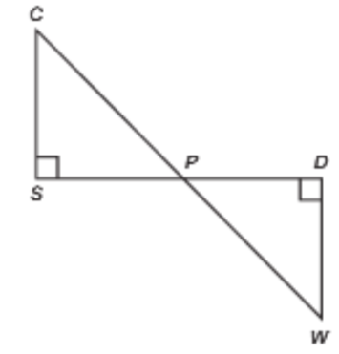Geometry Unit 4 Day 6 HW

1. 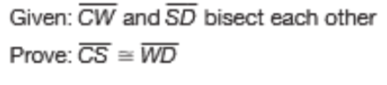

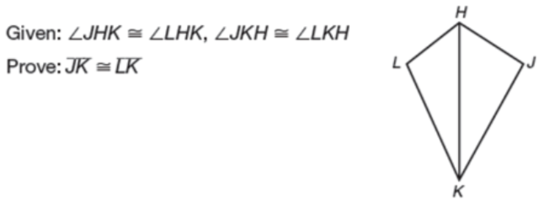

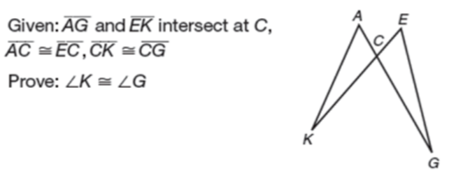

1. 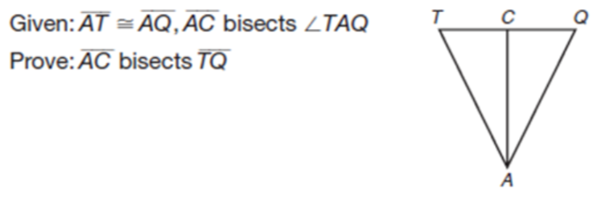

Geometry Unit 4 Day 7 Notes HL Theorem

Learning Target – Students will prove triangles congruent using the HL theorem.

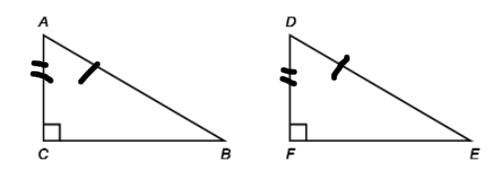We have already learned that the general case of SSA does not prove that two triangles are congruent. However, in the special case of a right triangle, this congruence criteria can work. It’s called HL (Hypotenuse-Leg).

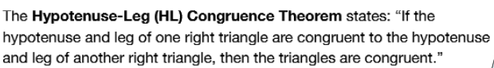

1. Can the pairs of triangles below be proven congruent by HL? If yes, write the congruence statement. If no, explain why not.
2. 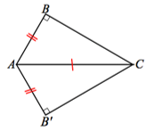 b. 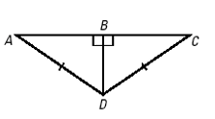

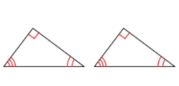c. 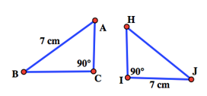 d.

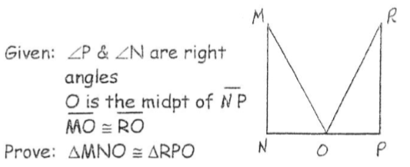

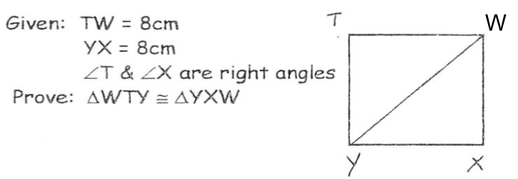

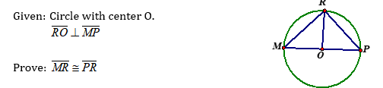

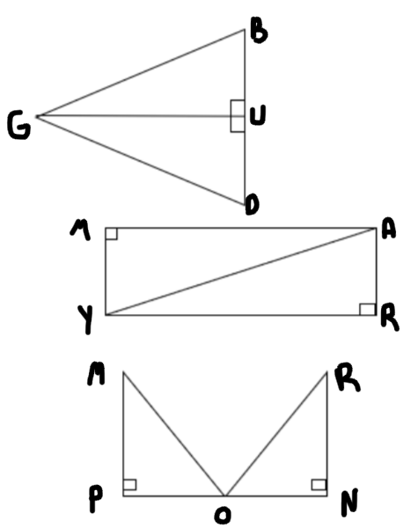Geometry Unit 4 Day 7 HW

1. **Given**: $\overline{GU}⊥\overline{DB}$

$\overline{GB}≅\overline{GD}$

**Prove**: $ΔGUD≅ΔGUB$

1. **Given**: $∠M and ∠R$ are right angles

$\overline{MY}≅\overline{AR}$

**Prove**: $∆MAY≅∆RYA$

**Given**: $∠P and ∠N$ are right angles

O is the midpoint of $\overline{NP}$

$$\overline{MO}≅\overline{RO}$$

**Prove**: $∆MNO≅∆RPO$

Geometry Unit 4 Day 10 Hinge Theorem and Triangle Inequalities

Learning Target – Students will explore the relationships between angles and sides in triangles.

In this lesson you will explore some angle and side relationships in triangles.

1. Explore the relationship between an angle of a triangle and a side opposite that angle.
   1. As Mrs. Blanton increases the size of the angle, what happens to the length of the third side of the triangle?

**The Hinge Theorem** – If two sides of one triangle are congruent to two sides of another triangle, and the included angle in the first triangle is larger than the included angle in the other triangle, then the third side of the first triangle is longer than the third side of the other triangle.

* 1. If another student in your class made a triangle with two sides the same length as the ones Mrs. Blanton used, but the included angle is smaller than the included angle in Mrs. Blanton’s triangle, what can you conclude about the third side of that student’s triangle compared to Mrs. Blanton’s triangle?

**The Converse of the Hinge Theorem** – If two sides of one triangle are congruent to two sides of another triangle, and the third side of the first triangle is longer than the third side of the other triangle, then the included angle in the first triangle is larger than the included angle in the other triangle.

* 1. Two students discussed their geometry assignment on the phone. Tony drew triangle ABC with AB=6cm, BC=10cm, AC=8 cm. Angelica drew triangle ABC with AB=6cm, BC=10cm and AC=11 cm. Using the converse of the Hinge Theorem, what conclusion can you draw about their triangles?

1. Exploring angles and sides within a triangle.
   1. Draw a scalene triangle. Label the vertex of the largest angle A, the vertex of the smallest angle, T and the third angle R. Measure all the angle measures and side lengths.
   2. What is the longest side of your triangle?
   3. What is the shortest side of your triangle?
   4. Compare your answers to parts b and c to your neighbor’s. What do you notice about the longest side compared to the largest angle in each of your triangles?
   5. Based on your results complete the **theorem** and it’s converse:

The longest side of a triangle lies opposite the angle with the ________________ measure and the shortest side lies opposite the angle with the ____________ measure.

Conversely, in a triangle, the angle with the greatest measure lies opposite the ________________ side and the angle with the least measure lies opposite the ______________ side.

1. Which side of the triangle is the longest? Shortest? How do you know?
   1. 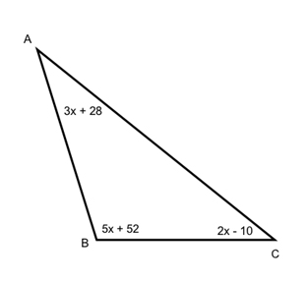 B.

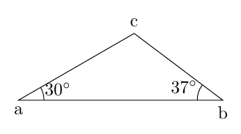

1. 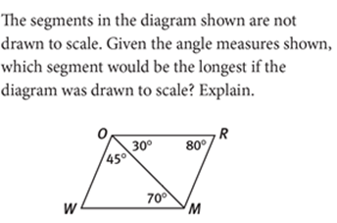
2. **The Triangle Inequality Theorem** – The sum of the lengths of any two sides of a triangle must be ___________________________________________________________.

ALL 3 sets of numbers must satisfy the rule

1. Example:

A. Can a triangle be formed with side lengths 3, 4, and 10?

B. Can a triangle be formed with side lengths 4, 10 and 12?

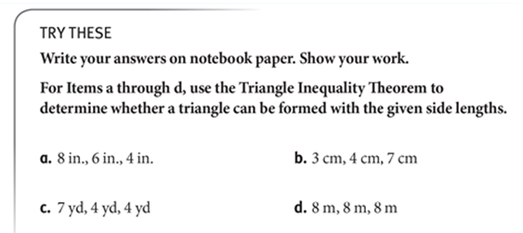

1. A triangle has sides of length 9 and 4. What are the possible lengths for the third side?

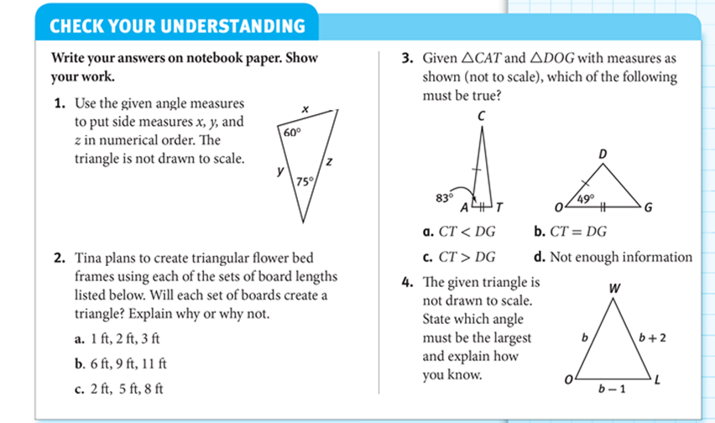

Geometry Unit 4 Day 10 HW 







Two sides of a triangle are given. Give the range of values that are possible for the length of the third side of the triangle.



Geometry Unit 4 Day 11 Triangle angle sum

Learning Target – Students will discover and apply the triangle angle sum theorem and triangle exterior angle theorem.

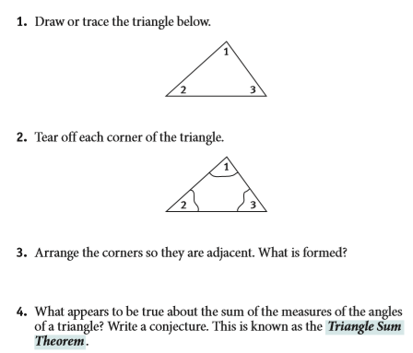

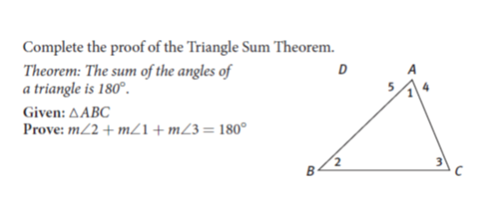5.

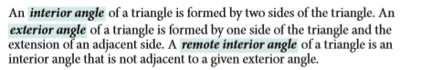

6.

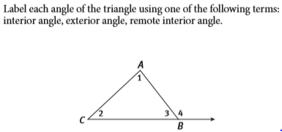

The Triangle Exterior Angle Theorem - the measure of an exterior angle of a triangle is equal to the sum of the measures of it's two remote interior angles.

7. Find the value of x.

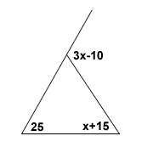a. b.

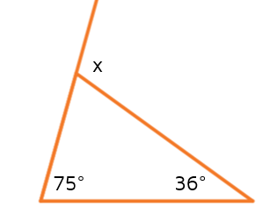

8.

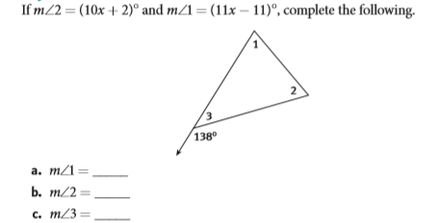

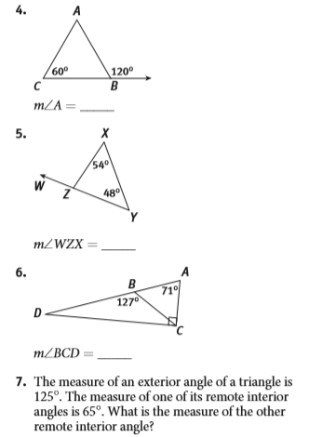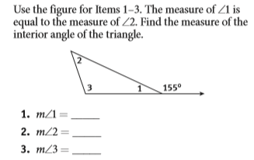Geometry Unit 4 Day 11 HW

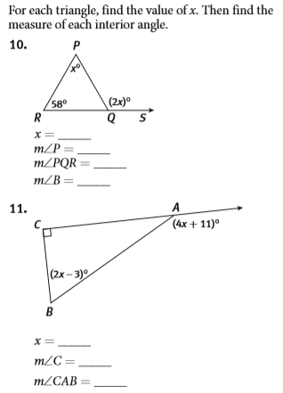Continued

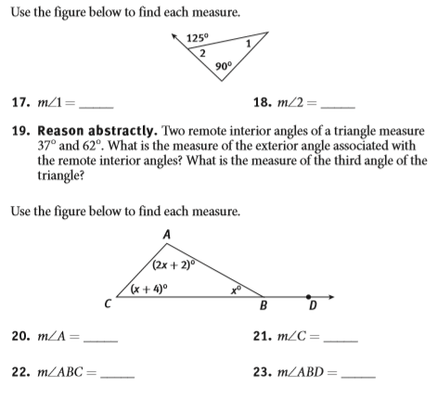

Geometry Unit 4 Day 12 Segments In Triangles

Students will identify and use the perpendicular bisector, altitude, median and angle bisector in a triangle.

4 types of segments in triangles

* Altitude – a segment from a vertex of the triangle, perpendicular to the opposite side.
* Median – a segment from a vertex of the triangle to the midpoint of the opposite side.
* Perpendicular bisector – a line or part of a line that is perpendicular to the side of a triangle, through the midpoint.
* Angle bisector – a line or part of a line that splits an angle of a triangle into two congruent parts.

1. Add the definition of each type of segment to your vocabulary.
2. Draw a triangle and a picture of each segment in your vocab. Be sure to mark the congruent parts.

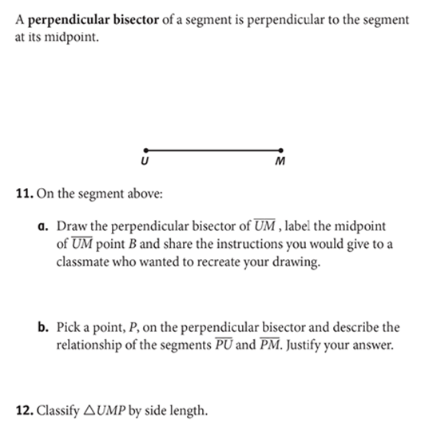

**13.** Add the **perpendicular bisector theorem** to your vocab.

If a point is on the perpendicular bisector of a segment, then it is equidistant from the endpoints of the segment.

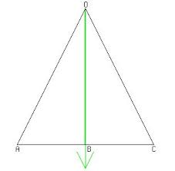Proofs using special segments

14. Given: OB is a median  
 OB is an altitude

Prove:

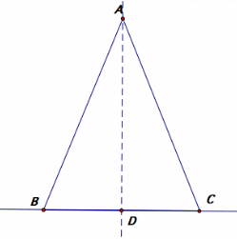

15. Given: AD bisects angle BAC

AD is an altitude

Prove: $AB≅AC$

Geometry Homework unit 4 day 12

1. 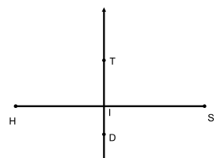

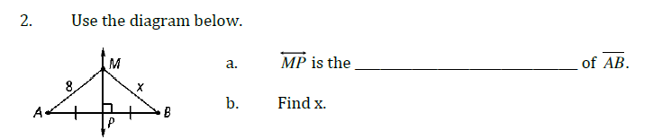

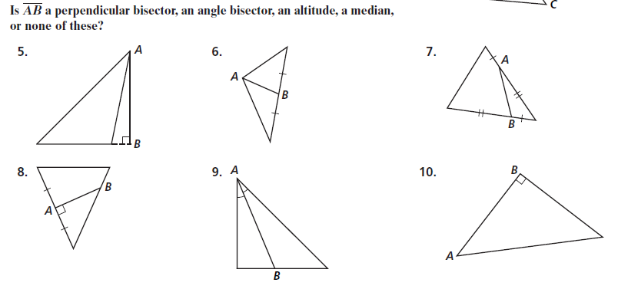

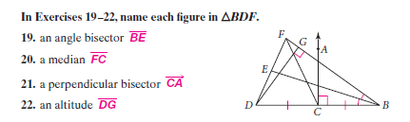



Geometry Unit 4 Day 13 Isosceles and Equilateral Triangles

Learning Target – Students will apply theorems about isosceles and equilateral triangles.

Isosceles

* Iso – Greek meaning same/equal. Skelos – Greek meaning leg.
* Isosceles Triangle - A triangle with at least two congruent sides.
* Leg - The sides that are congruent.
* Base - The noncongruent side.
* Base Angle - The angles adjacent to the base. These angles are opposite the pair of congruent sides.
* Vertex Angle - The angle included by the legs. It is opposite the base.

1. Mark to the triangle shown so that it is isosceles.
2. Mark the triangle shown so that it is isosceles in another way.
3. Label the names of the parts of the triangle so that it is isosceles.

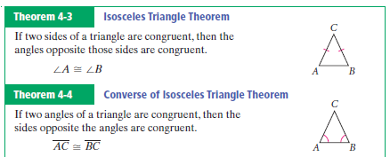

1. How are the two theorems above different?
2. Use the figure to the right for question 5.

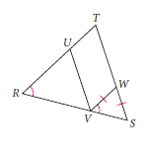





c. Can you deduce that triangle RUV is isosceles? Explain.

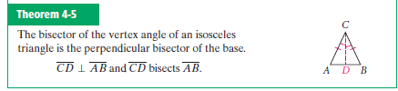

1. By drawing in the red segment, what have I created?
2. How do you know?
3. How could you use this knowledge to prove the isosceles triangle theorem?

9.

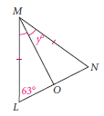 

10. An angle exterior to the vertex angle of an isosceles triangle measures 80 degrees. Find the angle measures of the triangle.

11. Mark the triangle so it is equilateral.

12. Based on what we just learned about an isosceles triangle, what can you conclude about the angles of an equilateral triangle. Justify your answer.

13. What is the measure of each angle in an equilateral triangle? Explain.

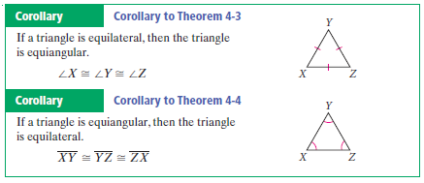

14. Given: AD is a perpendicular bisector.  
Prove: Triangle ABC is isosceles.  
 

Geometry Unit 4 Day 13 HW

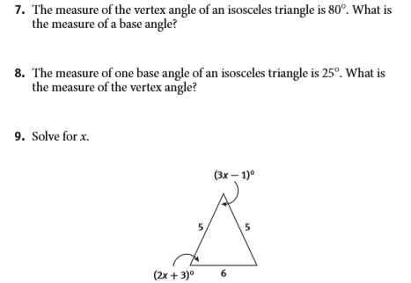

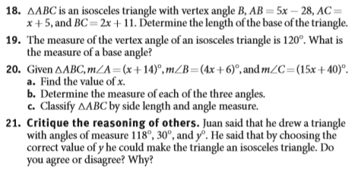

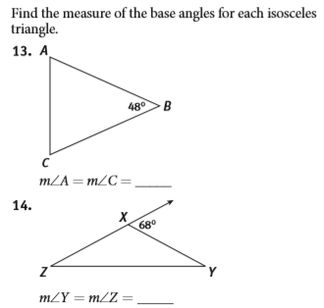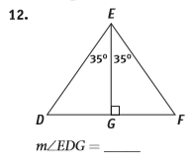

Geometry Unit 4 Day 14

* Draw, label and cut out a large scalene triangle, ABC. Name the angles on the inside, so you don’t cut them away when you cut the angle out. Label the largest angle C.
* Fold A onto C. What does the fold mark? Label this point L.
* Fold B onto C. What does the fold mark? Label this point N.
* Draw line LN.
* Fold the triangle on LN.
* Fold A to C.
* Fold B to C.
* How does line LN compare to line AB?
* Make a conjecture about how the segment joining the midpoints of the two sides of a triangle is related to the third side of the triangle.

Midsegment – segment of a triangle connecting the midpoints of the two sides.

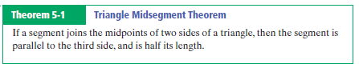

1. 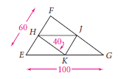

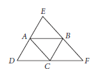

1. 
2. Justify your thinking.
3. What can you conclude about angle EBA and angle BFC? Justify your thinking.

Geometry Unit 4 Day 14 HW

Honors Geometry Homework Midsegments

Show all work for credit

Find the value of x. 



Find the value of each variable for 32, and 33.





hints – slope ,midpoint, distance

