Geometry Unit 3 proofs practice day
For numbers 1-3, write a two column proof for each.
- Given:
Prove: x=10
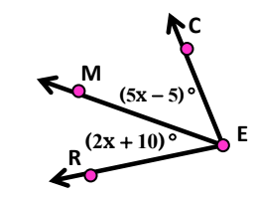

- Given: 5x + 3(x+4) = 28
Prove: x = 2

- Given: 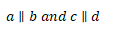
Prove: $∠4≅∠10$
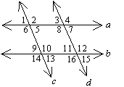
Identify the property for each statement below.
- $If a=b, then b=a.$
- $If AB≅CD, and CD≅LM, then AB≅LM.$
- $CM≅CM$
- $If 3x+4=34, then 3x=30.$

Review
- For the following conditional state each of the following:
If two lines intersect at right angles, then they are perpendicular.
- Converse:

- Inverse:
- Contrapositive:
- Can a biconditional be formed? Explain. Write the biconditional if it can be formed.
- Identify the hypothesis and conclusion in the conditional below.
If it rains today, then practice will be cancelled.

- Give a counterexample to the following:
If you have visited Texas, then you have been to Texas.

- Write in if- then form.
All squares have four 90 degree angles.

