Geometry Unit 3 Day 1

Learning Target – Students will use inductive reasoning to make conjectures and deductive reasoning to draw conclusions.

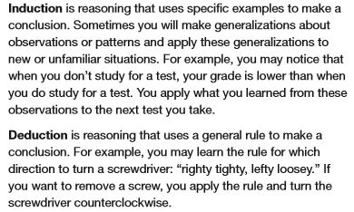

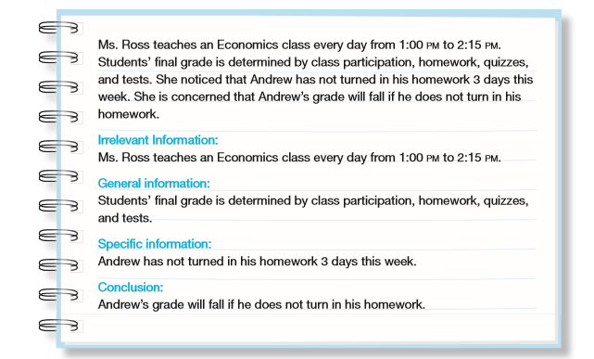



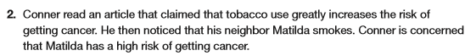

a. What was Conner’s conclusion?

b. Did Conner use inductive or deductive reasoning? Explain.

c. Is Conner’s conclusion correct? Explain your reasoning.



1. Did Molly use inductive or deductive reasoning? Explain.
2. Is Molly’s conclusion correct Explain your reasoning.

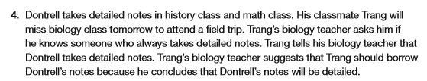











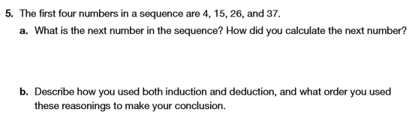

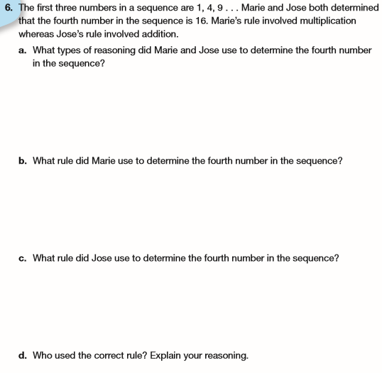

Geometry Unit 3 Day 1 HW

2.1 Homework

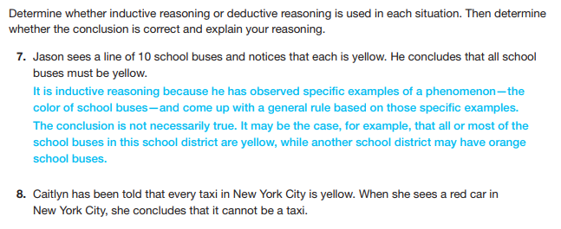

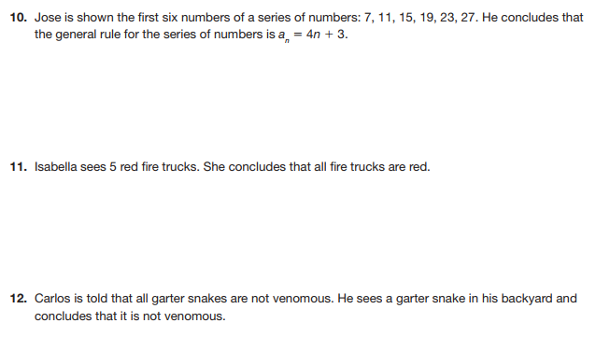

continued on next page

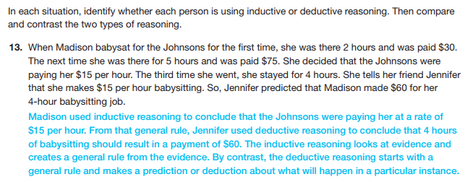

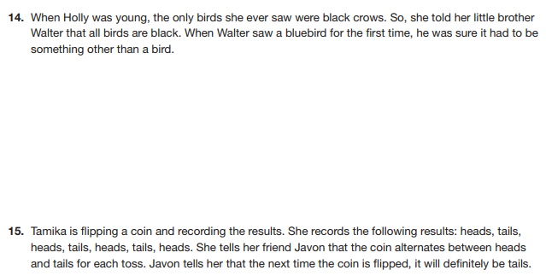

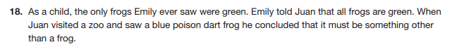

Geometry Unit 3 Day 2 Two Column Proofs

Students will use deductive reasoning and properties to write algebraic two column proofs.

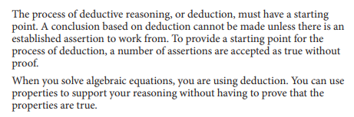







1. Using one property per step, show how to solve the equation $6-x=5x+30.$ Name each operation or property used to justify each step.

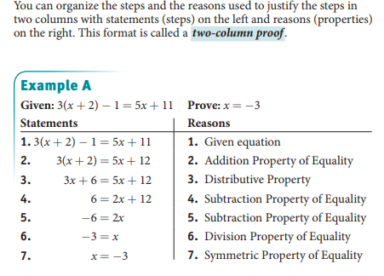

1. Write a two column proof for the following.

Given: $2x-20=40-3x$  
Prove: $x=12$

1. Write a two column proof for the following:

Given: $4x+9=18-\frac{1}{2}x$ 
Prove: $x=2$

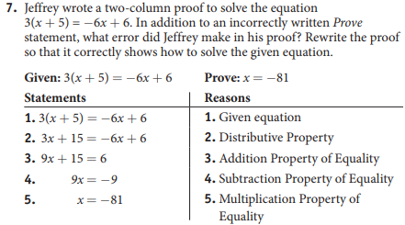

Practice:

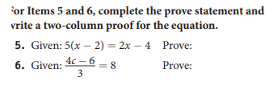

Geometry Unit 3 Day 2 HW

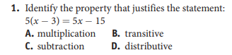

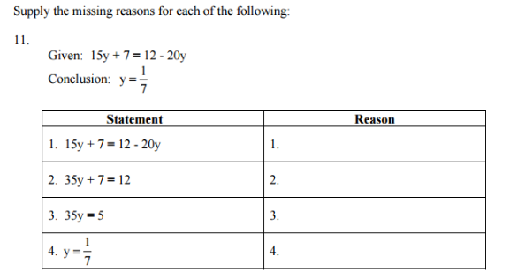

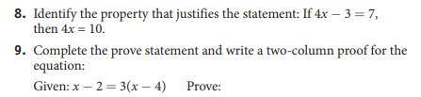

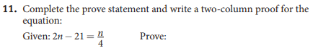

Continues

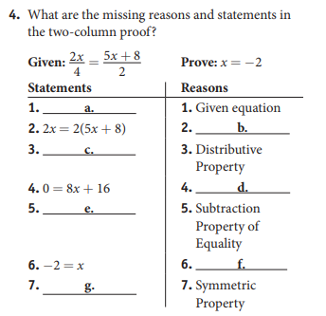

Geometry Unit 3 Day 3 More Two Column Proofs

Learning Targets – Students will use algebraic and geometric concepts to write two column proofs.







Relationships



State whether each relationship is reflexive, symmetric, transitive, or none of these.

1. Is taller than
2. Is equal to
3. Is congruent to
4. Lives in a different state than.
5. Is the same height as.

Geometry Unit 3 Day 3 HW

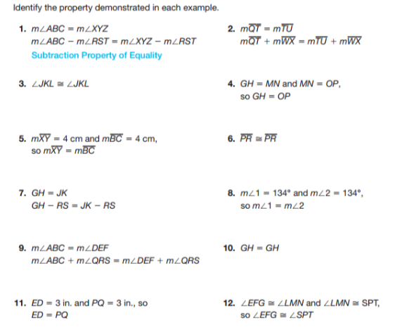

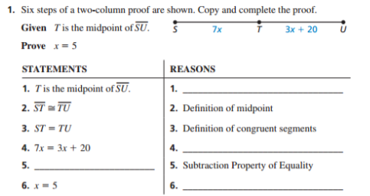

Continued on next page

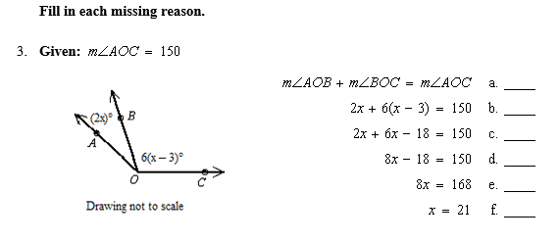

Geometry Unit 3 Day 5 Conditional Statements and counterexamples

Learning Target – Students will identify the hypothesis and conclusion of a conditional statement and give a counterexample for a false conditional statement.

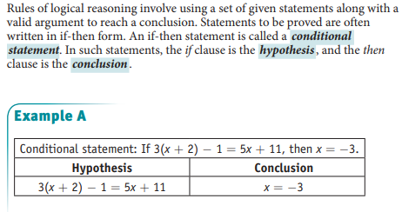

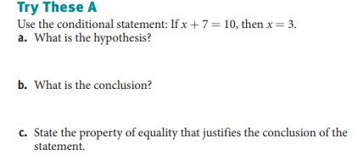

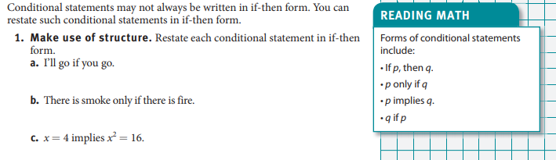

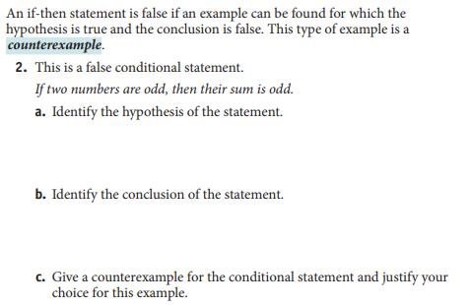

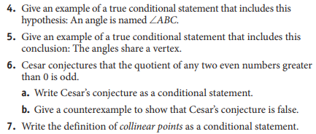

Geometry Unit 3 Day 5 Homework

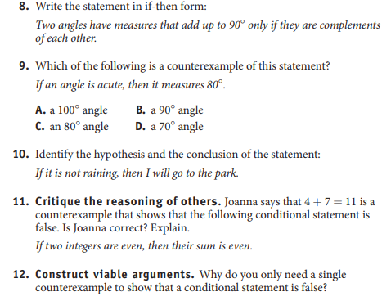

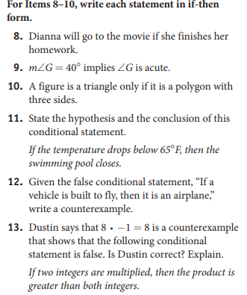

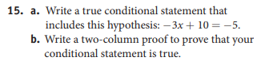

Geometry Unit 3 Day 6 Converse, Inverse, and contrapositive

Learning Target – Students will write the converse, inverse and contrapositive of a conditional statement. Students will write and interpret biconditional statements.

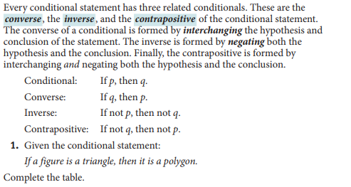

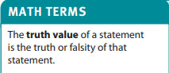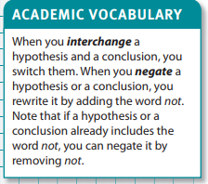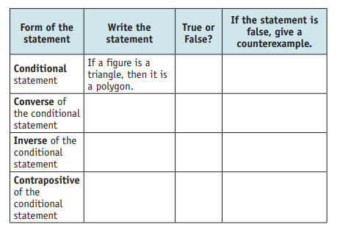

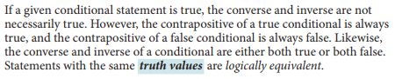

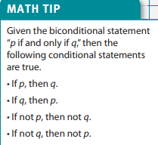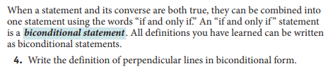

5. Consider the statement: Numbers that end in 2 are even.

a. Rewrite in if-then form and state whether it is true or false.

b. Write the converse and state it’s truth value

c. Write the inverse and state it’s truth value.

d. Write the contrapositve and state it’s truth value.

e. Can the conditional statement be written as a bi-conditional? Why or why-not?

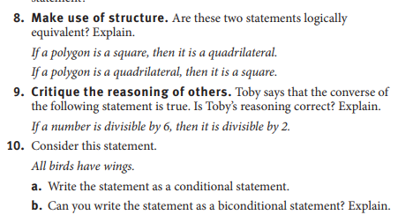

Geometry Unit 3 Day 6 HW

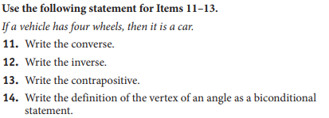

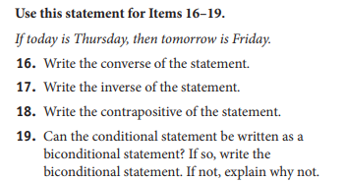

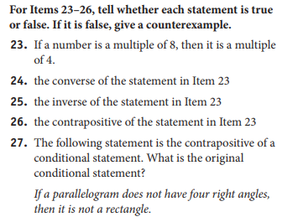

Geometry Unit 3 Day 8 Proofs about Segments and Angles

Learning Target – Students will write two column geometric proofs about segments and angles.

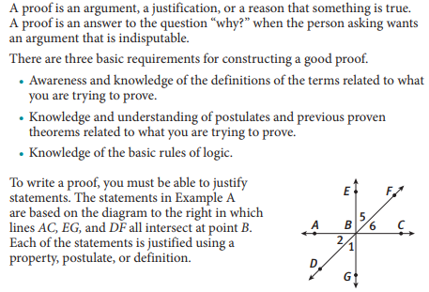

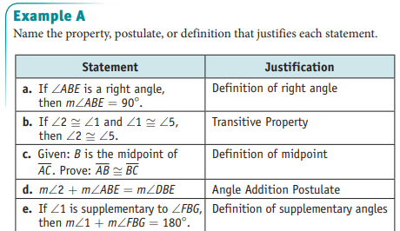

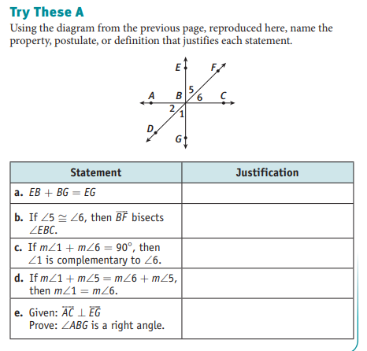

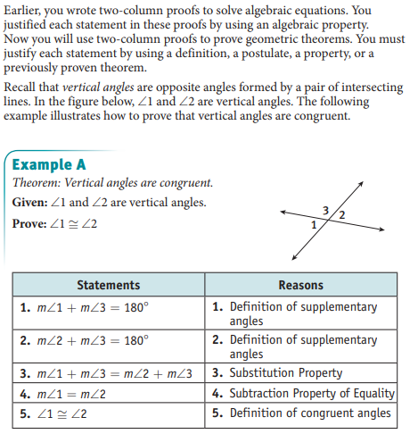

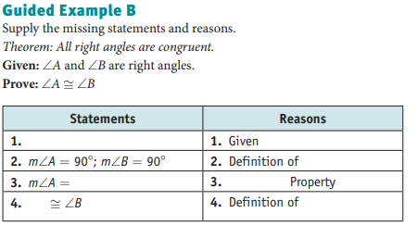

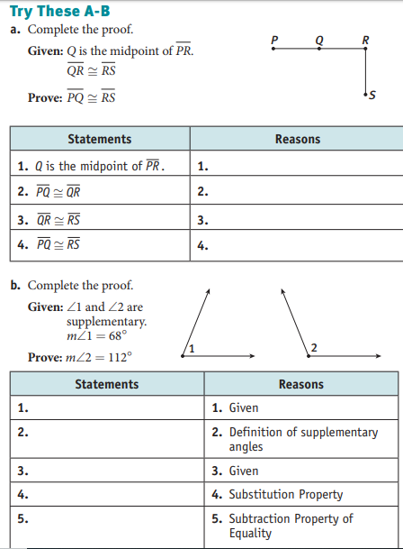

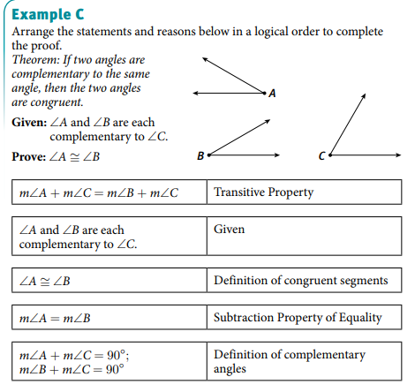

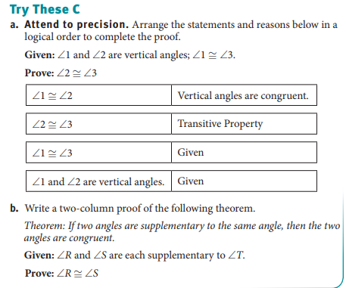

Geometry Unit 3 Day 8 Homework

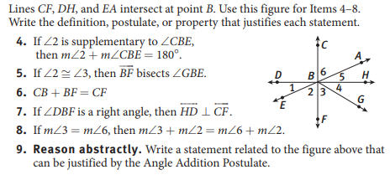

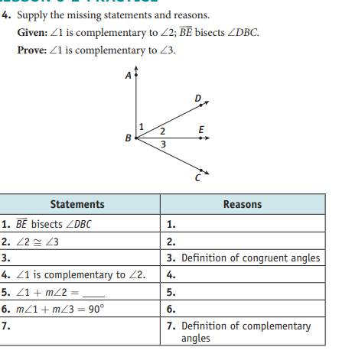

Continued

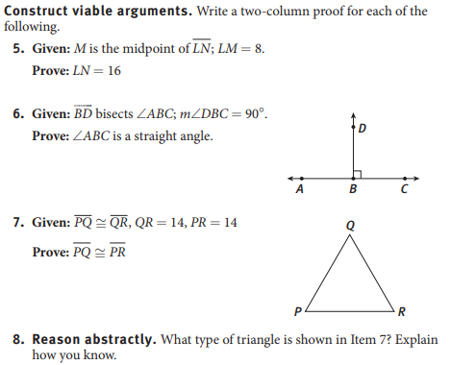

Geometry Unit 3 day 11 and 12 Parallel Lines and Transversals

Learning Target – Students will identify angle pairs formed by parallel lines and transversals and use their relationship to find angle measures.

A transversal is a line that intersects two coplanar lines at two distinct points. Pairs of the 8 angles formed have special names suggested by their positions.

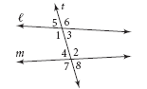

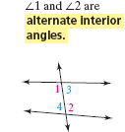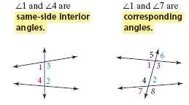

1. Name another pair of each type of angle shown in the diagram.

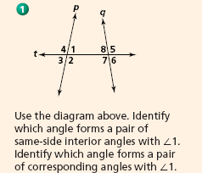

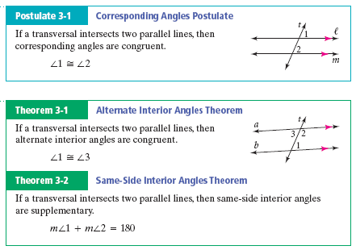

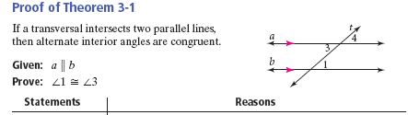

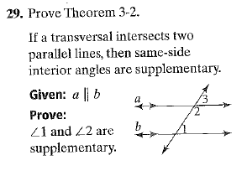

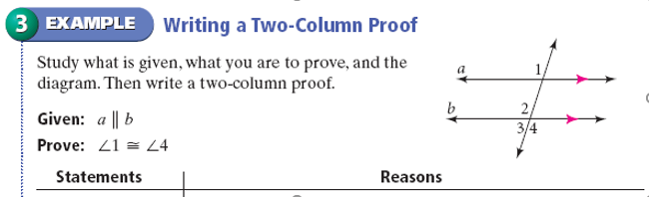

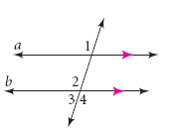

* 1 and 4 are alternate exterior angles.
* 1 and 3 are same side exterior angles.

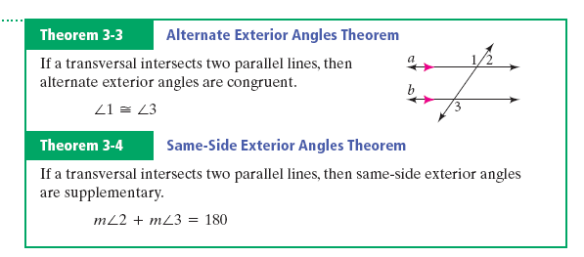

1. 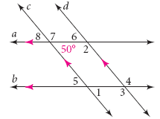Find the measure of each angle in the diagram. Name the theorem or postulate that justifies your answer and the angle it pairs with.
2. Find the values of x and y. Find the measure of each angle. 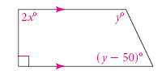

Geometry Unit 3 Day 11 and 12 Homework

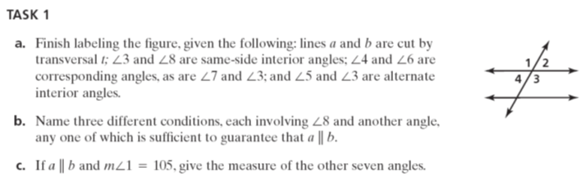

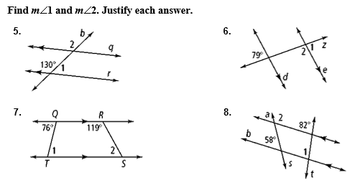

True or False?



Geometry Unit 3 Day 13 Converses

Learning Target – students will use the converses of postulates and theorems about angle pairs and transversals to prove lines are parallel.

1. Write down the converse of each of the following:
   * The corresponding angles postulate
   * Alternate Interior Angles Theorem
   * Same Side interior angles theorem
2. How is the converse different from the original?
3. How could it be used?

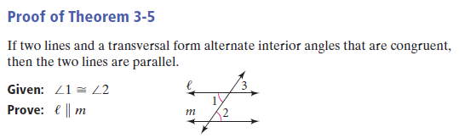

1. 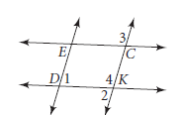
2. 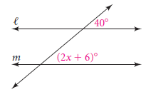
3. 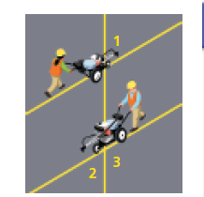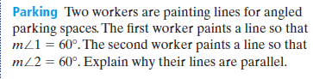

Geometry Unit 3 Day 13 HW

Parallel Lines and Transversals



**Given**

1)  True or False

2)  and .

.

3)  True or False

4) 

**Given**

5) Name a pair of alternate interior angles on transversal *t*.

6) Name a pair of corresponding angles on transversal *n*.

8)  True or False

9) and , find *x*.

10)  Find each angle and justify your answer:







Geometry Unit 3 Day 14 Writing proofs with parallel and perpendicular lines.

Use the picture for questions 1-4.

1. Given: $f∥g, m∥n$

Prove:



16

2. Given:f∥g,m∥n

Prove:∡4≅ ∡16

3. Given:f∥g,m∥n

Prove:∡7 is supplementary to ∡13

4. Given:f∥g, :∡8≅ ∡13

Prove: m∥n

Geometry HW Day 14

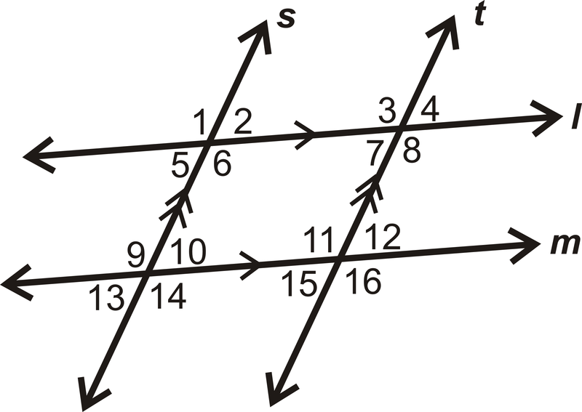Use the picture for questions 1-4.

1. Given:

Prove:

2. Given: s∥t, m∥l

Prove:∡1≅ ∡16

3. Given: s∥t, m∥l

Prove:∡5 is supplementary to ∡11

4. Given: s∥t, :∡8≅ ∡14

Prove: m∥l