Geometry Unit 3 Day 11 Proofs
Questions to ask when writing a proof.
- What is the same?
- Is there a key word? Between, midpoint, bisector, or perpendicular
- Do I need a diagram?
- What can I take from the diagram?
Between
Midpoint
Bisector
Perpendicular
Things you can use from a drawing:
A. reflexive property
B. Segment Addition
C. Angle Addition
D. Vertical Angles
E. Labeled parts (right <)
F. Linear Pairs
Write a two column proof for each.
1.
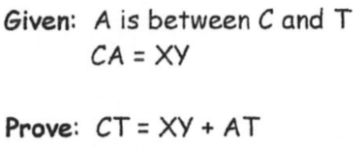
2.
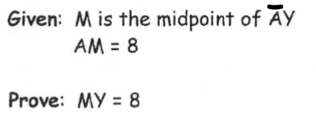

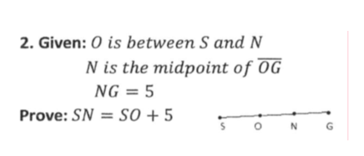
3.

4.
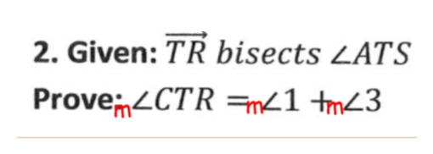

- Given: $∠A and ∠B are Complementary.$
$∠A and ∠K are Complementary.$
Prove :$∠B≅∠K$

