Geometry Unit 2 Review
- What point is collinear to C and D?
E
A
F
D
B
G
C
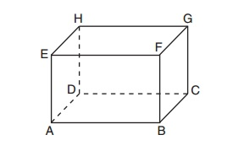
2. State the intersection of plane HGCD and plane ABCD

3. What lines are skew to AD? (There are four)

4. How many points does it take to create a line? How many points does it take to create a plane?

5. Draw a rectangular plane ABC
6. Draw line $\overset{⃡}{RS}$
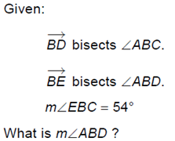
7.
48°

8. What is the difference between a line, a segment, and a ray? Draw line XY, segment XY, and ray XY. Name them using the correct notation.

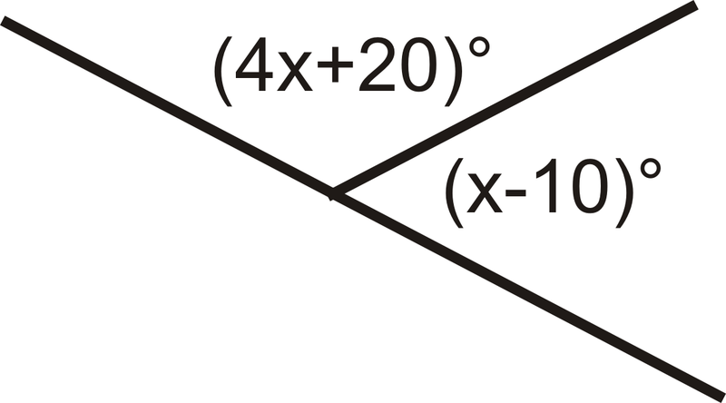
9. Find x then find each angle measurement. 10. Find y then find each angle measurement (including the non-labeled angles)
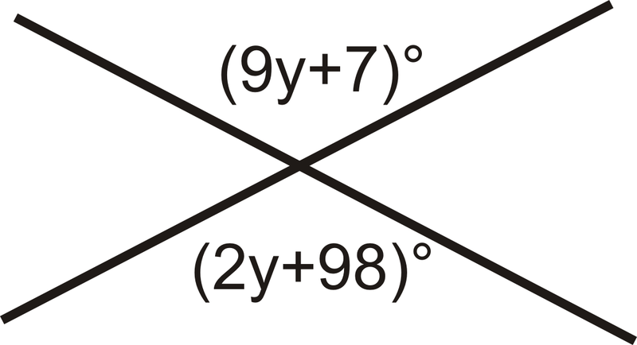

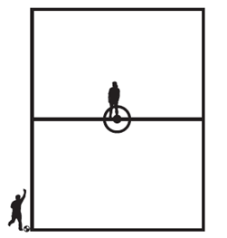
- The dimensions of a soccer field are 76 yards by 120 yards. A player kicks the ball from a corner to her teammate in the exact center of the field. What is the distance, to the nearest yard, the ball travels?

- A high school basketball team is going to Cleveland to see a NBA game. A coordinate grid is superimposed on a highway map of Ohio. The high school is at point (2, 4) and Quicken Loans Arena is at the point (7, 1). The map shows a highway rest stop halfway between the cities. What are the coordinates of the rest stop? What is the approximate distance between the high school and the stadium? (One unit ~ 3.7 miles)

- On the $(x,y)$ coordinate plane, $∆ABC$ has coordinates $A\left(-7, 5\right), B\left(-2, -2\right), C\left(1,3\right)$. What is the length of the segment that joins vertex A with the midpoint of $\overline{BC}$? Round to the nearest tenth.

- $M$ is the midpoint of $\overline{AB}$ for the points A(4, -3) and B(-6, 5). Find $MB$. Round to the nearest tenth.

- Angle A and Angle B are supplementary. If angle A =x, what is the measure of angle B in terms of x?

- 4 times the measure of the supplement o an angle is 100 degrees more than 9 times the measure of the angle’s complement. Find the measure of the angle, it’s complement, and it’s supplement.
- Draw each of the following.
$\overline{AB}$
$\overset{⃡}{AB}$
$\vec{AB}$
$\vec{BA}$

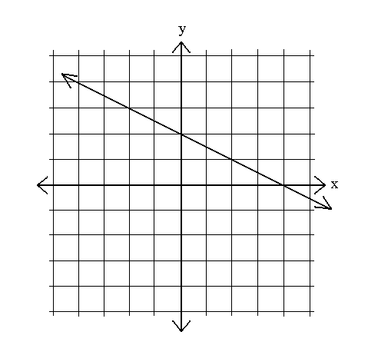
Chapter 1 review – 2 questions from chapter 1 will show up on the chapter 2 test!
- Write the equation of the line in
- slope-intercept form
- standard form.

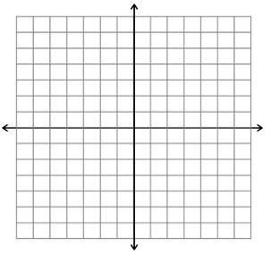
- Graph the equation 3x+6y=18. Identify the intercepts.
x- intercept ______
y- intercept _____

Write definitions of the following in your own words.
- Adjacent Angles
- Angle
- Bisect
- Collinear
- Complementary Angles
- Coplanar
- Line
- Noncollinear
- Noncoplanar
- Plane
- Point
- Ray
- Segment
- Supplementary Angles
- Vertical Angles

