Geometry Unit 2 Day 1 Notes Naming Geometric Figures
Learning Target – Students can identify and name points, lines, planes, line segments, rays and angles using correct notation.
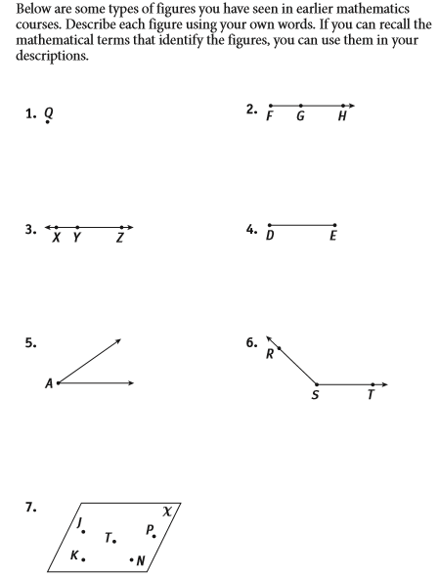
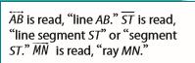
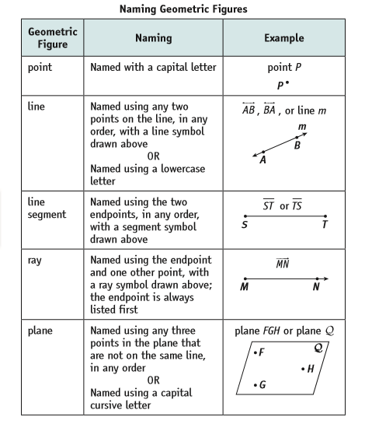
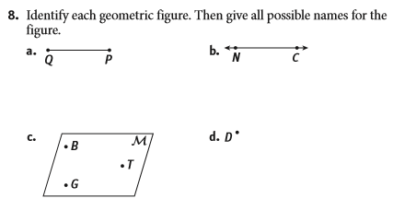
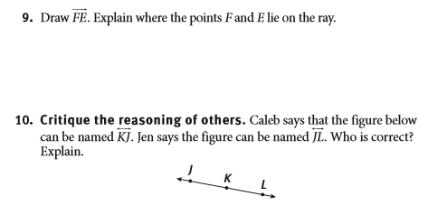
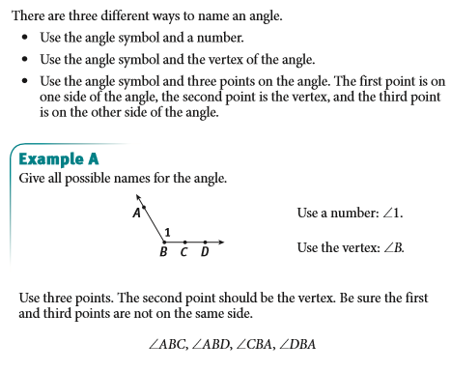
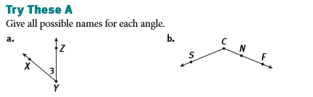

Geometry Unit 2 Day 1 HW
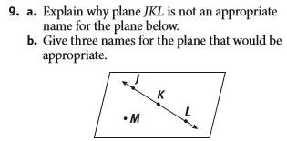
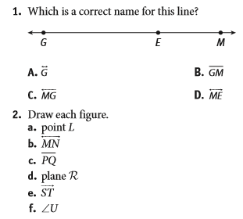

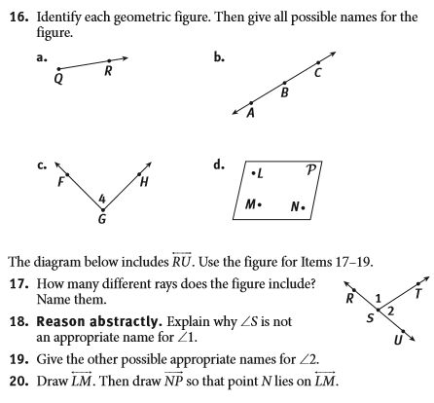

Geometry Unit 1 Day 2 Angles and Angle Pairs
Learning Target: Students will describe and draw angles and angle pairs. Students will identify circles and their parts.
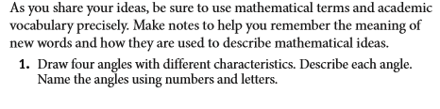

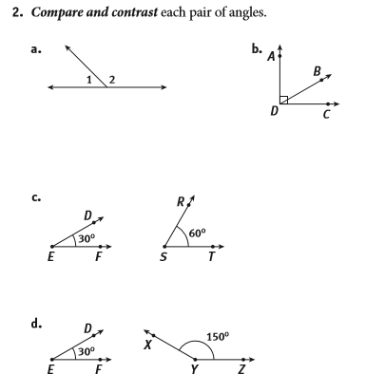
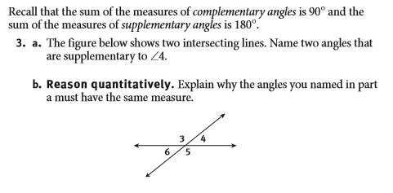
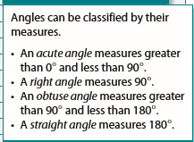
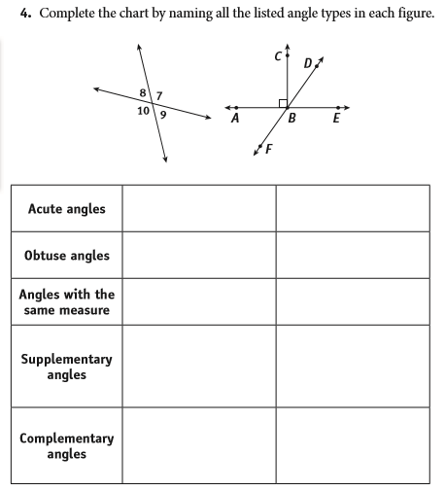

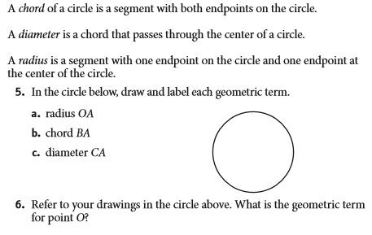

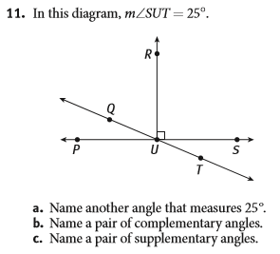
Geometry Unit 2 Day 2 HW
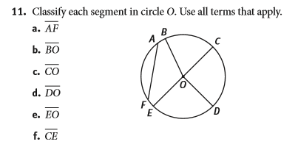

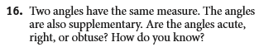
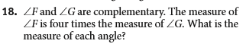
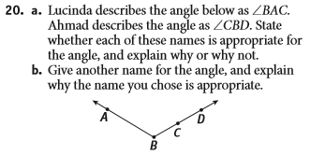
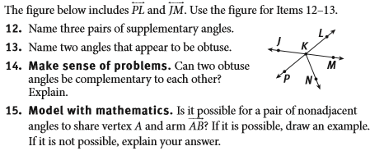

Geometry Unit 2 Day 3 The axiomatic system of Geometry
Learning Target – Students will distinguish between defined and undefined terms.
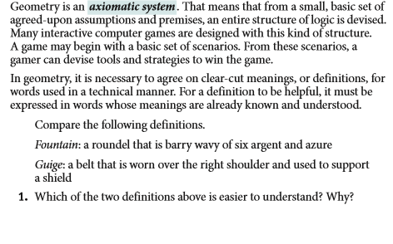
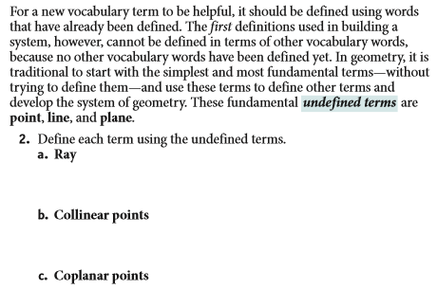

***Vocab reinforcement activity

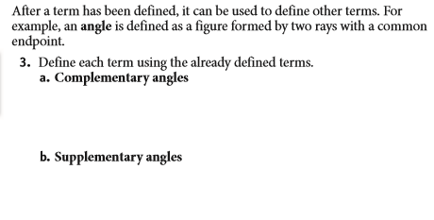
- Make a Conjecture – How many lines can be drawn between 2 points? Justify your thinking.
- Make a conjecture: If two lines intersect they intersect in a __________________. Justify your thinking.
- Make a conjecture: If two planes intersect, then they intersect in a ______________. Justify your thinking
- Make a conjecture: Through any ________ noncollinear points there is exactly one plane. Justify your thinking.
Skew lines are lines that are in different planes and never intersect. The difference between parallel lines and skew lines is parallel lines lie in the same plane while skew lines lie in different planes. In the diagram below, CB and DH are parallel, but CB and GE are skew.
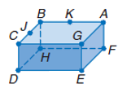
- Name the intersection of Plane CGE and AGF.
- Name the intersection of segment CG and GA.
- Name two line segments that are parallel to segment GE.
- Name a line segment that is skew to BA.
- Name two planes that are parallel.

Homework Unit 2 Day 3
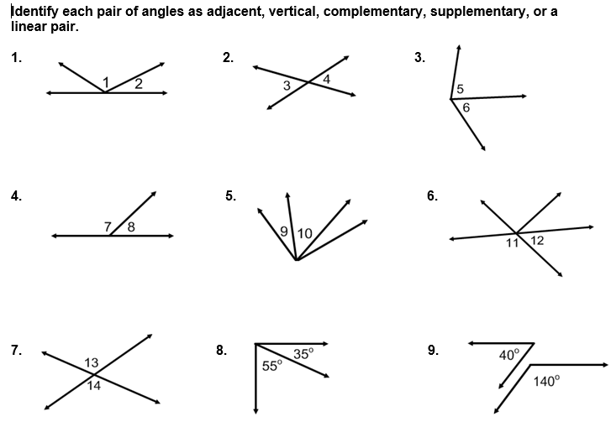
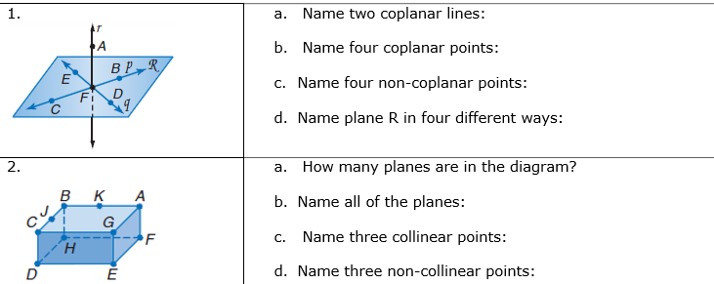
Continues on next page!
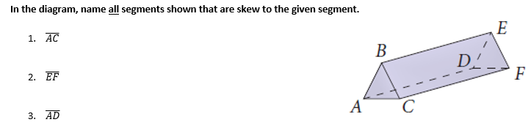
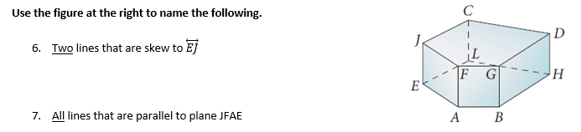

Geometry Unit 2 Day 4 Segment Addition Postulate and Midpoints
Learning Target – Students will use the segment addition postulate and the definition of midpoint to find lengths of segments
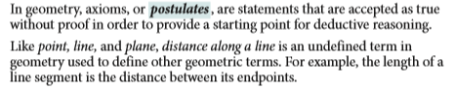
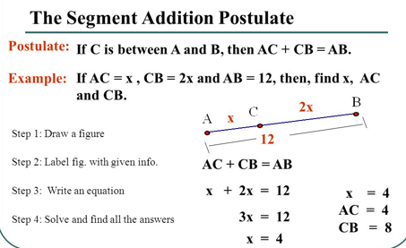

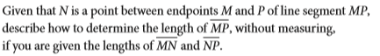

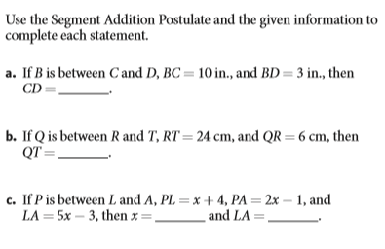
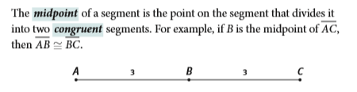
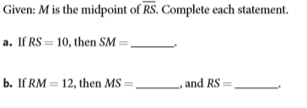

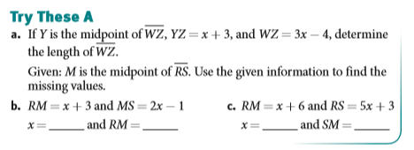

Geometry Unit 2 Day 4 Homework
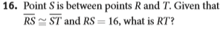
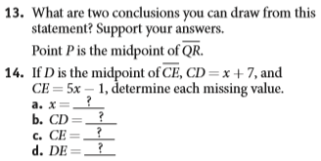
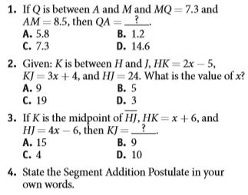
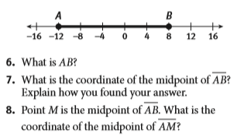

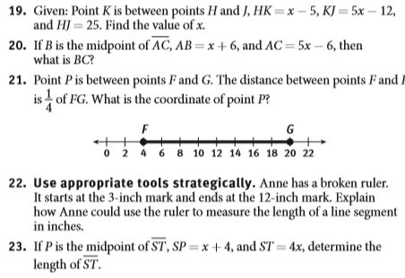

Geometry Unit 2 Day 5 Finding Angle Measures.
Learning Target – Students will use the Angle Addition Postulate and definition of definition of bisect, complementary, supplementary, and vertical angles to find angle measures.
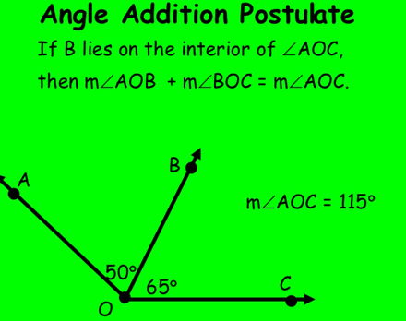

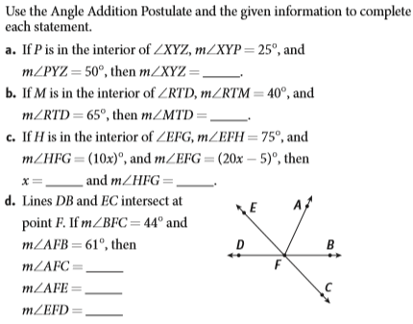

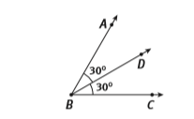
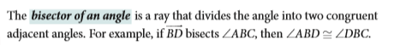

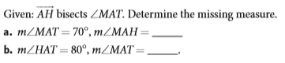

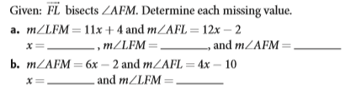

- 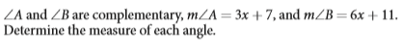

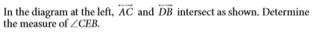
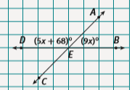
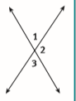
- Use the picture to answer the questions. Angles 1 and 3 are vertical angles. Vertical angles have the same measure.
Find $m∡2.$

- A. an angle measures x degrees, write an expression for the measure of it’s compliment.
B. an angle measures x degrees, write an expression for the measure of it’s supplement.
C. two times the measure of the supplement of an angle is sixty degrees more than four times the measure of the angle’s complement. Find the measure of the angle, its complement, and its supplement.

Geometry Unit 2 Day 5 HW
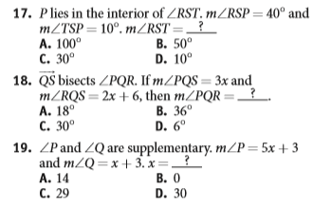
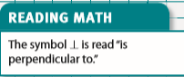
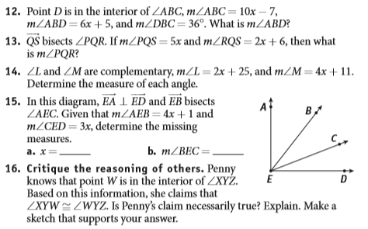
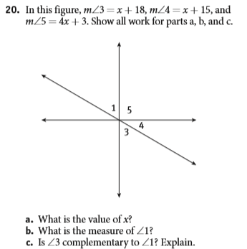

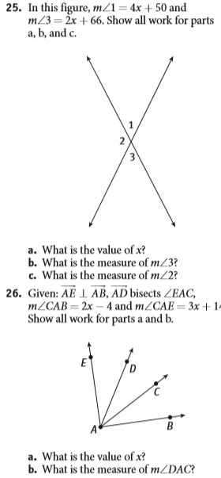

27. Two times the measure of the supplement of an angle is 100 degrees more than three times the measure of the angle’s complement. Find the measure of the angle, its complement, and its supplement.

Geometry Unit 2 Day 6 Pythagorean Theorem and Distance Formula
Learning Target – Students will derive the distance formula and use it to find the distance between two points on a coordinate plane.
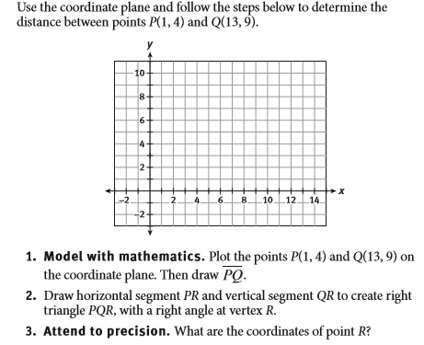
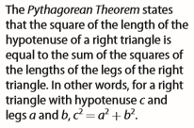
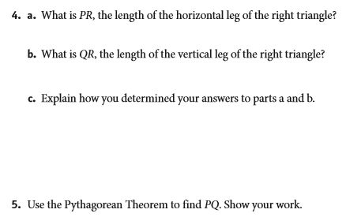

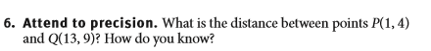
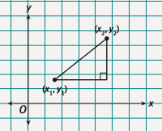
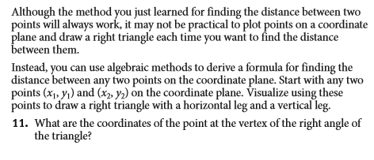
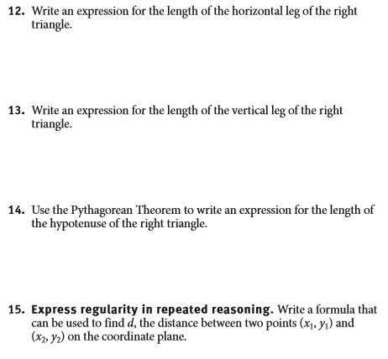
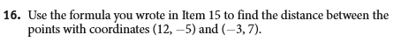

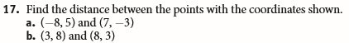

Geometry Unit 2 Day 6 HW
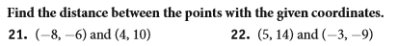
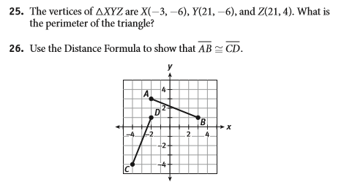
27.
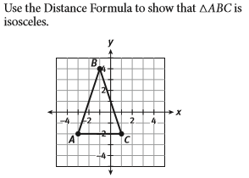

Geometry Unit 2 Day 7 Midpoint Formula
Learning Target – Use the midpoint formula to find the coordinates of a midpoint on the coordinate plane.
- Define midpoint.
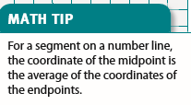
- Write a formula that could be used to find the midpoint between two points A($x_{1},y_{1}) and B\left(x_{2},y_{2}\right).$

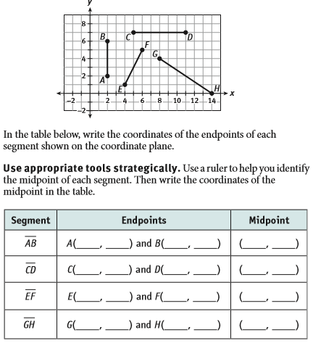
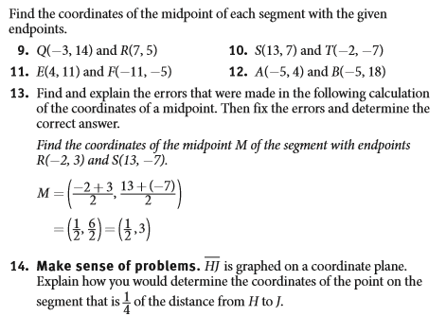
15. 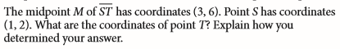

Geometry Unit 2 Day 7 HW
