Geometry Unit 2 Midpoint and Distance problem solving practice
- M is the midpoint of $\overline{XY}$ for the points X(4,-1) and Y(2,-5.)
  - Find the coordinates of M.
  - Find MX.

- In the triangle below, M is the midpoint of AB. Find the length of the segment that joins vertex C with M.
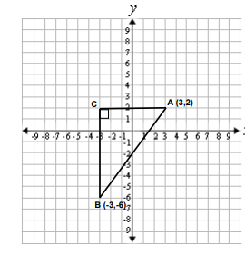
- Caliyaah is traveling to Peru for her summer vacation. She looks at a map of the path of her flight. Her plane leaves from Georgia, located at (5, 16) on the map’s coordinate grid, makes a stop at the halfway point, Panama, and then heads to its destination, Peru, located at (7, 8) on the map’s coordinate grid. Find the location of Panama on Caliyaah’s map. What’s the approximate distance from Georgia to Peru if one unit is approximately 29 miles.

