Geometry Unit 1 Day 1 Solving Multistep Equations

Learning Target – Students will solve multistep equations including those with rational coefficients.

To solve an equation with variables on both sides of the equal sign, use the Addition or Subtraction Property of equality to write an equivalent equation with the variable terms on one side. Then isolate the variable.

Warm up

1. Solve 2+5k=3k-6. Be sure to check your answer.

Practice:

1. 3.

4. 5.

6.

If equations contain grouping symbols (such as parenthesis or brackets) use the distributive property to remove the grouping symbols then solve.

Example

Solve $6\left(5m-3\right)=\frac{1}{3}(24m+12)$

You try: Solve each of the following

6. 7.

The equations we have solved so far all have one solution, or one number that when substituted for the variable, makes the equation true. These equations are SOMETIMES true. Attempting to solve the equations will result in a single value.

Some equations have no solution. That is, there is no value of the variable that will make the equation true. So these equations are NEVER true. Attempting to solve the equation will result in a FALSE statement.

Some equations are true for all values of the variable. These equations have infinitely many solutions and are ALWAYS true. These equations are called identities. Attempting to solve the equation will result in a true statement.

|  |  |  |  |
| --- | --- | --- | --- |
| Number of solutions | When the equation is true | What it looks like  Example | Represent the solution |
| 1 | Sometimes | x=7 | x=7 |
| 0 | Never | 5=-14 | No solution |
| Infinitely many | Always | 5=5 | Infinitely many solutions OR  All real numbers |

1. Solve
2. $5x+5=3\left(5x-4\right)-10x$ b. $3\left(2b-1\right)-7=6b-10$

Geometry Unit 1 Day 1 Homework

1. 2. 

3.  4. 

5. 

6. 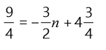 7. 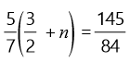

8. 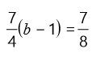 9. 

Geometry Unit 1 Day 2 Writing equations of lines in slope intercept form

Learning Target – Students will write equations of lines in slope intercept form.

Warm Up

1.  2. 

[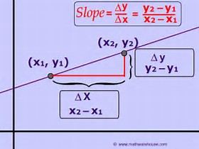](https://www.bing.com/images/search?view=detailV2&ccid=qGumZoIP&id=D931E8008BAED3DD388E7C905A8E155565ED983D&thid=OIP.qGumZoIPVH05C-4xbJwOXgEsDh&q=slope+of+a+line&simid=608036314110427983&selectedIndex=1)In a **linear function**, the rate of change will always be constant. No matter which two ordered pairs that you choose, you will get the same rate of change. This means that the graph of a linear function will always be a straight line. The **slope** of a line is the same as it’s rate of change. For any two points on a line ($x_{1},x_{2}) and (y_{1},y_{2})$

$$m=\frac{change in y}{change in x}=\frac{∆y}{∆x}=\frac{y_{2}-y_{1}}{x_{2}-x_{1}}$$

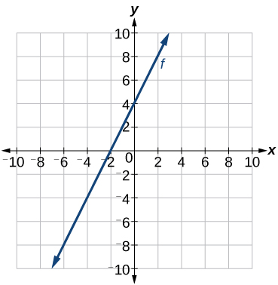

1. Find the slope of a line passing through (-4,3) and (2,5).
2. Find the slope of the line shown to the right.
3. Find the slope of the line through (-5, 3) and (2, 5).
4. Find the slope and y intercept of the line shown.

[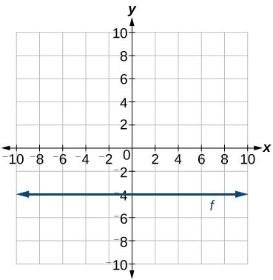](https://www.google.com/url?sa=i&rct=j&q=&esrc=s&source=images&cd=&cad=rja&uact=8&ved=2ahUKEwiZxYvSgq7cAhVMb60KHZ9kCI4QjRx6BAgBEAU&url=https://courses.lumenlearning.com/precalcone/chapter/write-the-equation-for-a-linear-function-from-the-graph-of-a-line/&psig=AOvVaw2syw2rkCVtpCSUMk40-YNx&ust=1532187838903715)

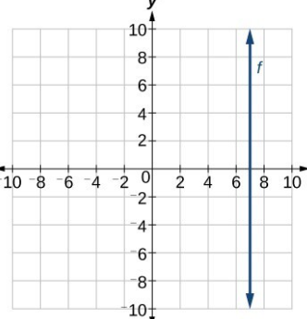

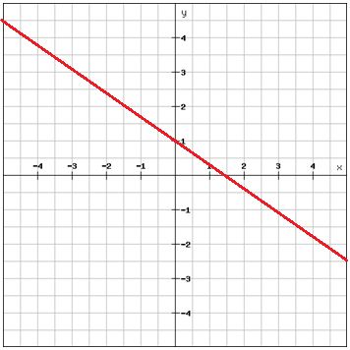The slope intercept form of the equation of a line is $y=mx+b$, where m is the slope and b is the y intercept.

1. Why do you think this is called slope intercept form?

If you are given the slope and y intercept of a line, you can find an equation of the line by substituting the values of m and b into the slope intercept form.

Example:

Write the equation of the line given:

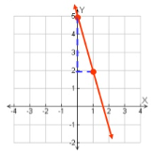

You can also write the equation of a line in slope intercept form if you know

1. The slope and one point on the line.
2. Two points on the line.

Example A:

Write the equation of a line in slope intercept form that passes through (2,1) with a slope of 3.

Example B:

Write an equation of a line that passes through (3,1) and (2,4).

Geometry Unit 1 Day 2 Homework

Find the slope of each line.

1. 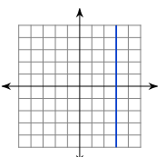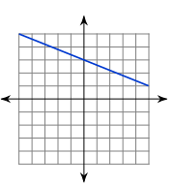2. 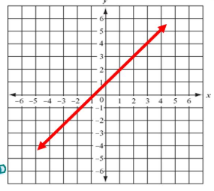3.

Write the equation of the line in slope intercept form.

4.  5.

1. Through
2. 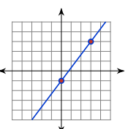

8. 

Geometry Unit 1 Day 3 Writing equations of lines in Point Slope Form

Learning Target: Students will write equations of lines in point slope form.

Warm up

1. Write the equation of a line in slope intercept from between (-4,-2) and (-5,-6).

If you know the slope of a line and the coordinates of a point on the line, you can use the **point-slope form** to find an equation of the line. The point slope form for the equation of a line is

$$y-y_{1}=m(x-x_{1})$$

Where m is the slope and ($x_{1}, y_{1})$ is any point on the line.

1. Write the equation of a line in point slope form where the line passes through (-2,5) with a slope of 3.
2. Convert your answer to slope intercept form.

***Use your whiteboard to practice.

You can use two points on a line to write it’s equation. You can choose either point slope or slope intercept form.

Example:

Write the equation of a line that passes through (-2,7) and (3,-3).

***Use your whiteboard to practice.

*** Desmos Practice Activity with a partner.

Learning Target – Students will write equations of lines in point slope form.

Items needed – Dry erase board, marker, eraser, computer



For each problem above

Step 1 – Write the equation of a line in point slope form that passes through those two points.

Step 2 – Convert your equation to slope intercept form.

Step 3 – Go to [www.desmos.com](http://www.desmos.com) and click start graphing.

Step 4 – In the top left hand corner you will see a plus, add an expression twice so that you have three boxes under the plus sign.

Step 5 – Type your ordered pairs in the first two boxes.

Step 6 – type the slope intercept form of your equation into the third box.

Step 7 – You will know that your equation is correct if your line passes through the two given points.

Step 8 – if you are correct check in with your teacher – show your work and desmos screen

Step 9 – if you are not correct, find your mistake and correct it, check it in desmos and then check in with your teacher.

Geometry Unit 1 Day 3 HW

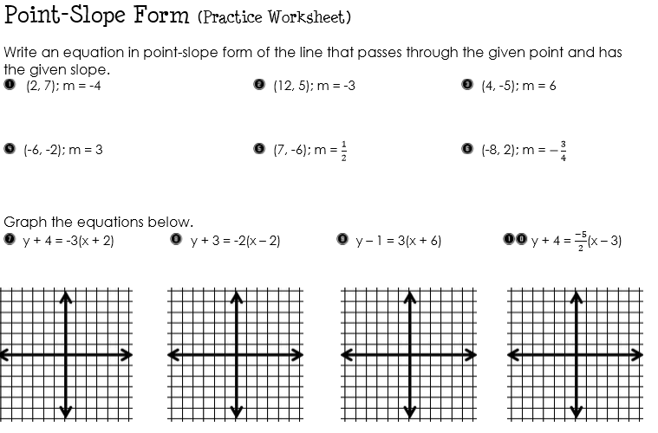

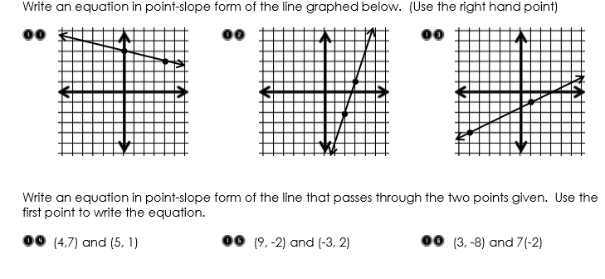

Geometry Unit 1 Day 4 Writing Equations of Lines in Standard Form

Learning Target : students will write equations of lines in standard form.

Warm up:

1. Write the equation of a line in point slope form through (4,5) and (6,8) in point slope form.
2. Convert the equation of your line from question 1 to slope intercept form.

**3 Forms of Linear Equations**

**Slope intercept form $y=mx+b$** m=slope, b=y intercept

**Point Slope form $y-y_{1}=m\left(x-x_{1}\right)$** m=slope and ( $x_{1},y_{1})$ is a point on the line.

**Standard Form $Ax+By=C$** A, B, and C are integers with a GCF of 1, $A≥0$, and A and B are both nonzero

Example – Write the equation of a line with a slope of $\frac{1}{2}$ and a y intercept of 5. Then convert your equation to standard form.

You try:

1. Write the equation of a line with a slope of -9 through the point (2,2). Convert to standard form.
2. Convert to standard form.
   1. $-\frac{3}{10}x=8y-15$ b. $2y=4x+5$ c. $3x-6y-9=0$

Geometry Unit 1 Day 4 HW

Write the equation of a line in standard form given the following conditions:

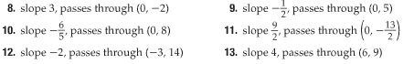

Geometry Unit 1 Day 6 Graphing Equations of lines

Learning Target – Students will graph equations of lines in slope intercept, point slope, and standard form.

Example:

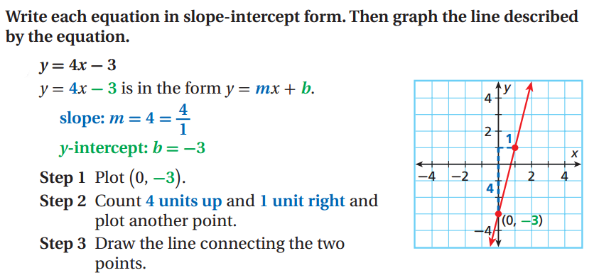

***Use your whiteboard to practice graphing with the class.

If you are given the slope and y intercept of a line, you can find an equation of the line by substituting the values of m and b into the slope intercept form.

Example:

Write the equation of the line given:



***Practice on whiteboards

A linear function has ordered pairs that satisfy the equation $f\left(x\right)=mx+b$, where m is the slope or rate of change and b is the y intercept. Since two points determine a line, one way to graph a linear function is to find the points at which the graph intersects the x and y axis and connect them with a line. The point where the graph crosses the x axis is called the x-intercept and the point where the graph crosses the y axis is called the y intercept.

1. What do you know about the coordinate for the x intercept of any graph?
2. What do you know about the coordinate for the y intercept of any graph?
3. Find the x and y intercept of the graph 2x-3y+12=0. Then graph the equation.

[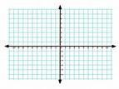](https://www.bing.com/images/search?q=coordinate+grid&id=9D2C52D8AAA0A6D8245A224EF77BDB764F12EC8F&FORM=IQFRBA)

1. Find the x and y intercept of 8x-12y=24. Then graph the equation.

[](https://www.bing.com/images/search?q=coordinate+grid&id=9D2C52D8AAA0A6D8245A224EF77BDB764F12EC8F&FORM=IQFRBA)

1. [](https://www.bing.com/images/search?q=coordinate+grid&id=9D2C52D8AAA0A6D8245A224EF77BDB764F12EC8F&FORM=IQFRBA)Find the x and y intercept of y=3x+7. Then graph the equation.

Geometry Unit 1 Day 6 Homework

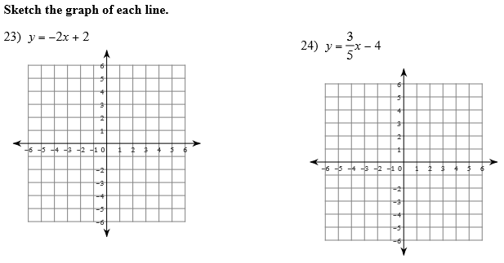

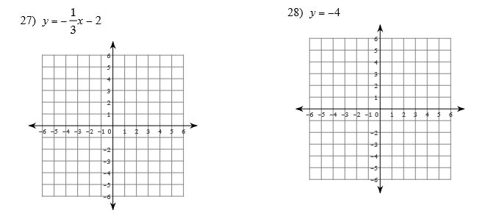

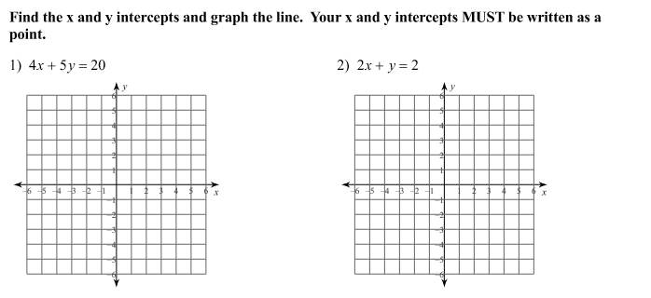

Geometry Unit 1 Day 8 Writing equations of parallel and perpendicular lines

Learning Target – Students will write equations of lines parallel or perpendicular to a given line.

Slope can help you determine whether two lines are parallel or perpendicular.

1. What does it mean for two lines to be parallel?
2. What does it mean for two lines to be perpendicular?

In today’s lesson you will explore these relationships. Work with your partner to complete the desmos activity at student.desmos.com class code _________. You must log in and use your real name to receive credit for this assignment.

**Parallel** lines have the same slope.

**Perpendicular** lines have opposite reciprocal slopes. Vertical and horizontal lines are perpendicular.

Write an equation of a line in slope intercept form for the line that passes through (5,-6) and is parallel to the line $y=-\frac{3}{2}x+7.$

How would your answer to the equation above change if the line were to be perpendicular to the given line?

Geometry Unit 1 Day 8 HW

Write the equation of the line described in slope intercept form.

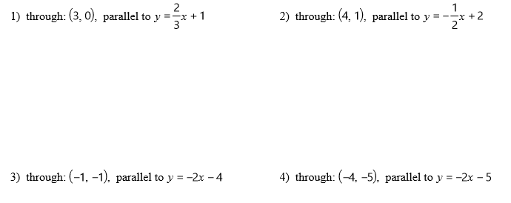

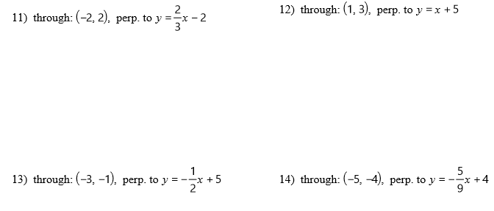

Geometry Unit 1 Day 10 Parallel and Perpendicular Lines

The coordinate system below is designed for a soccer field. Each unit represents one yard. The black ray beginning at point O represents the path of a ball from a corner kick. To have the best chance for a shot on the goal, Joe wants to run towards the ball so that his path meets the path of the ball at a right angle. At what point should Jack intersect the ball?

SHOW ALL WORK.



Geometry Unit 1 Day 9 Homework



2.) Write the equation of each line shown.

3.) Write the equation of a line perpendicular to line 1, through the point (2,3). Graph the line and label it line 3.

4.) Is line 3 perpendicular to line 2? Justify your answer.