Geometry Review for Unit 4 Quiz 2

1. Define and draw a picture of each. Be able to identify from a definition or a picture for tomorrow’s quiz
2. Scalene Triangle
3. Isosceles Triangle
4. Equilateral Triangle
5. Altitude
6. Median
7. Perpendicular bisector
8. Angle bisector
9. The perimeter of ∆ABC is 72. AB = 14x-4, BC = 12x, AC = 11x+2. By solving for x, determine whether ∆ABC is scalene, isosceles or equilateral.
10. Order the sides from smallest to largest.

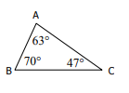

1. Order the angles from smallest to largest

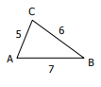

1. Determine whether a triangle can exist with the given sides. Explain
2. 6, 9, 16 b. 6, 9, 10 c. 6, 9, 15
3. Find the value of x and list the sides in order from smallest to largest if the angles have the following measures:



1. The vertex angle of an isosceles triangle is 40 degrees. Find the measure of each angle in the triangle.
2. The base angle of an isosceles triangle is 50 degrees. Find the measure of each angle in the triangle.
3. 
4. 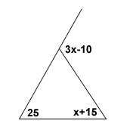Find the value of x. Then find the measure of the 3 unknown angles in the figure. Label them on the figure.
5. Find the value of x

