Geometry Review for Learning Check 4
- Write an equation of a line parallel to 5x+2y=11 through the point (4, -3).

- Are the lines parallel, perpendicular or neither? Explain.
2x+3y=7
-6x+4y=15

- Find the measure of the angle labeled ?
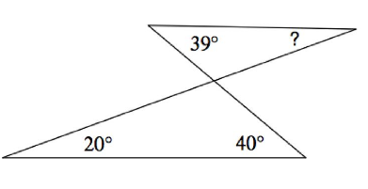
- LK bisects $∠JKP$ and QK bisects $∠PKM.$ Find the measure of $∠PKQ$.
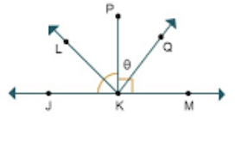
- $∠ROT=123$ degrees. Find the measure of $∠SOP$and $∠POT.$
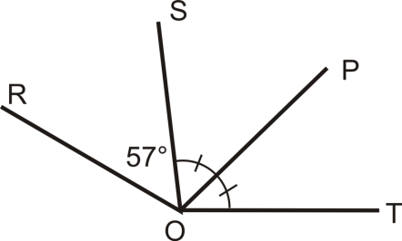
In the

- In the picture below angle 8 measures 120 degrees. Find the sum of angle 7 and angle 15.
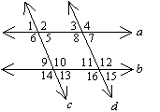

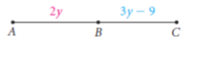
- Given: B is the midpoint of AC
Prove: y=9

- What other information to do need to prove the triangles are congruent using ASA?
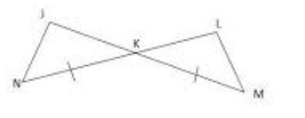
- What other information do you need to prove the triangles are congruent by SAS?
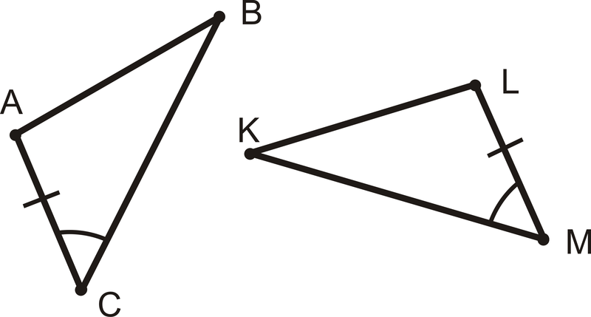
- What other information do you need to prove the triangles are congruent by HL?
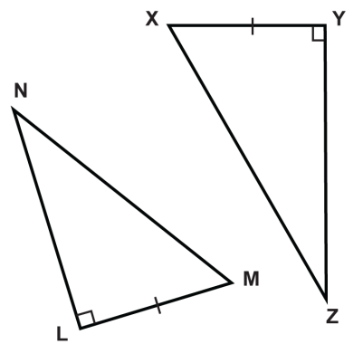
- M is the midpoint of KQ. What 2 congruence theorems could be used to prove the triangles are congruent? Explain.
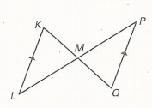
- Draw a parallelogram ABCD.
  - Which pairs of angles are congruent?
  - Which pairs of angles are supplementary?

- What is the sum of the measures of the exterior angles in a triangle? In a pentagon?

- What is the sum of the measures of the interior angles in a triangle? In a pentagon?

- Find the measure of angle A.
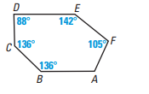

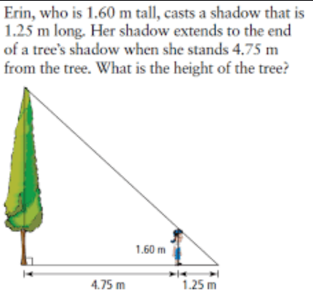
- Are the triangles similar? Explain.
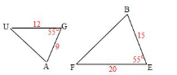
- Suppose you live at point (1,3) on a coordinate grid. There are two chic fi la’s located near your house. One is at (-2,4) and the other is at (5,7). Which one is closer?

- Find the midpoint f (5,7) and (1,3).

- Dilate the given triangle by a scale factor of 2. Give the coordinates for the new triangle A’B’C’ and graph the image.
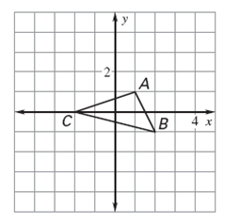
- Explain why ABC and A’B’C’ (from question 20) are similar using similarity criteria.

