Geometry HW Unit 4 Day 5

1. $∆CAT≅∆DOG$ Write all six pairs of congruent corresponding parts.

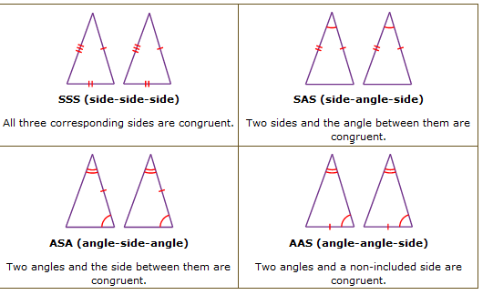

1. For each pair of congruent triangles below, write the congruence statement and name the theorem that proves they are congruent.

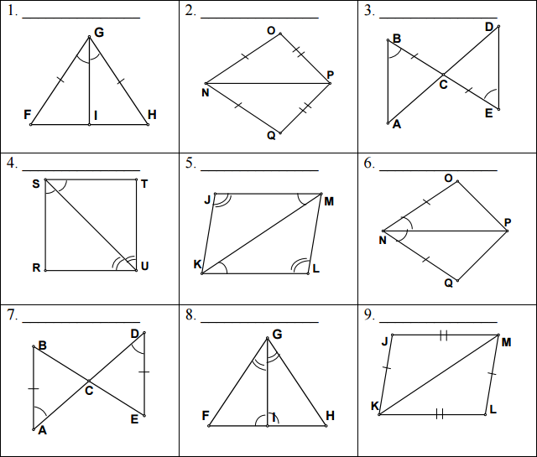

Write a two column Proof

1. 
2. 