Geometry Area review
- Find the area of a equilateral triangle with a side length of 20 feet.

- The area of a rhombus is 84 square inches. One diagonal is 12 in. Find the length of the other diagonal.

- Find the area of each rectangle.

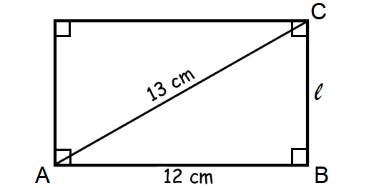
b. d=12 and angle ACB=24
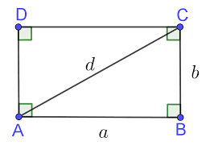

- Find the area of the shaded region.
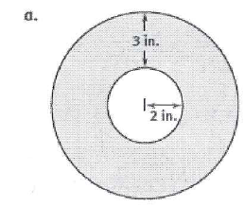
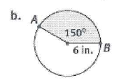
c.
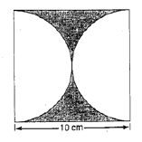
- Find the probability of landing in the unshaded region. The bigger circle has it’s center at O and a radius of 16 m.
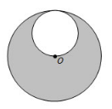
- The area of a parallelogram is 810 ft² and the height is 30 ft. what is the length of corresponding base?

- Find the area.
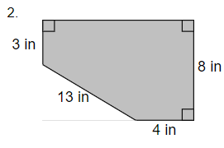
- Find the length of $\hat{AC.}$
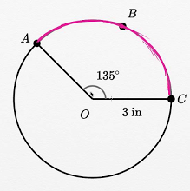
- Find the area.
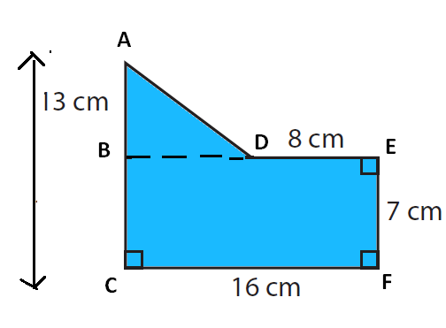

- The Area of the triangle is 350. Find the height.
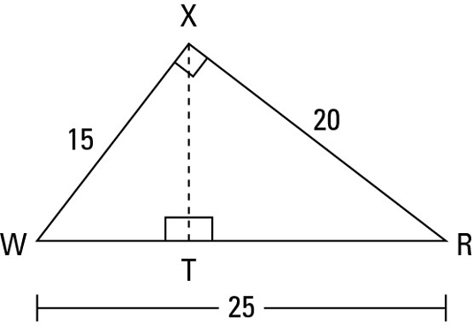

- Find the area of the rhombus.
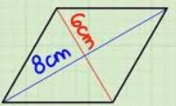
- Graph and find the area of the polygon with vertices of (2,-7) (4,-4) (4,8) and (2,5).
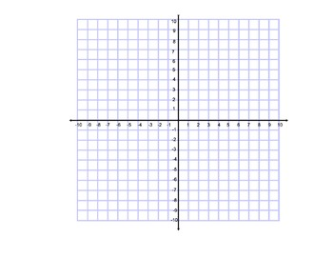
- Find the area of a regular pentagon with a side of 12 and an apothem of 4.

- Find the area of a regular hexagon with a side of 8.

- Find the distance between (-4,3) and (-7, -5).

- Use the isosceles trapezoid below to find the measure of all 4 angles if one of the acute base angles is 71 degrees.
